**Introduction to Github**

It is a **version control system.** A VCS is a software that tracks and manages changes to files over time. Basically, it allows us to access previous versions of code or make changes to them and so on.

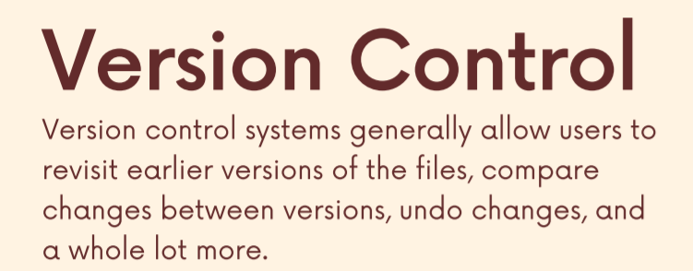

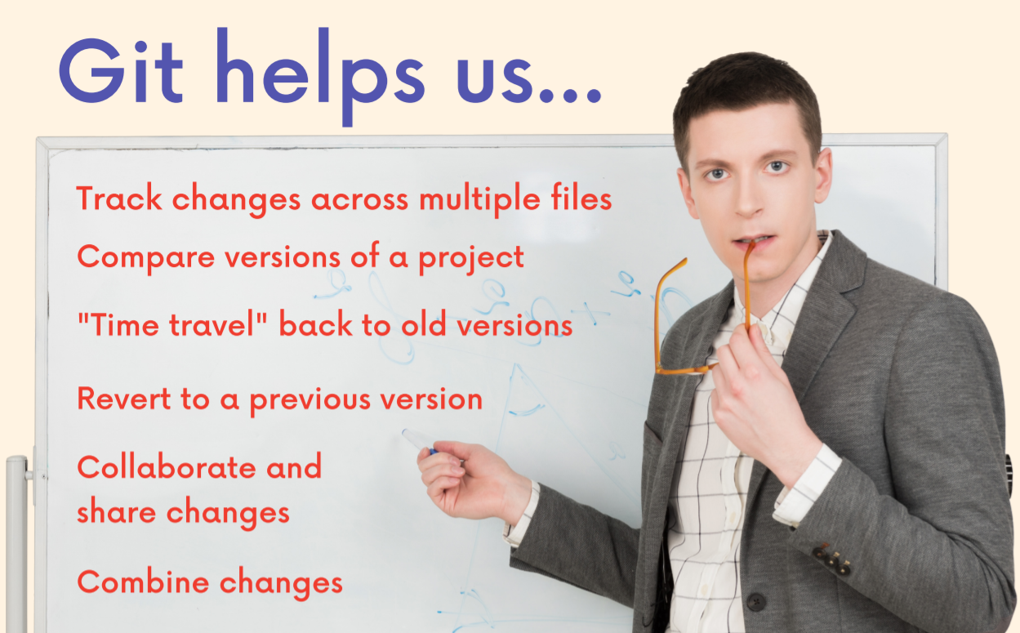

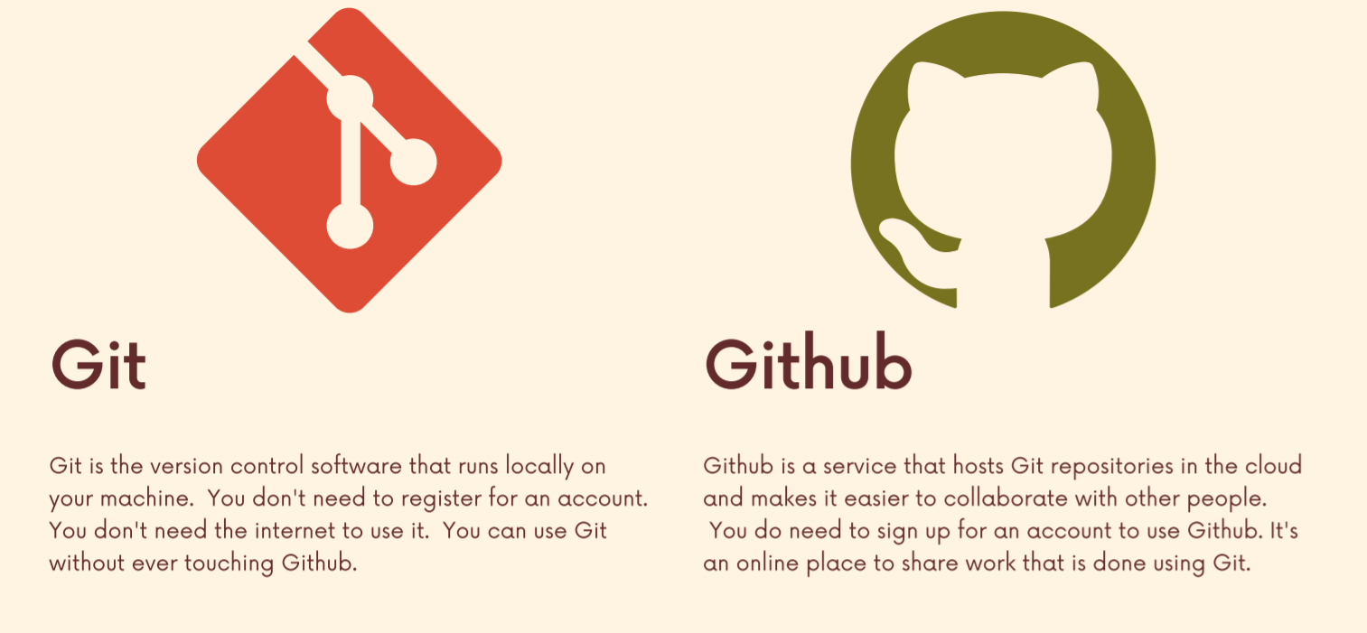

**Using GIT**

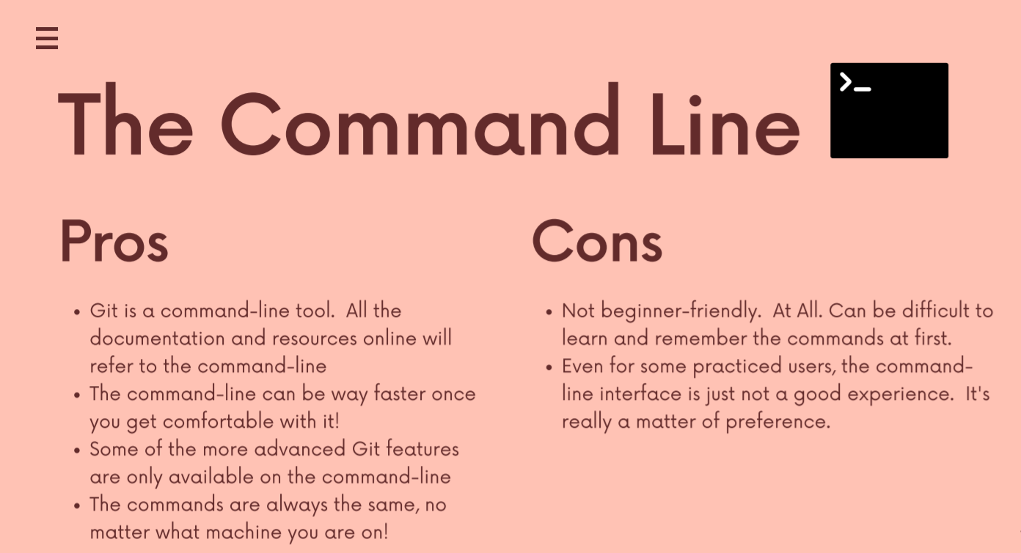

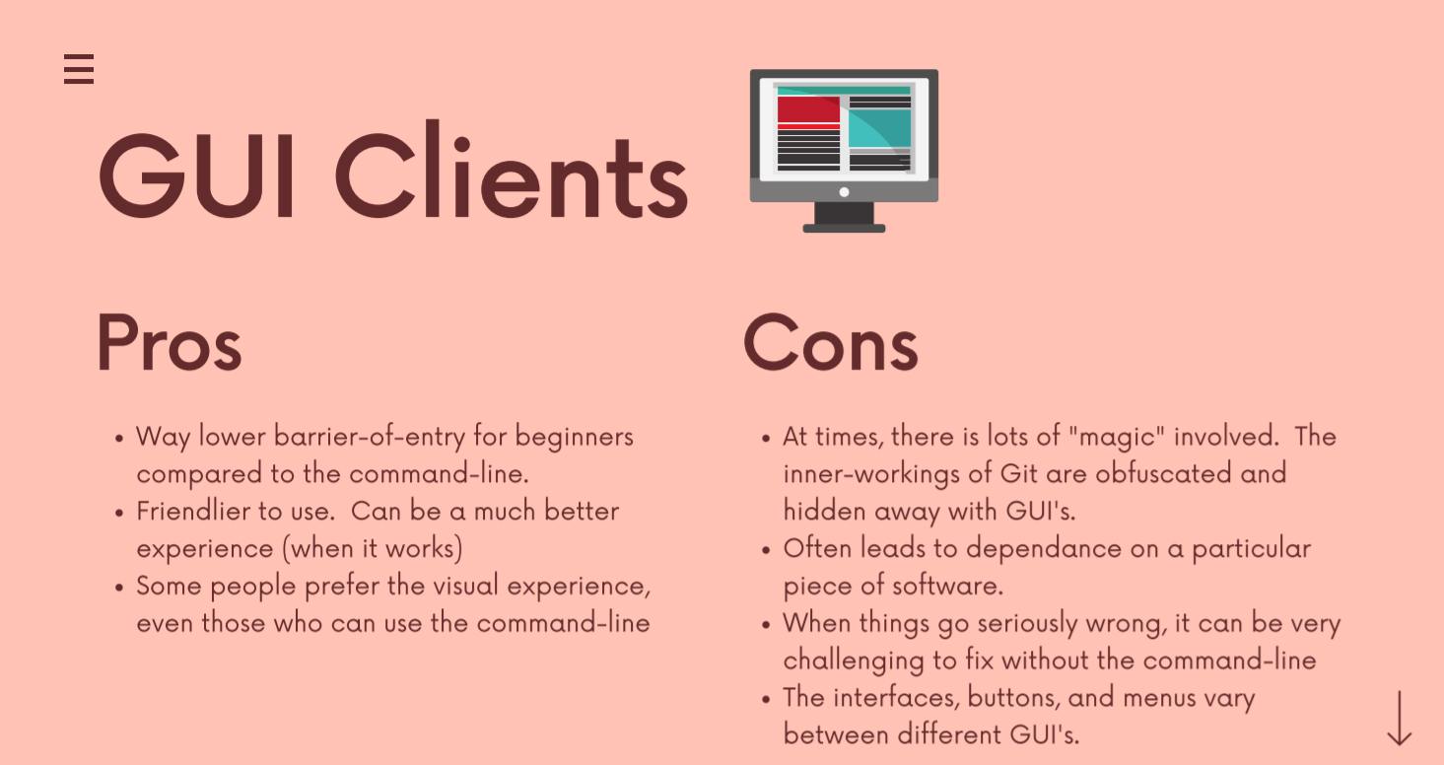

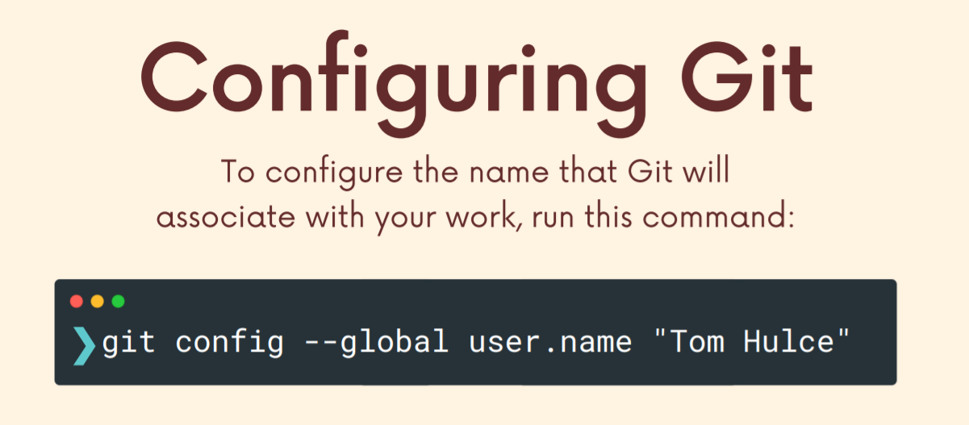

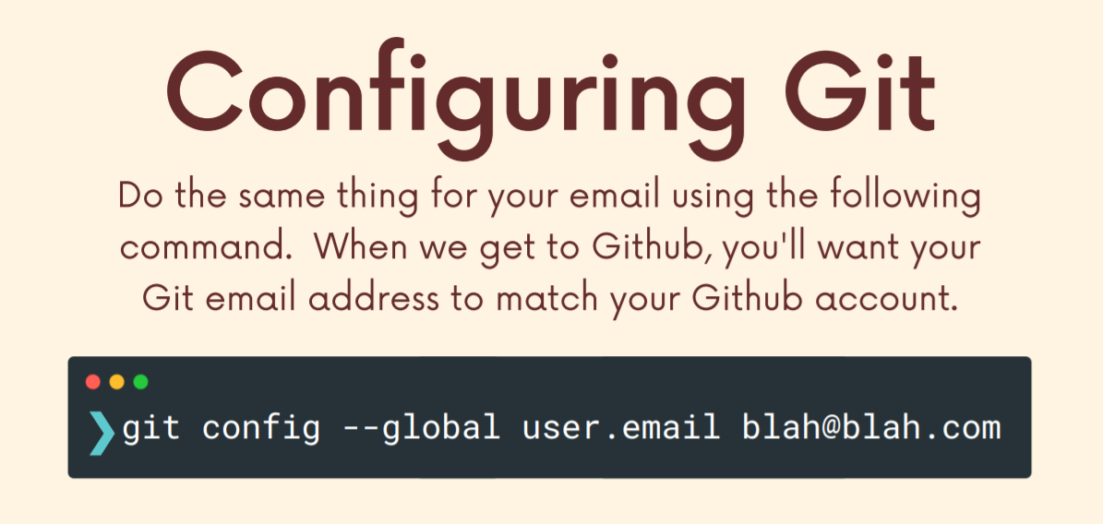

**Terminal Crash Course**

Traversing/navigating

**ls** – lists files of the current folder/directory. We can type ls and the name of a folder (within the current directory and immediately within it, not within a sub-folder of this directory because we are currently in the main directory and we can only view contents 1 level down and not 2 level down) to view its contents. Eg **ls pets/cats** to access cats folder within home directory and then pets directory.

**start . -** opens up the current directory/file explorer. We can type start . and the name of a folder (within the current directory) to open its contents.

**clear –** clears the terminal.

**pwd –** print working directory prints out the current location/path.

**cd –** change directory to switch between folders/directory.

**cd .. –** going back 1 folder.

Making new folders/deleting new folders

**touch –** to make a file/files within the current directory/location. Eg **touch orange.js red.txt**. To make a file within a sub folder/directory without going to that directory first/without going to that location, we can write the complete path, i.e., **touch pets/cat.js**.

**mkdir –** to make directories/folders. If we want to add a space in the name of a single folder then we can use **“Sea Turtle”** (using “) else it is considered as 2 separate folders.

Deleting files and folders

**rm –** removes the file within the current directory. Eg **rm app.js**.

**rm -rf –** removes the directory.

**Basics of GIT: Adding and Committing**

Different repositories have their own unique git history.

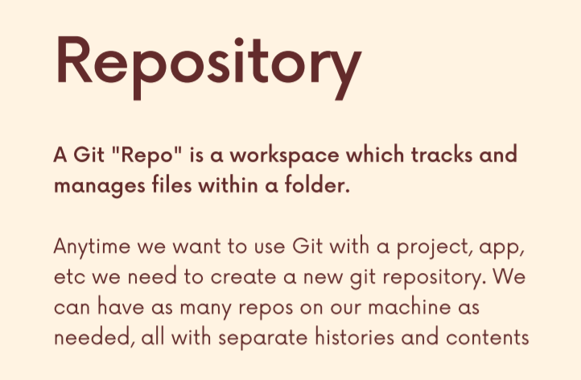

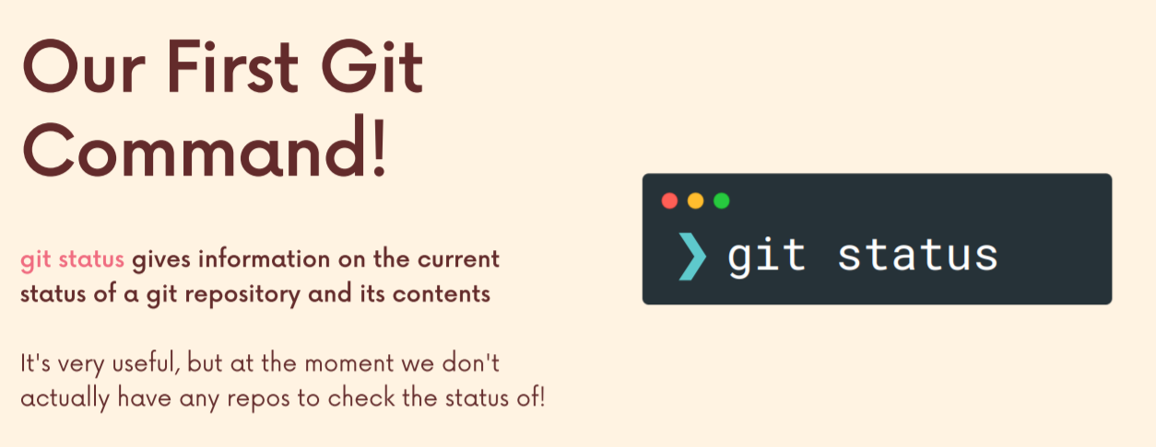

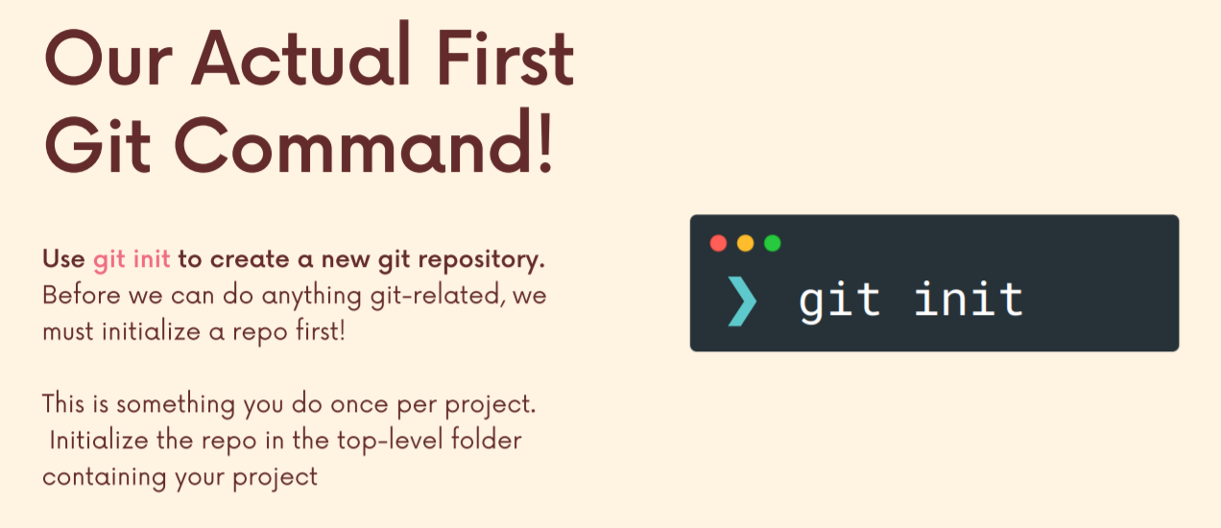

Let’s quickly talk about a common issue that some students run into early on and to explain it first, we need to understand that when we have a git repo, we initialize it, get repo that's in one directory. Right. In our case, it was the my first novel directory. But Git is going to watch everything that happens in this directory, including anything nested further down, as you know, child or grandchild directories and so on.

OK, so I'm two folders in two levels deep, but I can still type git status. I still get feedback that says yes, you are in a git repo. So it's not just this folder. My first novel, it's everything nested in that folder. So it's top down. And that's important to understand for a couple of reasons. One, any files and folders and changes I do in this directory for this one project are tracked by GIT if I initialize the repo like I did. But two, it's important to understand we do not want to be initializing another repo inside of an existing repo. I made a warning sign to make this clear. We want to keep our repository separate and you don't want to run get init inside of an existing repository. It's not the end of the world, but at some point things will go wrong. Git will get confused because it's tracking everything happening in a folder. And if one of those folders has git also initialized, then it's git tracking git and it just gets confused. So we want to avoid that. And the easiest thing to do is just make sure when you run, get in it, make sure you're not in a repository. And that's why I showed you to use git status first.

So if I wanted to make a new repository, I'm writing a new novel, I want to have a separate history. I would try running git status. Oh, I'm in a repo that should tell me don't initialize a new repo in here. You're already in a repo. Go somewhere else. So let's back out a couple of levels. Let's keep going. So I've backed out and now I can make another directory, you know, book to go into that directory. Just show it over here. Here it is. And type git status, not a git repository. Now I can initialize. So it's not the end of the world. It won't give you an error message, but you want to be careful.

And in general, my rule is make a folder for a project and then initialize git in that folder. So don't you know you don't want to have a git repo on your desktop or your documents folder or on your entire machine that's tracking everything you could. But most people prefer to have one repo per project. So always run git status. Make sure you're not in a repo before you initialize. And if you do happen to end up with nested repos, you can sort it out by deleting one of a dot folders.

For more clarity: <https://www.udemy.com/course/git-and-github-bootcamp/learn/lecture/24524700#overview>

**Commit**

Commit is one of these checkpoints in a git repository and typically a single git repository has tons and tons of these, commits one after another, and eventually will learn how to go back to earlier commands, how to undo commits, how to just take a peek at an earlier commit. But for now, we're just going to focus on making these checkpoints. How do we do some stuff in a project? How do we, you know, add a new feature to a website and then make a commit and then repeat, do some more stuff, make it commit, do some more stuff, make a commitment. That is our goal.

So you can see here's the very first commit all the way up to some of the more recent ones. So there's, what, over 100, maybe 150, at least individual commits. And each one of them is a check point in time, a snapshot of the repository and the new work that I did, the new changes. And it includes a little message like, you know, refactor, async error, handler and post methods or something very silly and boring, like initial commit or, you know, add matchboxes back to some stylesheet whatever that message is, it's up to me. But there is a message along with this snapshot of my project in time.

Now, the next thing that's crucial to understand about making a commit is that it's not the same as just saving a file. It's actually think of it as something that's built on top of saving files. We have to make changes first and save them to our files before we can even commit. So we might use the term check point or save point. But we're not talking about just saving a file that has nothing to do with GIT. We save files all the time, but once we have made changes, we can then group them together into a commit. So on the right hand side I'm showing potentially a commit that I may have made. That includes changes to five four different files, plus a folder called Logo's and I can group that all together into a new commit. But first I would have written some new code in one of these files and saved it and then written more code in another one and saved it. Then I make that commit.

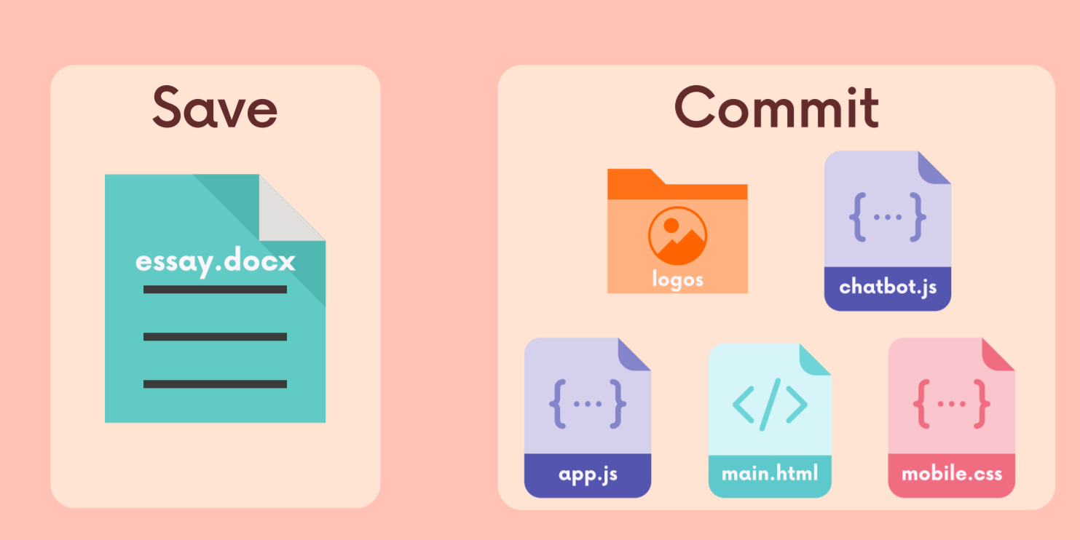

And the next thing that you need to know about making a commitment is that it's actually a multi-step process. It's not as simple as just hitting a button that says commit, commit, commit. Instead, there's an intermediate step where we actually call out the particular changes that we've made that we want to include in a commit. And this allows us to selectively make commits, which is really, really nice.

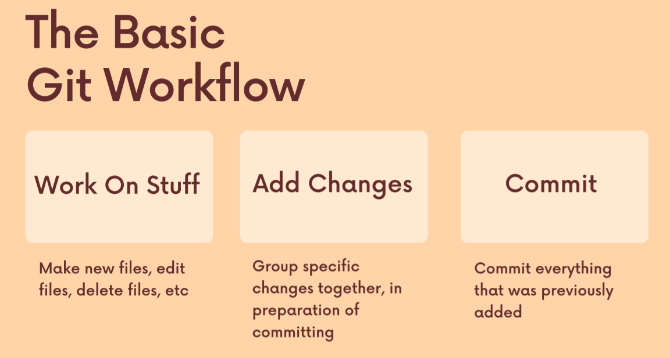

For example, imagine I've been working all day or all morning on some project. I spent a lot of time working on this project and I made changes to seven different files. As you can see, on the left hand side, I deleted a file, a modified two files I created for files. And instead of just making one generic commit that just says check point right now, instead, I can actually call out some of these and group them together based upon the actual stuff that I did. For example, I might group together those first three changes. I deleted a file called Team HTML and then I changed two files called about HTML and about CSS. Those were one thing that I did across three files. I added some new team member. To our about page, whatever the you know, about Page looks like, so that was one commit and then I can take these other four changes and group them together into a separate stand alone commit. So this is what I'm talking about when I say there's an intermediate step, we can select certain changes and make it commit with those changes. So we don't just say commit, commit, commit. Instead, we're getting in there with tweezers and we're saying, all right, this and this and this. Now we're going to commit those changes.

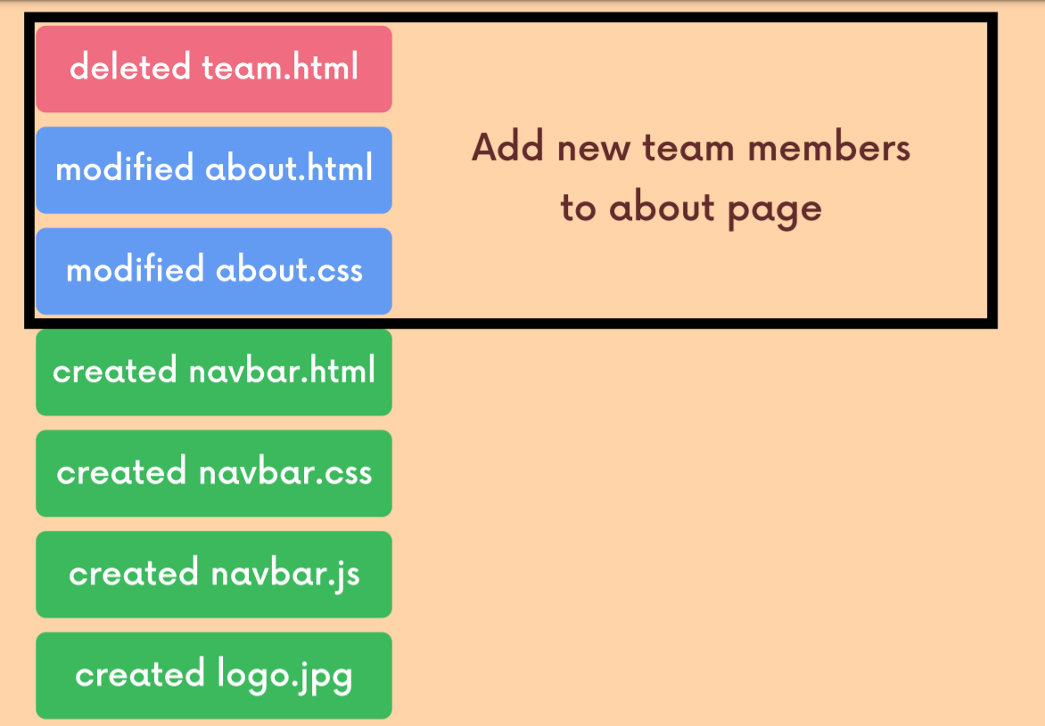

So just to reiterate all of this, a commit is a check point in time is a snapshot of changes in our repository. Eventually we'll be able to go back to earlier commits, undo, commits, merge, committed a whole bunch of things that we can do.

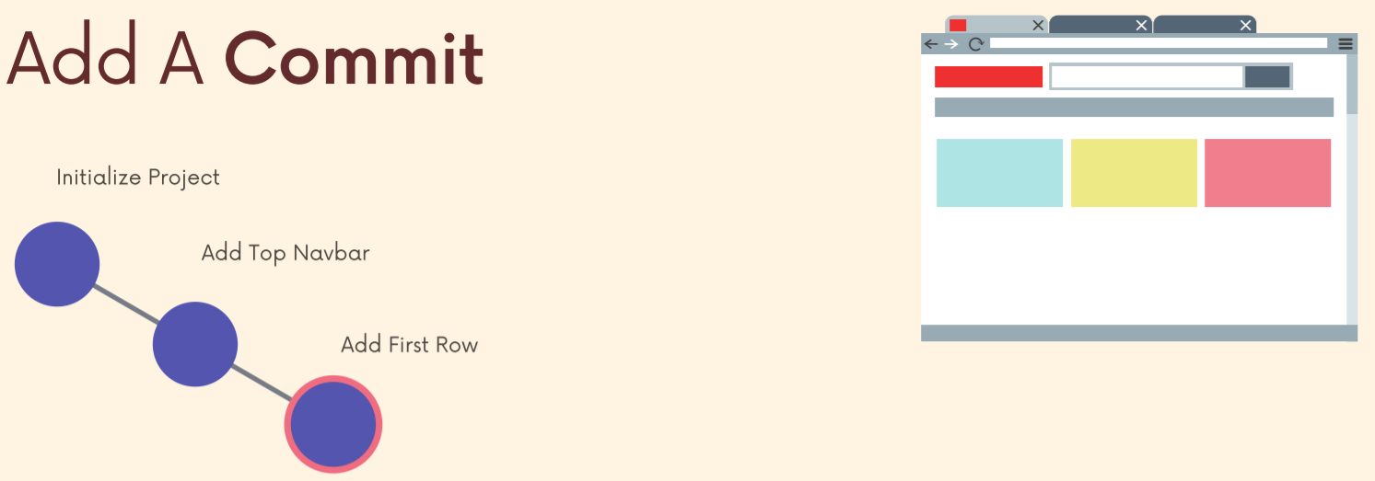

And when we make one of these snapshots, one of these commits, we can call out the specific changes that we want to include in a commit rather than just automatically including all changes in our project. We can select them. That's the first step, and then commit them.

**Command 1**

**\*\*\*So to actually make a commit, there are two associated commands. It's called Git add. And then the second command is git commit and we'll use git add in order to highlight or select those changes that we want to include in the upcoming commit.\*\*\***

Git add Command, which is the first of two commands that we'll use to make a commit. We use two commands because that allows us to separate out particular changes we've made. We can think that I use the imagery of tweezers so we can tweeze them out and select them before we make a commit so we can group things together. And this get add command is what enables that to happen. So, once we've done some work, we've actually made changes. We then call those changes out using the git add command to stage them for a commit and then we can make a commit.

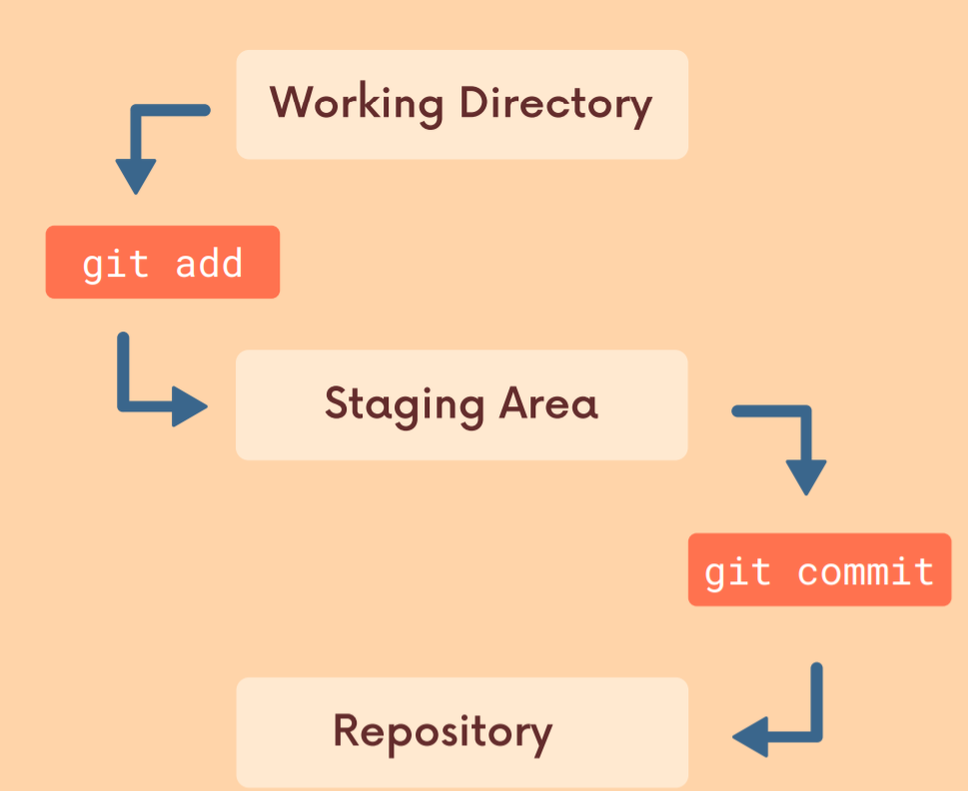

Let's start with this first one working directory. That's just a fancy way of referring to the directory, the place we're actually working on our project. The working directory just refers to this directory where I'm working.

Then we have the repository itself. This is the git folder. There's some stuff that's just there, some default contents. But once they actually make a commit, git commit changes, what is indicated actually adds new commits to that folder. So when we actually make a commit, we are updating that folder, the actual git repository. Otherwise, everything I've done so far is just in the working directory.

And then there's this intermediate thing, this zone, again, not a physical location, the staging area. And this is where we add our changes to before we make it commit.

So here's another flavor of diagram. We have those three terms, working directory, staging area and repository on the left side.

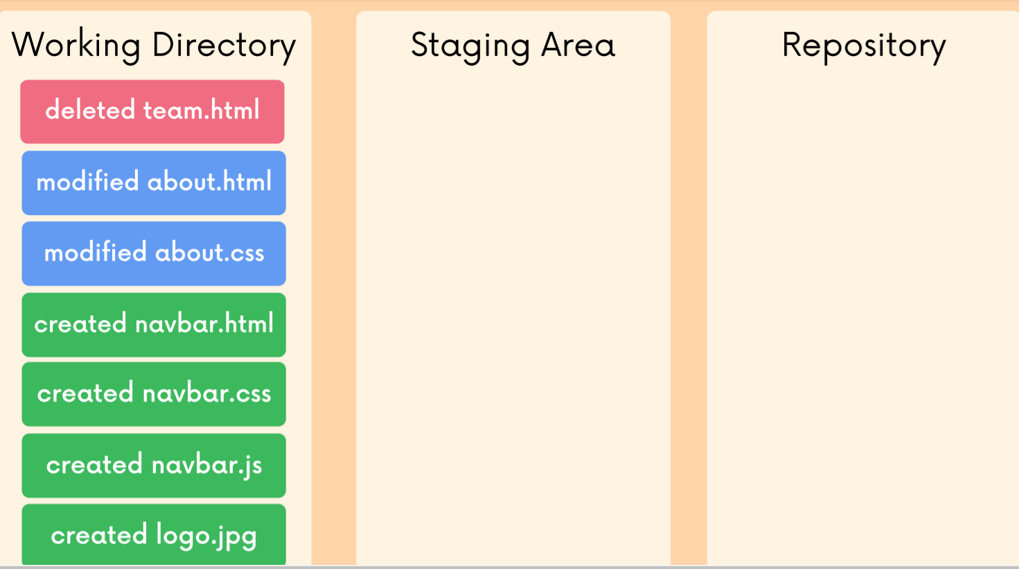

In the working directory, you can see a bunch of changes that I've made. So I've decided, OK, there's actually two discrete things I was working on and I'm going to make my first commit with those bottom four files that I change. They have to do with the nav bar. Date of the NFR or I created a new nav bar on our Web page, so I staged those changes first and I do that using the git add command

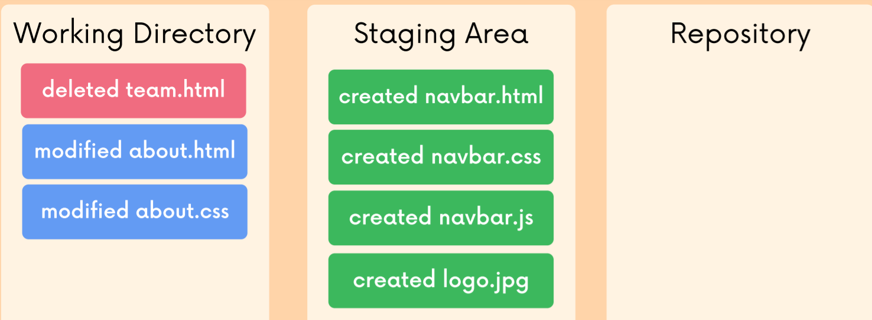

, then I can make it commit.

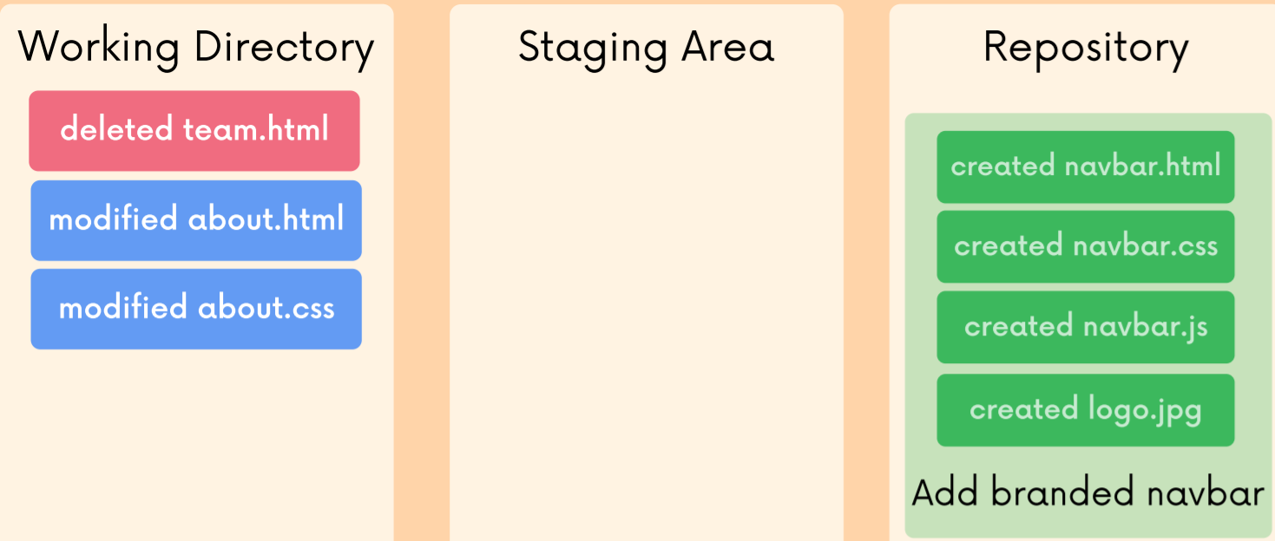

**\*\*\*Gt add is just going to stage changes so that I then commit them.\*\*\***

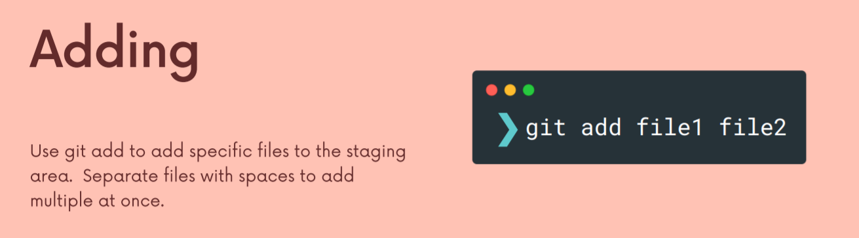

**Hence, git add allows us to stage different files together so that we can commit them together in 1 go. (Basically making particular files ready to be committed in 1 go). If we don’t use git add, we might not be able to commit specific files together. This is useful when we for example made 7 file changes out of which 5 belong to 1 component and 2 belong to another component and we want to commit changes for 1 component first and then the other one. Hence, we can group the 5files together and stage them and then commit them. Similarly for the 2 files.**

**Command 2**

OK, so now we're going to talk about the git commit command, which is the command we actually use to make a commit using whatever changes we have previously staged.

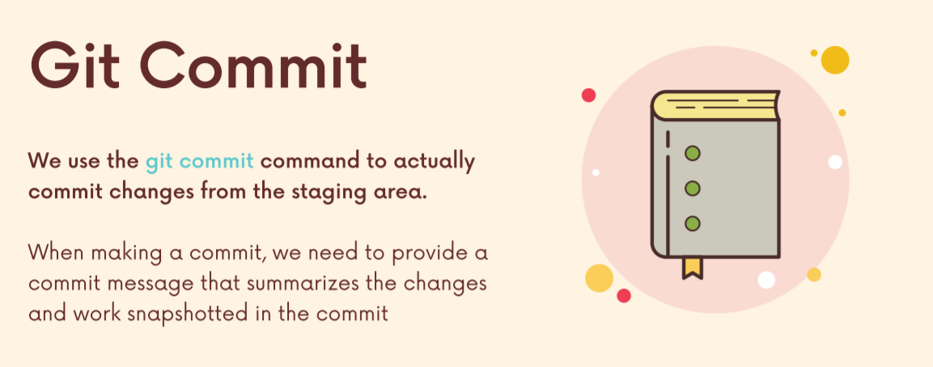

Before we run it, we need to discuss, commit messages whenever we make a commit, git expects us to include a message that describes or summarizes the changes included in that snapshot in the give and commit. A commit message should summarize the changes included in that commit.

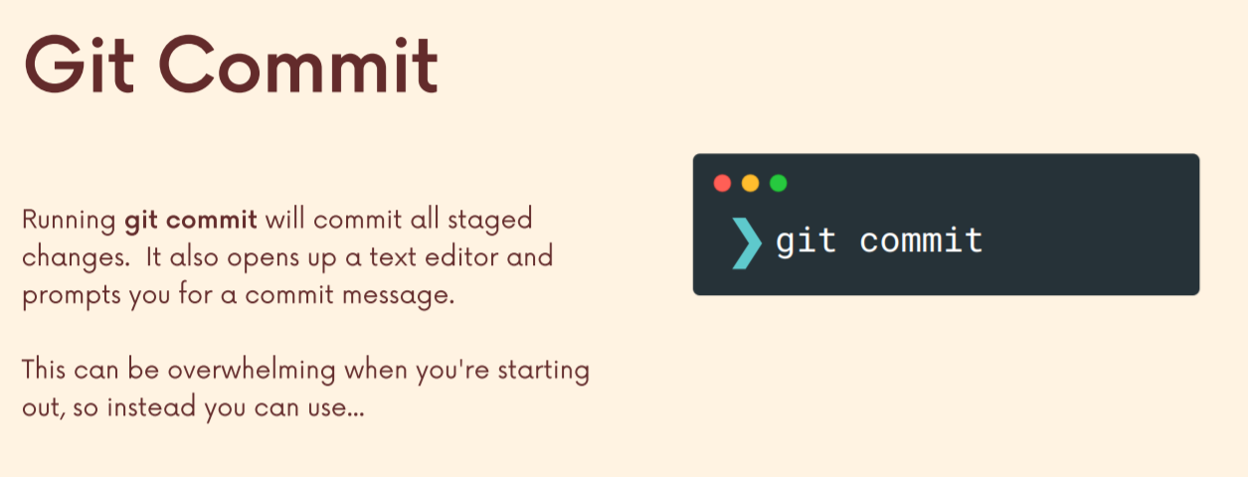

Git space, commit, and this will make it commit with whatever changes have been staged. However, it's going to try and use your default text editor. And, whatever your default, and is on your machine and most or many students don't have one configured, which is problematic because it will open up in something called Vem, which is a very, very not beginner friendly, very crazy, confusing editor in your terminal.

There's another variant rather than git commit which will pop up your editor and ask you for your message, we can just give get the message at the same time. So this dash m flag get commit dash m and then we provide a message and quotes get we'll use that message that we provide and make it commit with it rather than the previous (ss) flavor which asks us for a message as a secondary step.

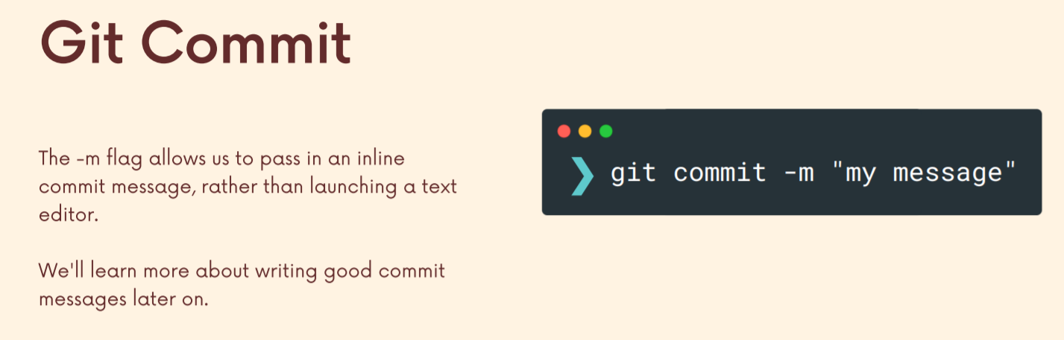

So always start with this. You don't have to configure an editor. You don't have to worry about Vim or another text editor. All you do is provide your message and hit enter.

**If we commit a file, GIT will be watching it continuously and even a small change like a change in the case of a single letter will be highlighted by GIT when we run git status. Hence, if we add a new file GIT considers it untracked, whereas after committing GIT watches over the file and notifies us about any change in the file. Unlike a newly untracked file, GIT watches over a file which has been committed previously and tells us about any changes that have happened on that file.**

**Hence, if we add a new file (not yet being watched by GIT) and modify an old file which is committed once (being watched by GIT) and we want to commit these both, then we can add these 2 using git add to the data space and commit them together.**

**Git log :** It just retrieves information and information. It retrieves to us is a log of the commits for a given repository. Just to ensure that when we ran git commit, it did commit.

**Git add . :** this will stage all the changes at once.

**Section 5: Commit in Detail**

We should try and make our commits atomic. Each commit should focus on a specific feature/function (one feature can include multiple files) and not multiple features together as this would allow us to roll back easily.

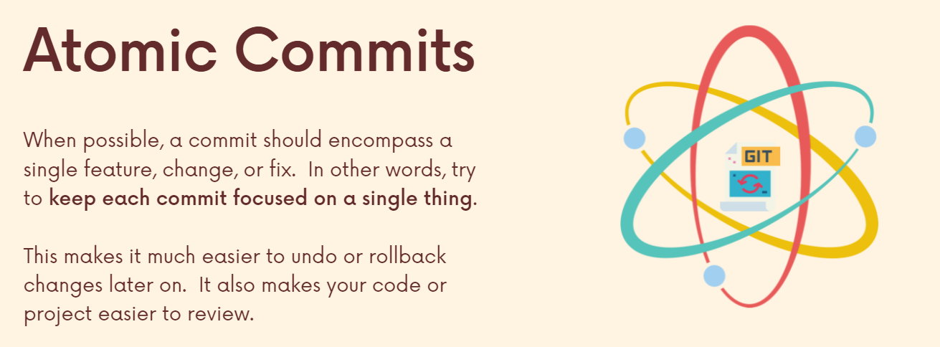

Let us say we have 4 files in which we have changed the name of someone and also we have created a new folder with 4 cat images in it. Hence, we will first add the 4 files and then commit them and after that we will add the folder and commit it (committing them together will be against atomic commit because these are 2 different features and we shouldn’t commit them together in a single go).

*So, I just made two separate commits instead of one larger comment following this idea, keeping our atomic breaking them down into some sort of single irreducible unit or peace instead of having like a multipurpose commit that just includes everything you did at once, break it down into smaller pieces. This matters a lot when you're working on code, especially when you're working with a team of people. And you may need to undo some of the things that you write. You may introduce a bug at some point. And if you boiled in a whole bunch of changes into one commit, rolling back that commit could undo a ton of work. But if you kept your commits atomic single purpose, then if somebody needs to undo one of them, you don't lose all that other work. It also makes your code easier to review if you do where when you do code reviews, it's just generally a practice.*

**Writing good commit messages**

Should be in imperative present tense.

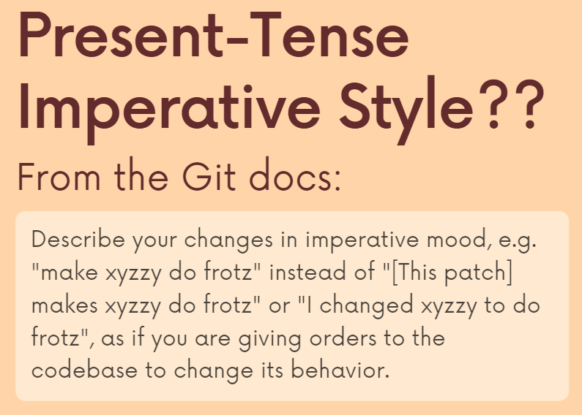

**Sometimes git commit -m “ “ is not the way to go and we use git commit and then in the vscode terminal we enter the message. This is because sometimes we might have a message comprising of multiple paras which we don’t want to type in a single line in our console.**

It now made the commit it was waiting and now it's not yet finished, so if I type git log, what did we see? Oh, well, we made that commit. It is here, but it's taking up so much space. That's really, really annoying. We can use git log with a small tweak so that we don't have to see the entire message in the case of a very long commit message.

**git log –oneline** this will shrink the message to 1 line and also the long code will be shrunk to a smaller code (this code is used when we want to access a previous commit, undo a commit or view a commit).

**Amending a Commit**

This allows us to edit or redo to update just the previous commit. So this doesn't work. If you made a mistake, 10 commit ago. This is only if you made a mistake, just one commit ago.

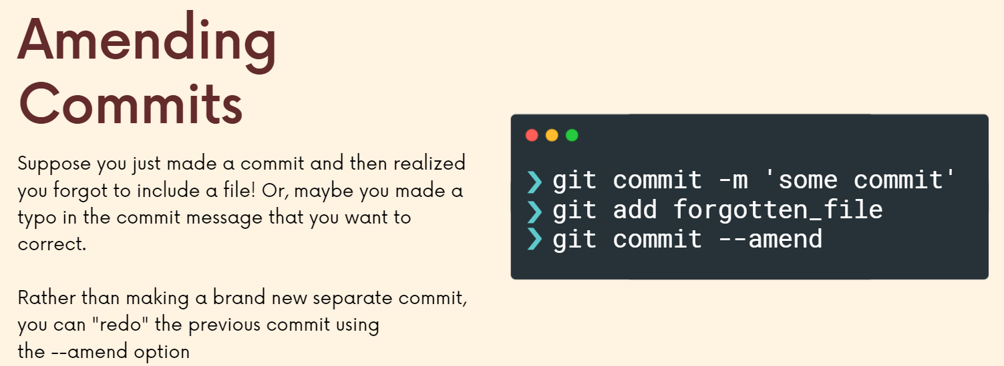

In the above figure we first staged 3 files and committed them but let us say we forgot to stage 1 file. Then we first stage that 1 file and type **git commit –amend** which will open the vscode editor and if we want to change the message we can or else we can just close it and then the newly staged file will also be committed to the previously 3 files.

So there's two reasons to do this. One is to include files, changes that you forgot that you somehow messed up in the previous comment. The other option is just to redo the commit message, or you could do both of them at the same time.

**Ignoring Files**

When you're working on a project and you're using git, there are often situations where you have files, directories that you just don't want git to know about or to track at any point you want them to be completely ignored. And there's a mechanism for doing this.

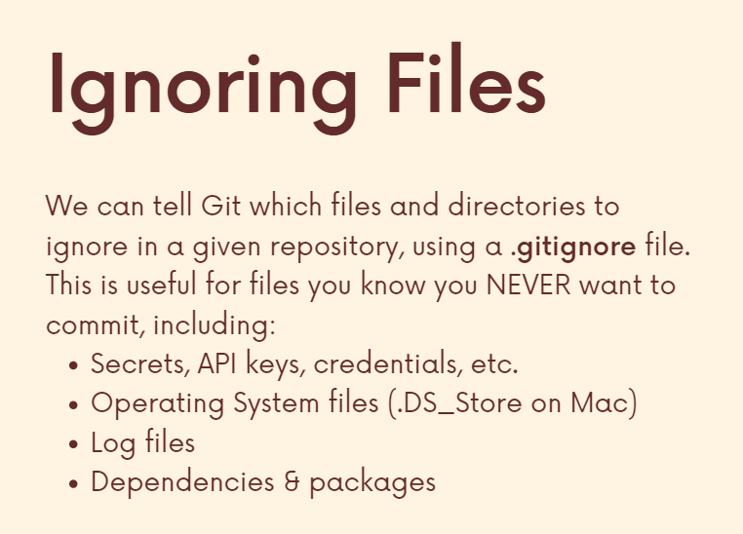

But before we go into that, let's talk about why you might want this. One of the most common situations is if you're working on an application, you're writing code where you're using API, keys, credentials, any sort of application secret that is tied potentially to a credit card like from AWS or some API that you're using where you don't want those to get out into the world. So, you put them in a separate file. And if you push your code up to GitHub, which I realized we haven't talked about, but if you share that code and you make it public, you don't want that file to be included. So, you'll still have the file yourself locally, but you don't want git to track it. Other things include operating system files. And then lastly, a really common scenario is dependencies or packages. So, if you've ever worked with Node or Python or really any well, any language and you work with a bunch of dependencies that you download and install, those do not need to be tracked by git.

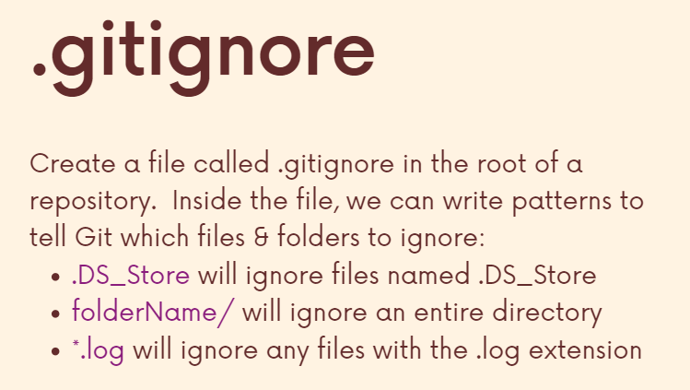

Example: we want GIT to track package.json as it includes the list of dependencies which the user can see and run npm install to download them. However, we do not want GIT to keep track of all dependencies as it will just bloat the file and since package.json already has that, we can simply access them using package.json.

Before making the git ignore file and adding file names there which need not be tracked by git, we cannot write **git add .** because it adds all the files (even the ones we wish to hide in the future). Hence, we first hide the files (make them not get tracked by git) and then we can write **git add . Any changes made to a hidden file will not be tracked/informed by git.**

**Section 6: Working with Branches**

Anyway, all that we need to know is that every commit has this unique hash, this unique identifier that corresponds to the commit and each commit references at least one parent commit that came before it. So here we can see this most recent commit in blue has commit that came before it, right. This pink one. And before that came this purple blue one. And that happens to be the initial commit. It does not have anything before it. It does not have a parent commit. That happens the very first time you commit. So, we have this linear history where one commit leads to the next, which leads to the next.

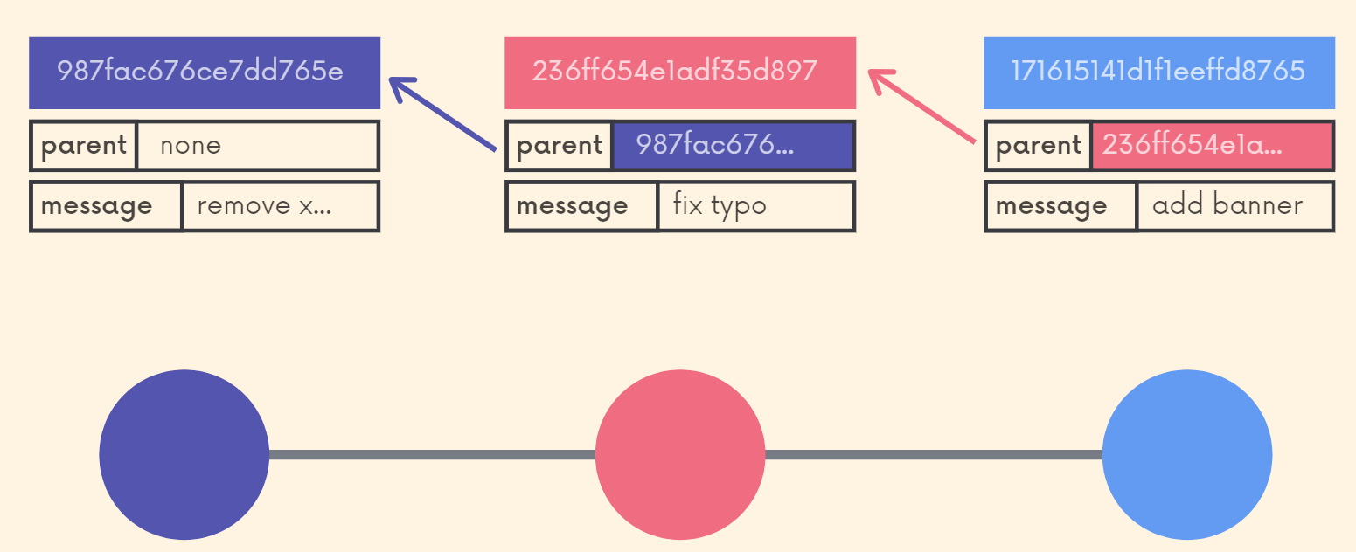

But often when we're working on a real project in the real world, we need to work in multiple contexts simultaneously.

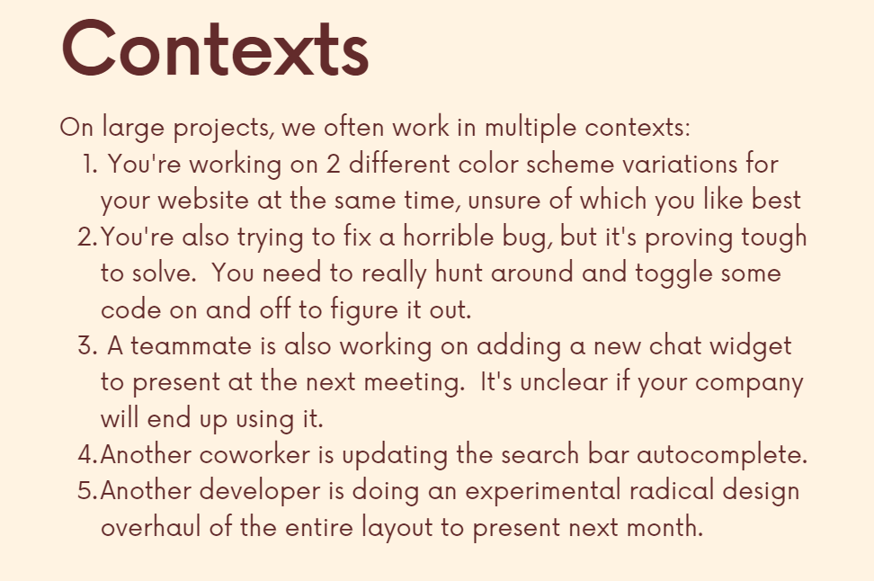

If we all worked in a linear fashion, one commit after the next this would be practically impossible. How could we be working on two separate things, some of which break other people's code? Right. If if I'm trying to fix a horrible bug and deleting a bunch of code removing files, I'm just making a mess. But I'm trying to work on some minor color scheme variations, or if someone's working on adding a chat widget to the bottom right of our screen, those things need to happen in separate contexts because they have implications on one another and they really need to happen in isolation until maybe at some point we decide to incorporate changes into each other's contexts.

So that is where branching comes in. That's exactly what get branches allow us to do.

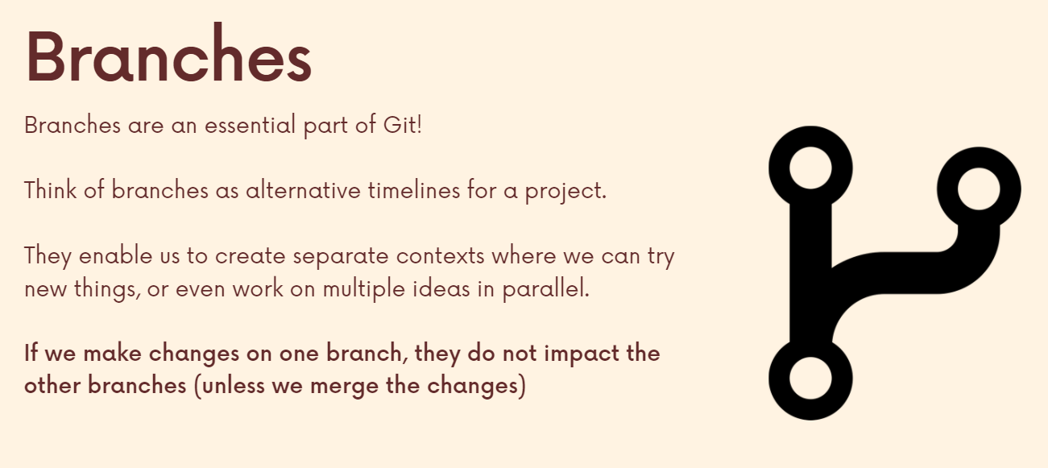

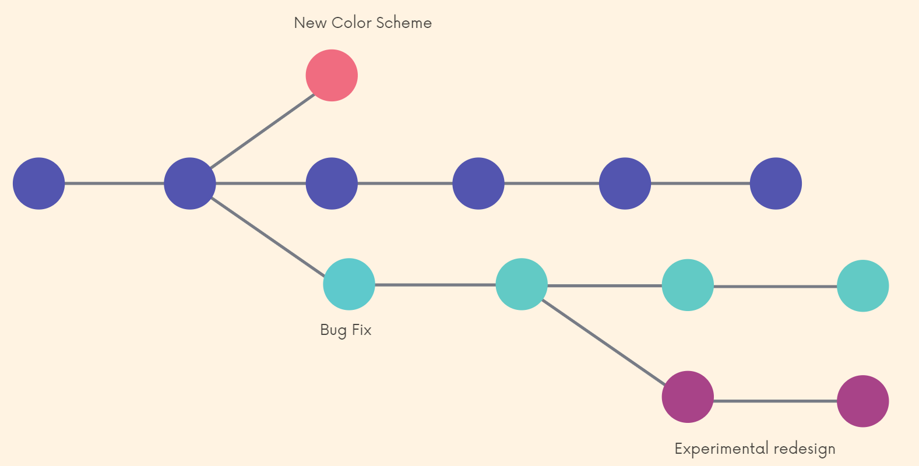

Finally, we can merge these branches (separate contexts) together.

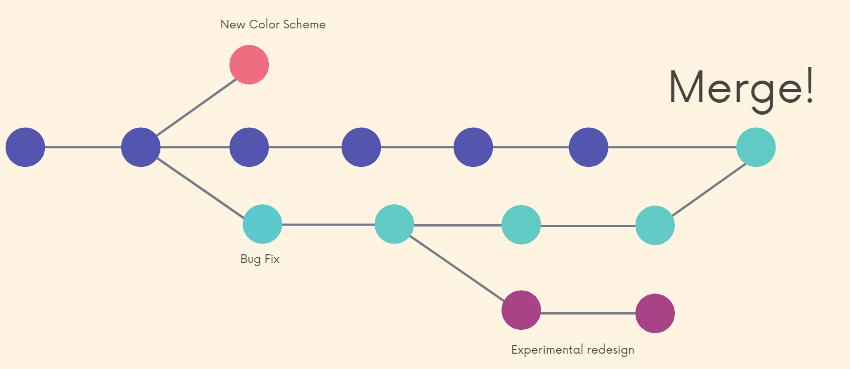

Whenever we make a new repo, it is initialised as the master branch.

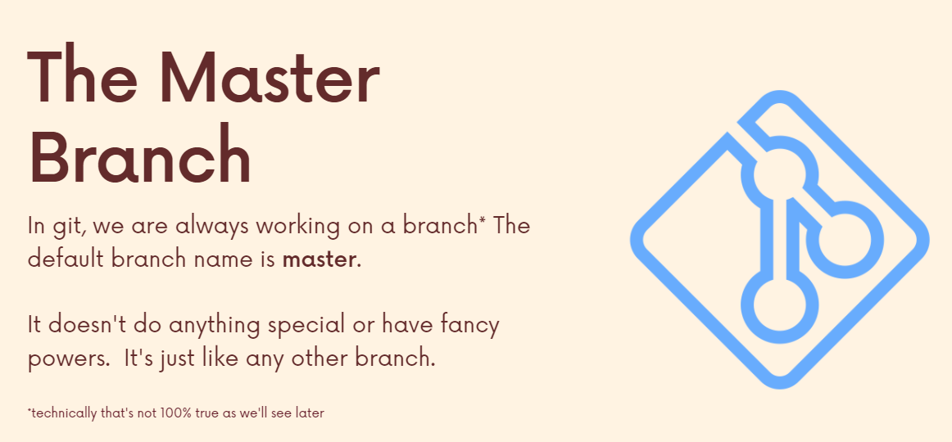

The most common overflow is by making different branches for specific features and if we want to include these features, we add them to the master branch.

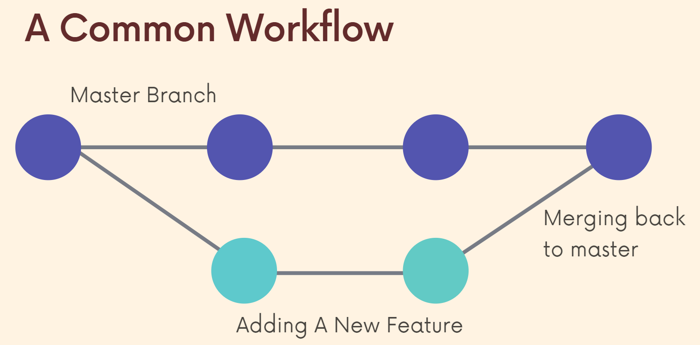

**Head**

I want to reiterate; head is a pointer. It's a reference to a branch pointer and a branch pointer is where a branch currently is. It's like that bookmark in a book.

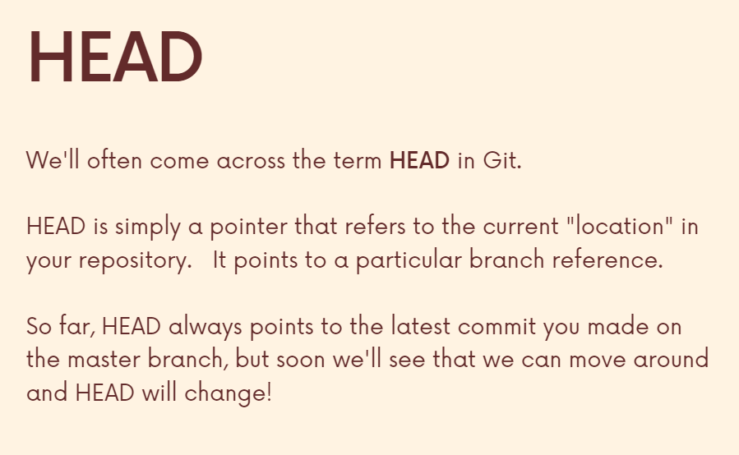

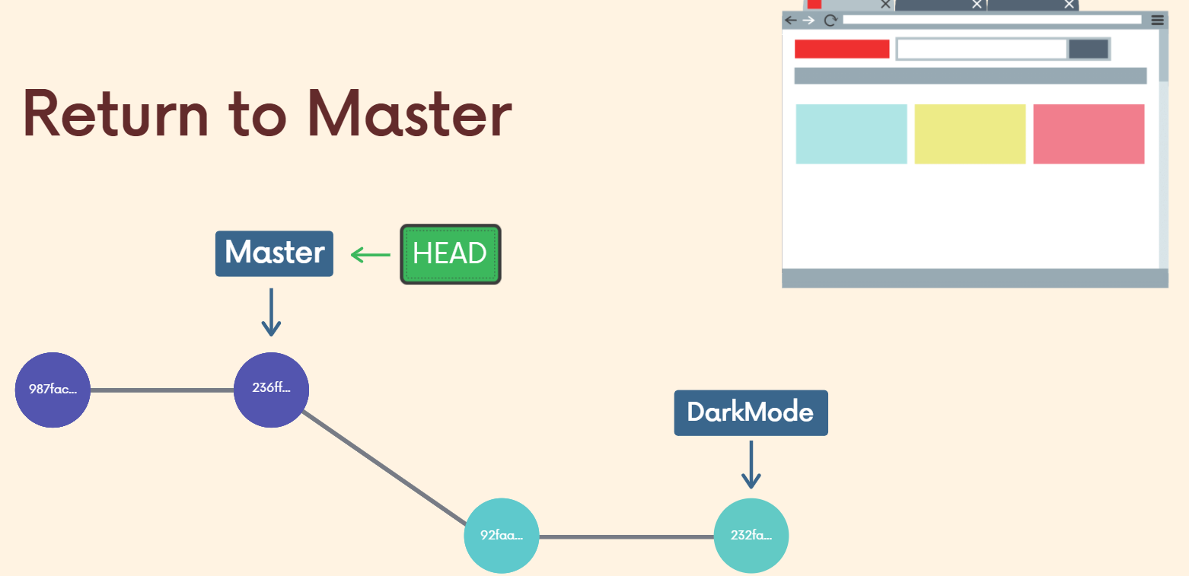

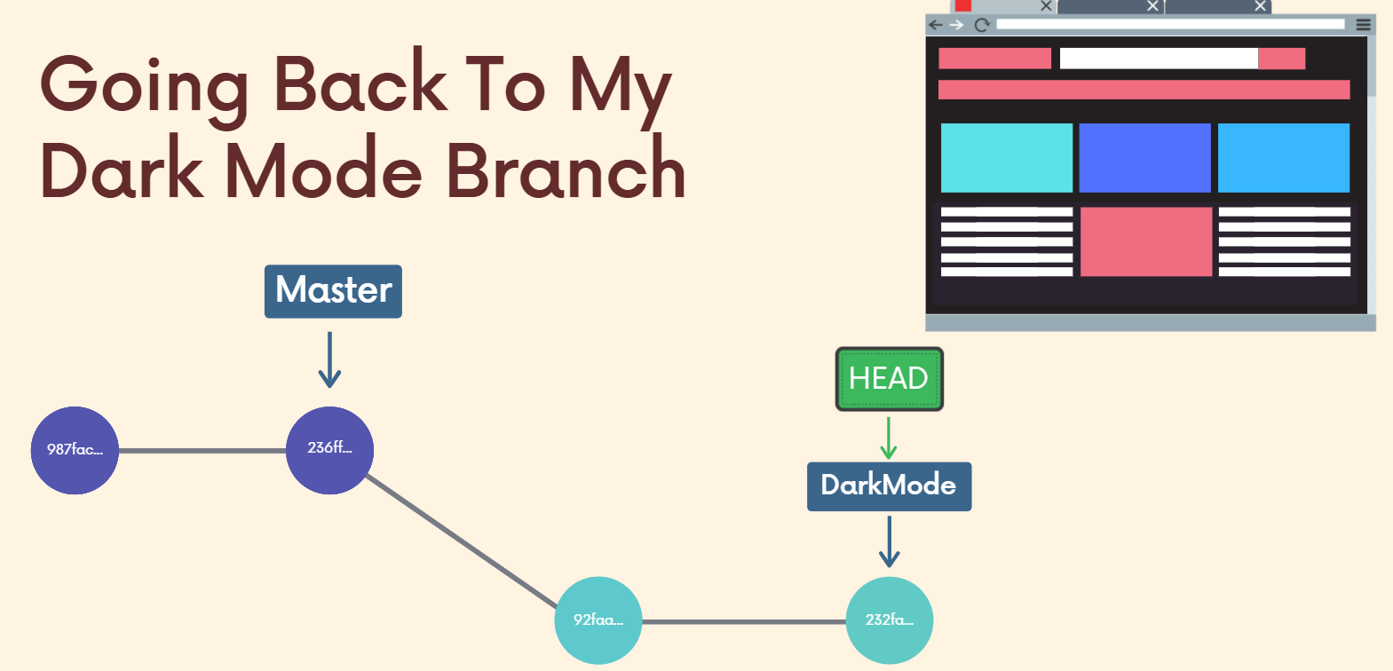

We can have any number of branches and each branch has a branch pointer, pointing to where we left off and head is just the thing which is open (which I am currently checking out in my repository).

**Viewing all Branches**

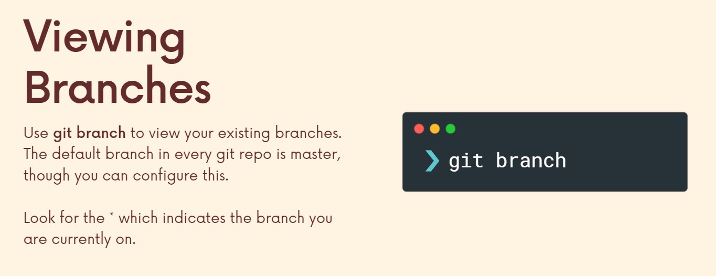

**Creating and Switching Branches**

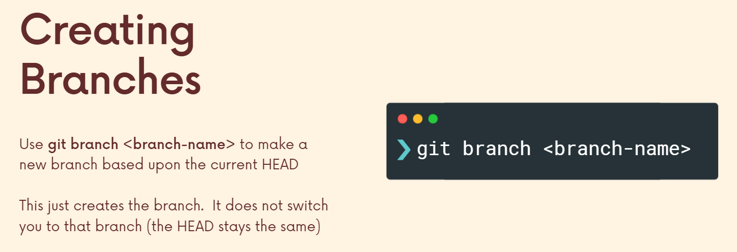

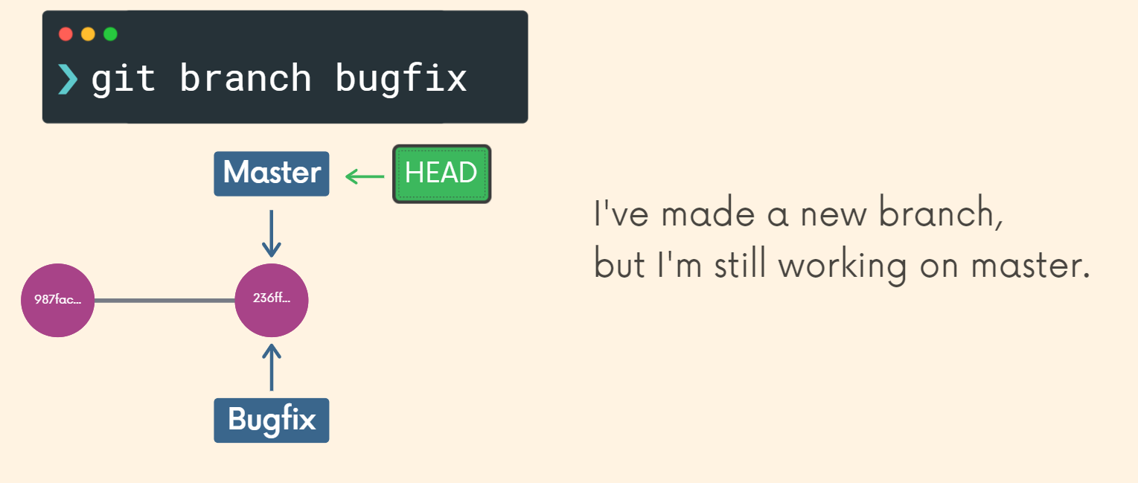

This will only create a branch but not switch to it (Notice the head pointer). The new Bugfix branch is created and points to the same commit (both Master and Bugfix branch point to the same commit).

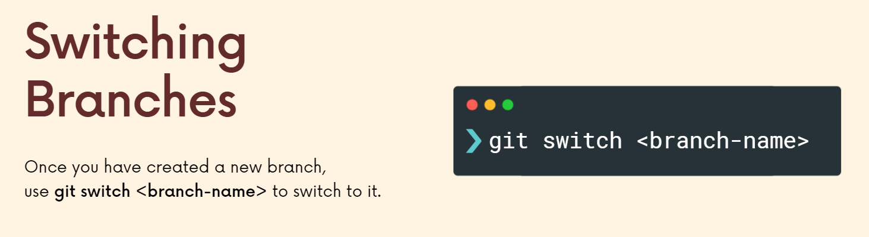

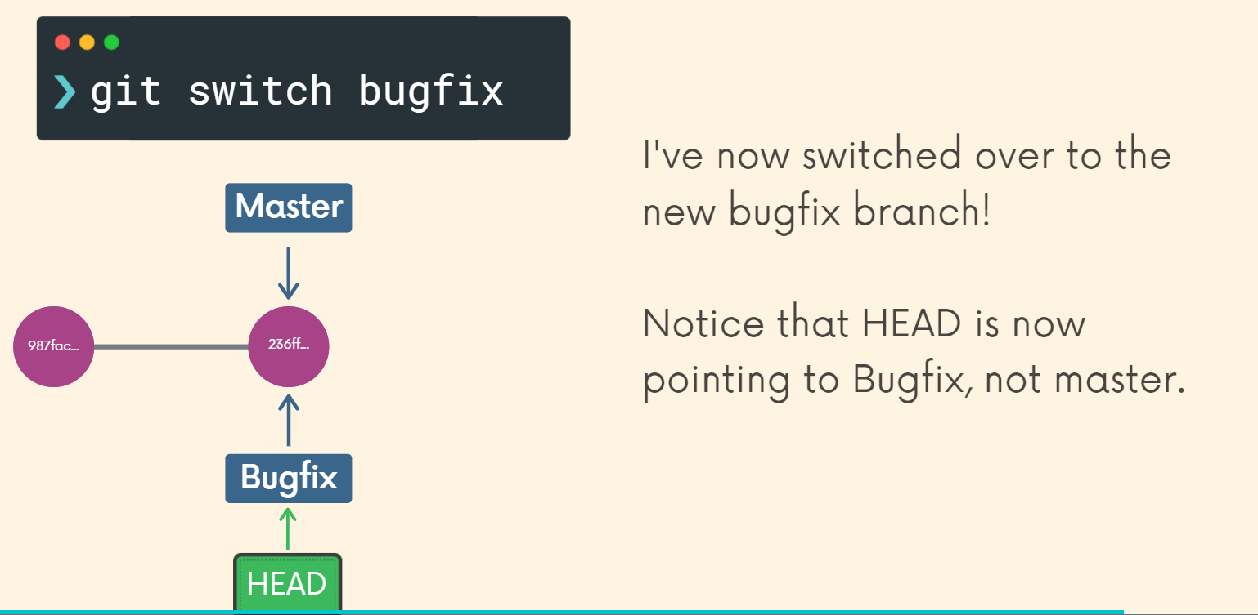

**Watch last 2 minutes of the video:** <https://www.udemy.com/course/git-and-github-bootcamp/learn/lecture/24619668#overview>

In order to create and switch to the branch in one go.

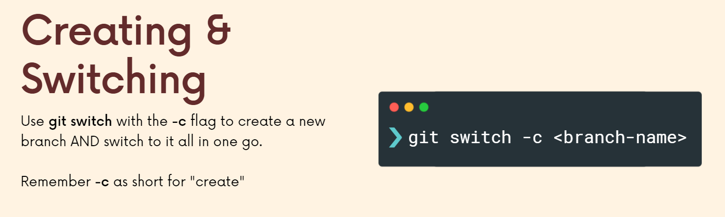

**\*\*\*GIT Switching is not limited to a single file. We can make separate files for separate branches. GIT ensures that specific files exist on their respective branches\*\*\***

**\*\*\*If we change something in a particular file and without committing it we try to change the branches then GIT will tell us that we can either stash our changes or the changes would be lost. However, if instead of making changes to a file, we add a new file which didn’t exist then since this new file didn’t exist previously in any of the branches, its gonna come with us to every branch we go to (GIT says there’s an untracked file you haven’t committed yet). Hence, its best to add and commit changes before switching branches to avoid all this. Hence, if we have unsaved changes which are conflicting (means an existing file is changed a bit) GIT yells at us, else it doesn’t say anything and the file is carried with us\*\*\***

**Deleting Branches**

**git branch -d branchname** (git branch is the command and -d is the option/flag)

1) We cannot delete a branch which we are currently viewing. Hence, we must be on a different branch initially.

2) If we want to delete a branch which has not yet been fully merged then we need to use **D** which is another way of saying **force** because without github or anything if we delete this branch then all of the work we have done on it would be lost (since the branch is not yet merged so the work was not combined with the master branch and hence would be lost).

**Renaming Branches**

**git branch -m newbranchname**

So all that we do if we want to rename a branch is first change to the branch that we want to rename. So this is kind of confusing because to delete a branch we had to go anywhere else but that branch we could not delete from the branch, but to rename you have to be on the branch again.

**Extra Info: Head is referencing to the branch and each branch reference is referencing a commit.**

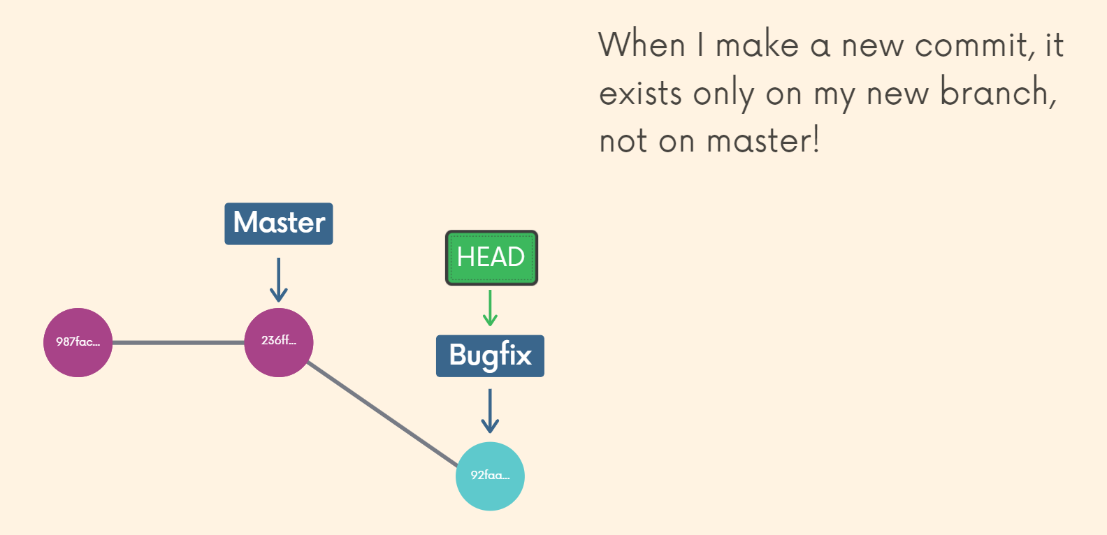

**Section 7: Merging Branches**

[**https://www.udemy.com/course/git-and-github-bootcamp/learn/lecture/24636472#overview**](https://www.udemy.com/course/git-and-github-bootcamp/learn/lecture/24636472#overview)

So the whole idea here is that with branches, we can work within the self-contained context. We can work on different things in parallel, but usually we want to incorporate some of what we've done into another branch. Right. We don't just work in a separate context and continue to work in a new, separate context. Every time we work on something, we need to combine some of the stuff we're doing. If you're working on a feature and I'm working on a feature and we work at the same company at some point, if both of those features are Argo's, they're good features. We want to incorporate them. You're going to need to merge your feature into some branch that I can get and I need to merge my feature in into some branch that you can get. And then sometimes we do just abandon a branch and we don't merge it. But if things go well, a lot of the time we combine work from one branch into another. So there's a command we use called Git Merge.

Master Branch: A lot of people treat it as the source of truth or the the most stable build of an application where you don't want to screw anything up. You don't do any experiments on master. So people work on a feature branch and then that work can then be incorporated back into the master branch if it's deemed appropriate. You know, it's it's solid and it's gone through some different checks and people like it. They can merge it back into master.

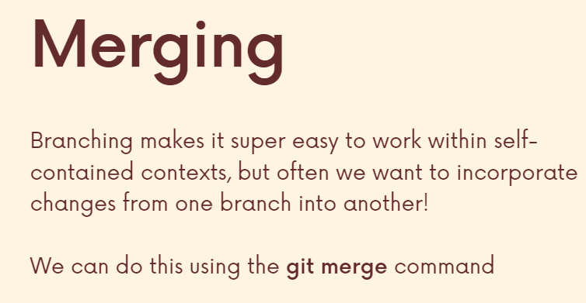

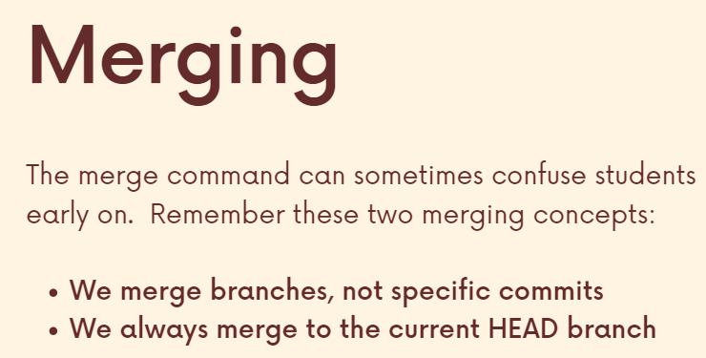

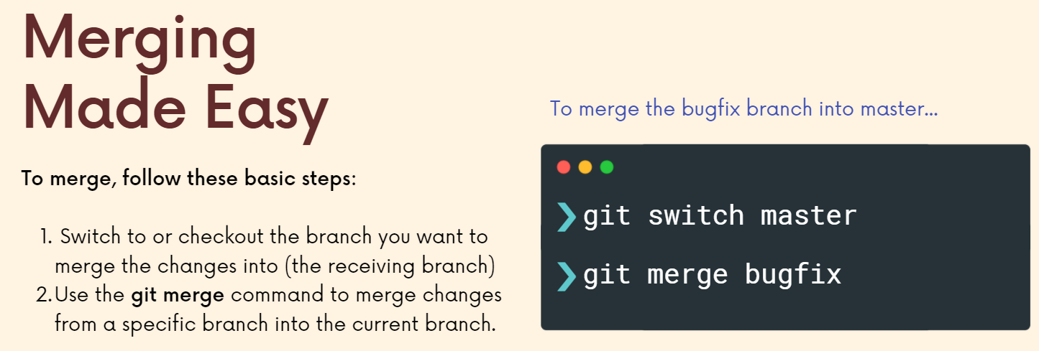

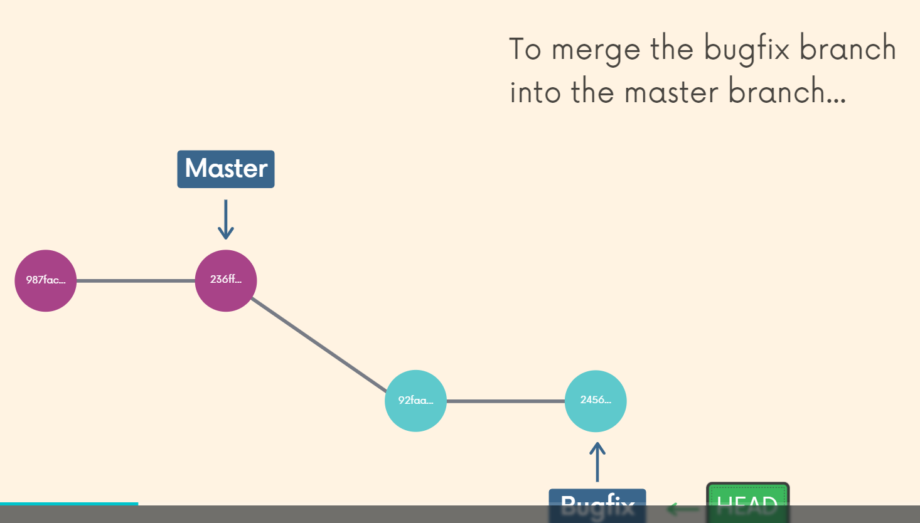

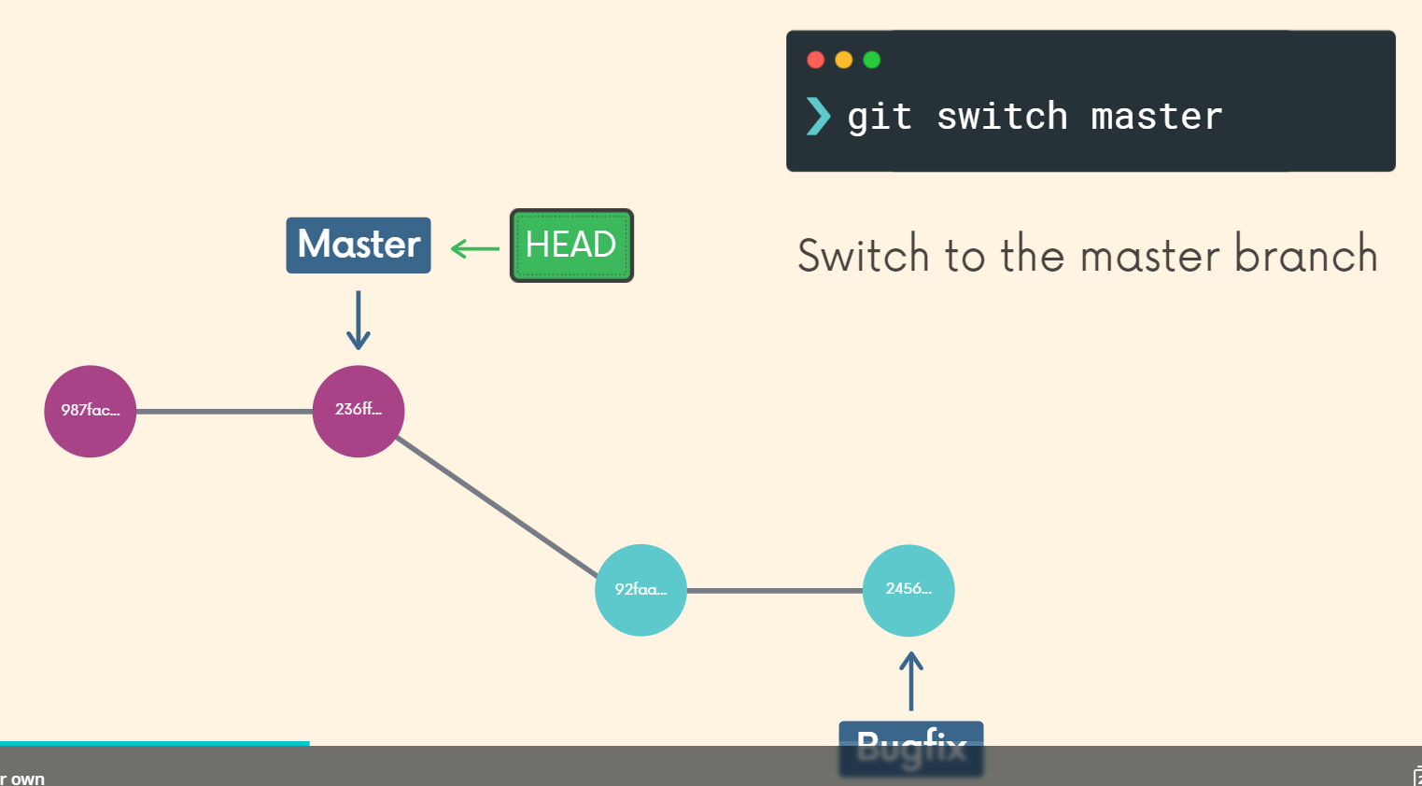

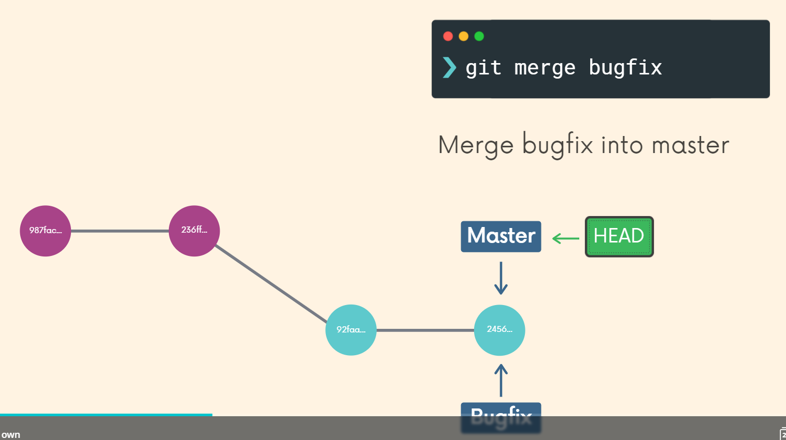

**Till now the bugfix branch contained all the commits of the master branch. However, what if there has been another commit in the master branch after the bugfix branch has been branched from it…**

**Non-fast forward merge without conflicting changes**

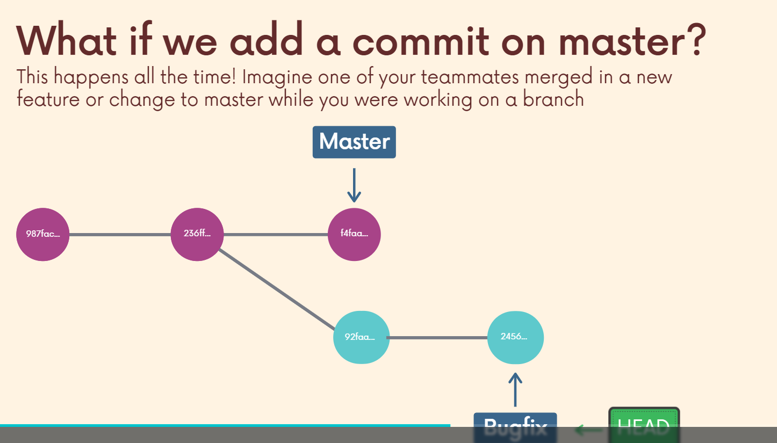

In the above case let us say I’m working on the bugfix branch and meanwhile a co-worker commits something on the master branch (which is now not a part of the Bugfix branch). Now, this does not remain a case of fast forwarding of the Master branch.

Hence, on master we have 1 commit that bugfix doesn’t know about and on bugfix we have 2 commits that master doesn’t know about. **(In this example we are not taking the case of a conflict, we have just added 1 new file to the master branch)**

**Hence, when we merge the branch, a new merge commit is created for us by GIT (which we have to name).**

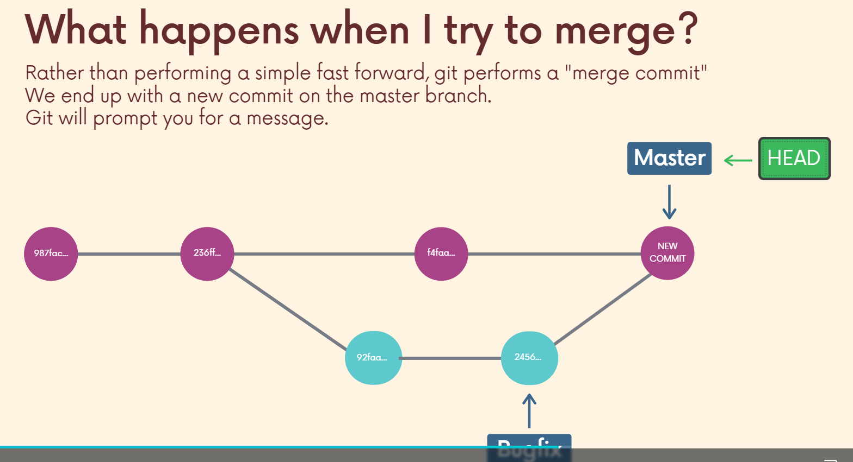

**Non-fast forward merge with conflicting changes**

All right, so now we get to talk about merge conflicts when we merge two branches, as we've seen git will do its best to automatically merge those changes, whether it's a fast forward or needs to make a merge, commit, as we saw in the last video, it tries to do things automatically. And so far it's succeeded in the two examples I've shown you. But if we had conflicting changes, for example, on one branch, somebody modified a file and on a second branch that were merging, somebody deleted the same file. Or another situation would be if on one branch I edit one line Seventy-Seven of some file and somebody else on the other branch. Or maybe it's me too. On the other branch I edit the same line line Seventy-Seven in the same file. Git doesn't know how to automatically merge that. How does it decide what to keep and what to get rid of. So, this is where merge conflicts come up. You have to manually resolve them.

When you run git merge and if there are conflicts, you'll see something like this conflict and then merge conflict in some file, automatic merge failed, fix the conflicts and then commit the result.

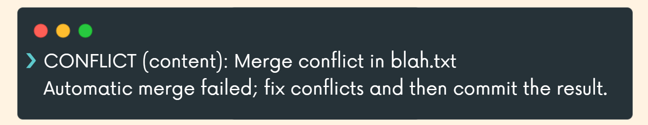

So this is a multi-step process. Get tells us there's conflicts. Then we have to go and open the files where there are conflicts and fix them and then we commit those changes. So the files where there are conflicts are actually decorated. They they have new content to indicate where there are conflicts. So when we open up a file, we'll see this weird stuff in their head and then a branch name.

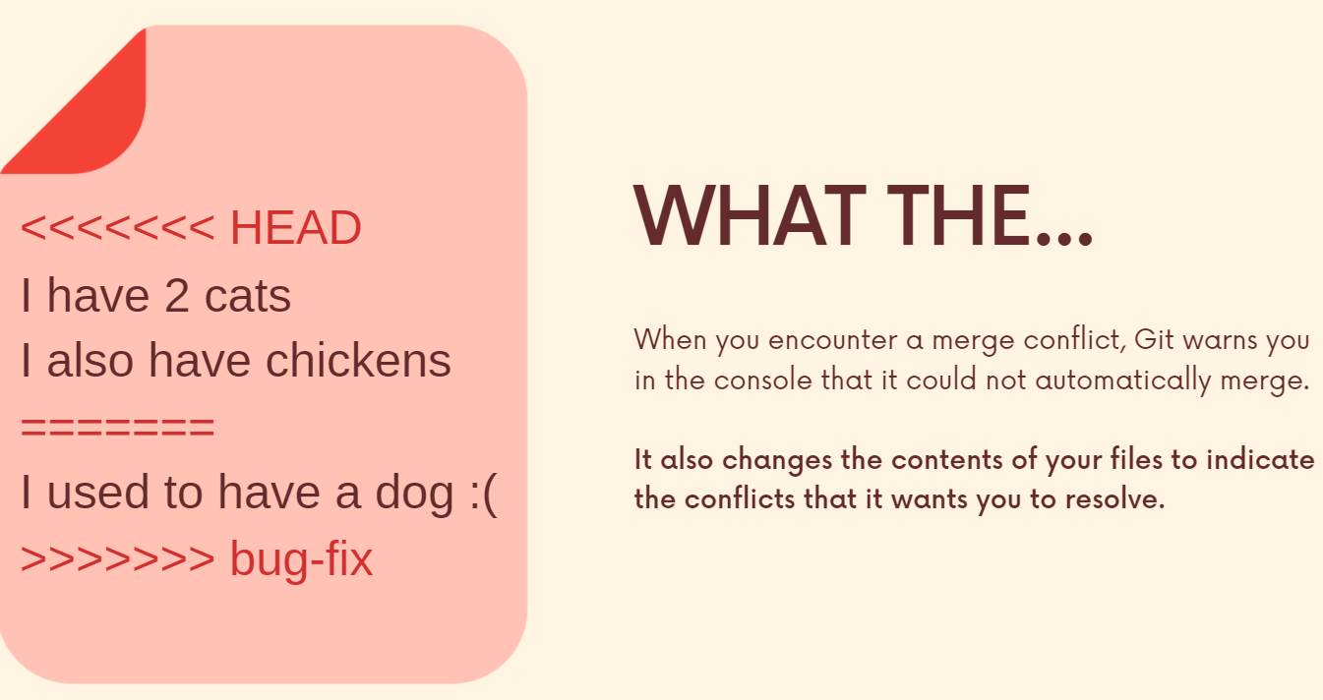

So what these markers indicate is what content came from my head branch, the branch I'm on, the recipient branch I'm trying to merge into, and that's indicated by the less than the little arrow head and then the equals sign. So this is what I had in this diagram on my, let's say, the master branch. This is the change I made. And then this is from the bug fix branch that I'm trying to merge in. So it's my job now to delete or keep both figure out which part I want, which part I don't want. It's totally up to me. I resolve it and then I get rid of these conflict markers, these symbols, and then I save the file and then I go back and add and commit changes.

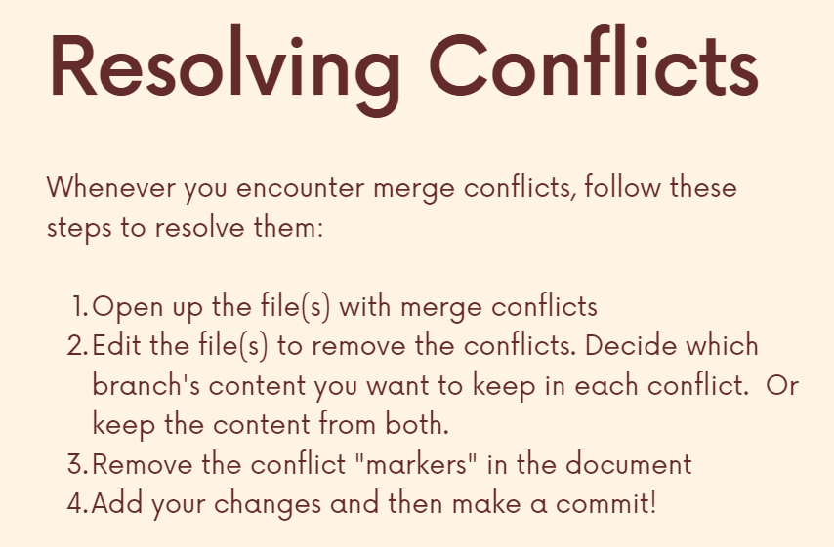

**Hence, here we as a human are resolving the errors and git is not gonna do that for us.**

Now let us say we create 2 branches and both these branches are working on the similar file and making changes to it (unlike previously where we didn’t get a conflict because the two branches worked on separate files) we get a conflict and now we have to resolve it on our own (GIT won’t do it for us).

**GIT tells us where the conflict occurs and that we need to resolve it, commit the files and then perform merging.**

**We can simply remove the markers and combine the inputs from both the branches (erase the common ones) or get rid of input from 1 branch and keep input from another branch and save and commit. (We just stage this file and commit it and it will be branched automatically (since we passed the branch command earlier but it failed due to the conflict which we have solved now and hence merging can take place))**

**\*\*\* There won’t be a conflict if two different files are touched. There can/cannot be a conflict if the same files are touched. \*\*\***

**Section 8: Comparing changes with GIT Diff**

So, the git diff command is all about showing changes in git so in a given repository. There are many situations where we might want to know what changed between the last commit and our working directory, what's changed between the staging area and the working directory, what's changed between two branches or two different files over a certain number of commits? What's changed between what we have locally versus what's on GitHub, all these different scenarios where we may want to learn about changes, about comparisons so the git diff command does that.

So it's more about just taking a peek at changes and trying to understand how things have changed.

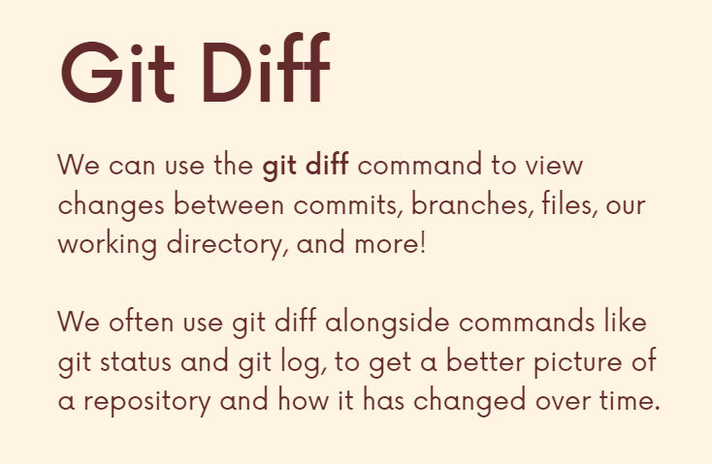

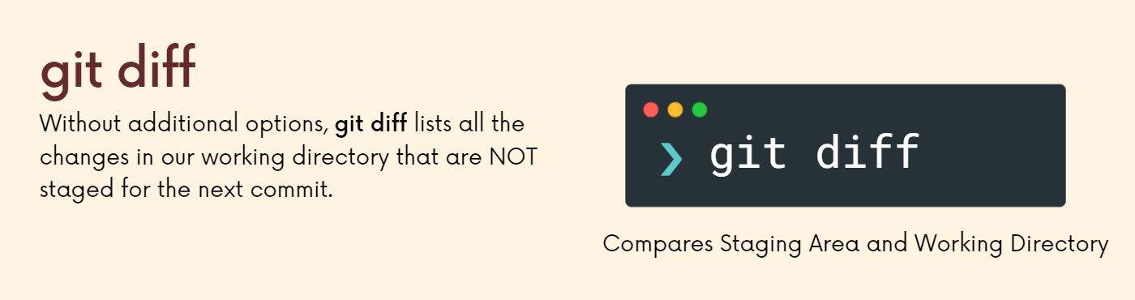

**Reading diff output**

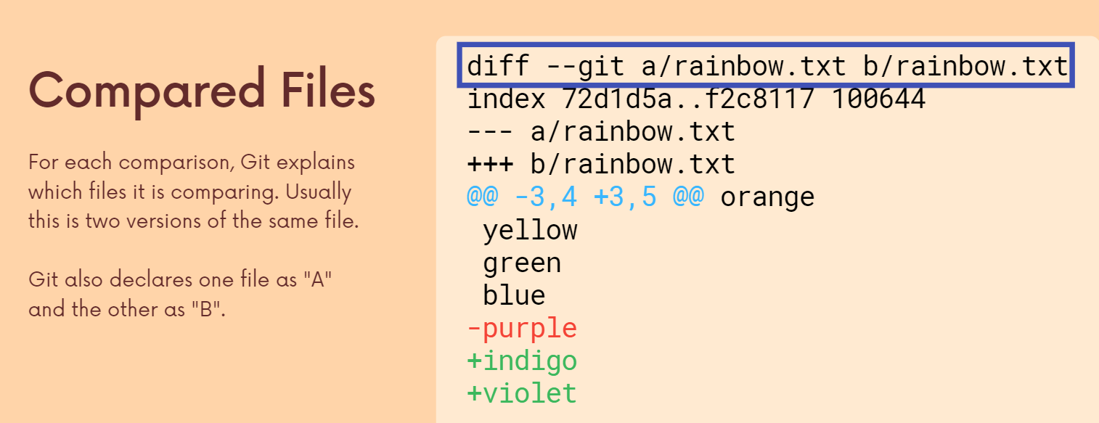

Line1: Typically, it's the same file just over time between commits, between branches, between your staging area and working directory. It's the same file typically.

Line2: Metadata about the files being compared.

Line3: For file a changes are indicated by – sign.

Line4: For file b changes are indicated by + sign.

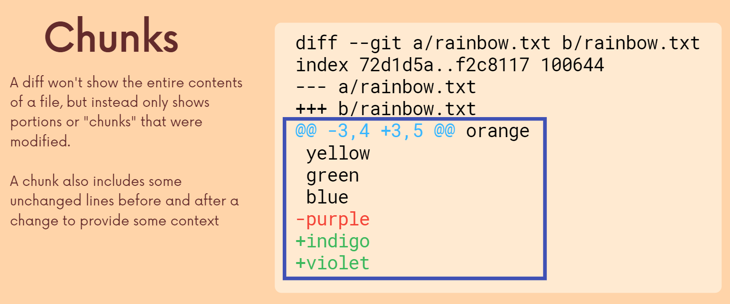

Line5: Chunk header which is at the start of each chunk. The two pair of numbers belong to file a and b respectively. It tells us how many lines and starting from which line the lines are extracted from each file.

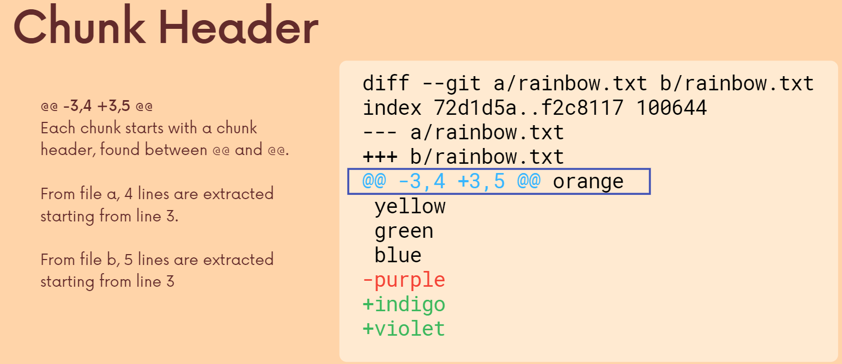

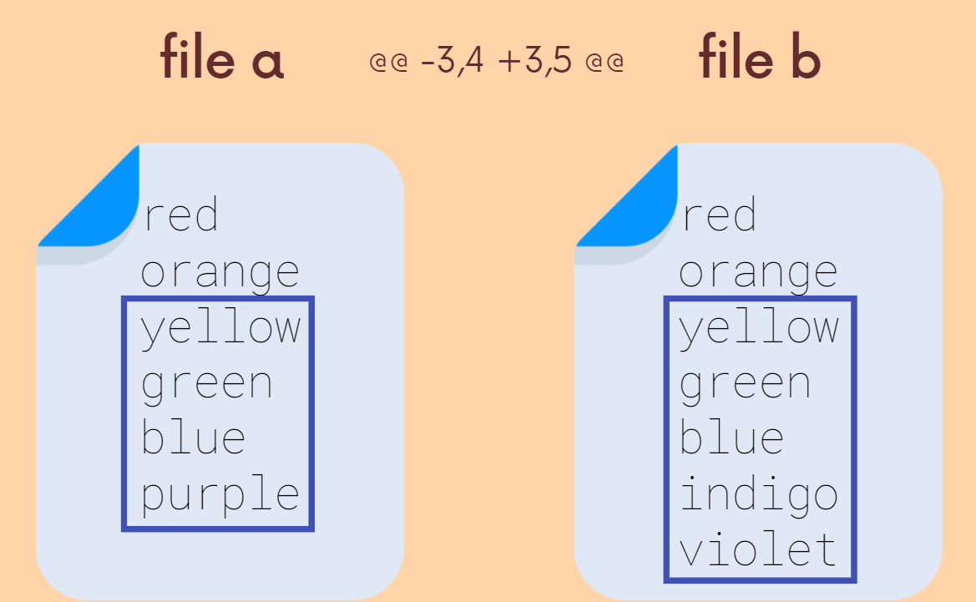

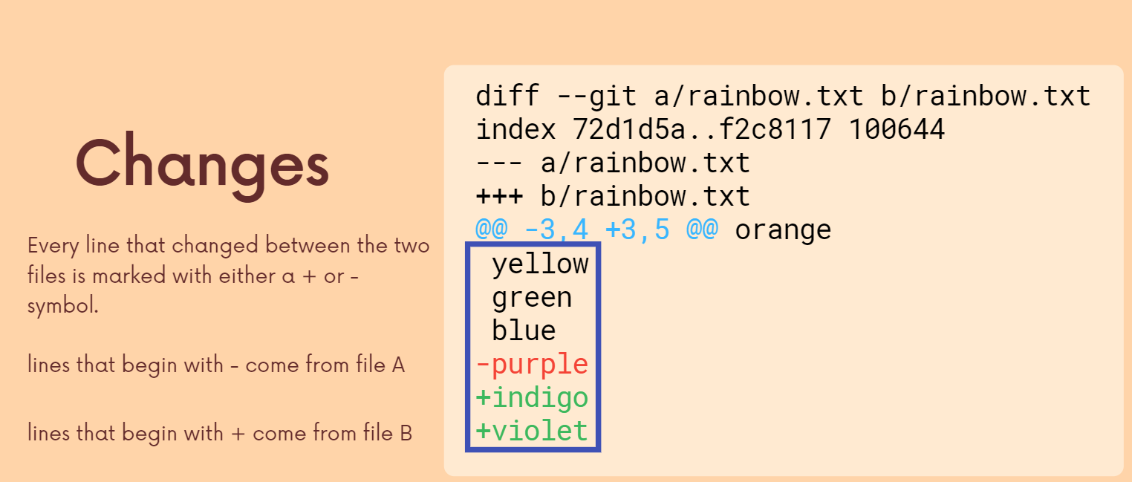

So this is the content of the file to file superimposed where we can see every line that starts the minus. There's a change that came from File A and every line that starts with the plus comes from file B. So these lines, yellow, green, blue, are unchanged, right? They exist in both, but then purple, which is actually red, but purple has that minus sign came from file and it's not in file B and then Indigo and Violet came from file B, they're not in file A, usually get picked A and B for us in such a way that you can think of file A as like the old stuff and file.

**Hence, first it shows the two versions of the file (at two different times), then the metadata, then each file is assigned a sign, then a chunk header and then finally the lines where changes are made (along with some lines above and below them which remain unchanged).**

**Different ways of using GIT Diff to make different comparisons**

**1) Viewing unstaged changes**

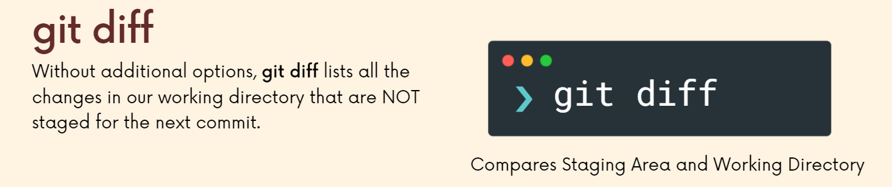

Basically, it compares the file which was last present in the staged area vs the file which currently is existing (not yet staged we can say).

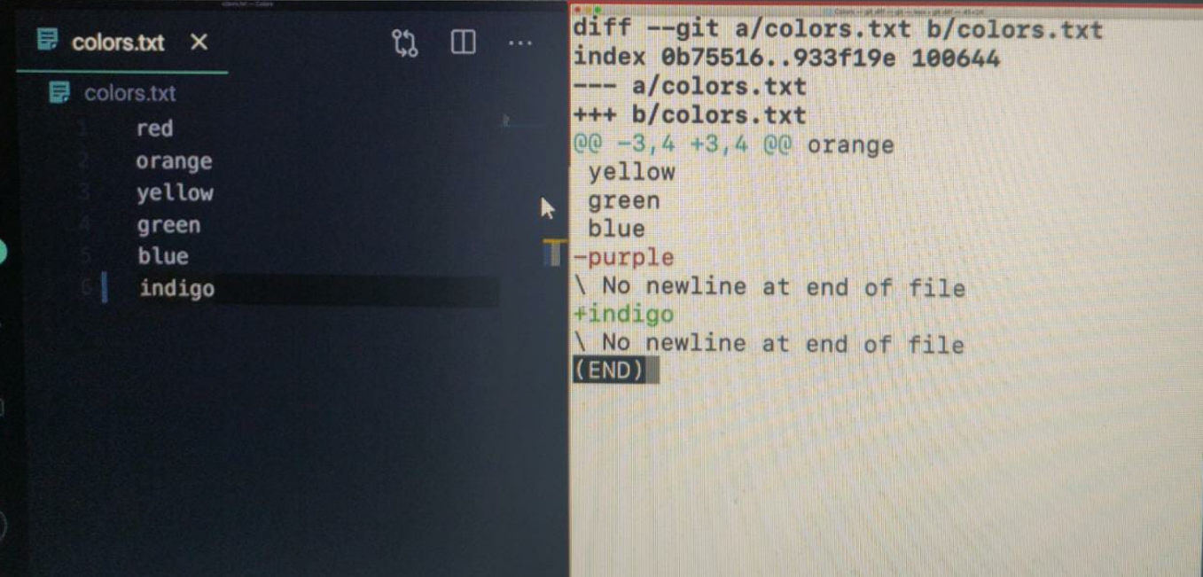

So in the version of our files that the staging area last knew about purple was still there. Right. That, so that minus sign means, versus with the version of the file that is actually in our working directory, we see that Indigo has been added.

**2) Viewing working directory changes**

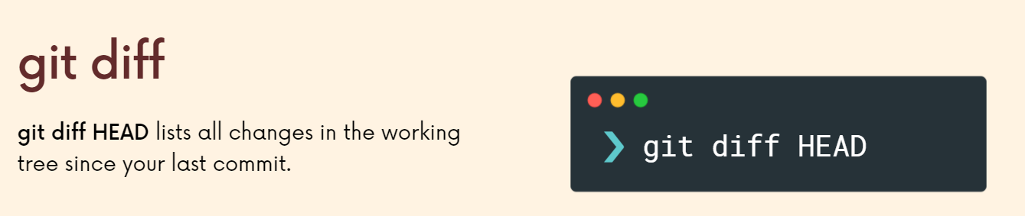

This shows everything we have changed since our last commit, i.e., **both staged and unstaged changes. (Regular get diff showed only unstaged changes)**

**Hence, after our second last SS if we type “git add colors.txt” and type “git diff” we wont get any changes since the newly staged area is same as the previous one. However, “git diff head” shows staged changes aswell since last commit and hence we get changed output like we did earlier.**

If we add a new file and stage it then also git diff wont show anything since nothing new is unstaged however, git diff head will show the new file vs old file (even thought it didn’t exist, in that case it will show it as null).

**3) Viewing staged changes**

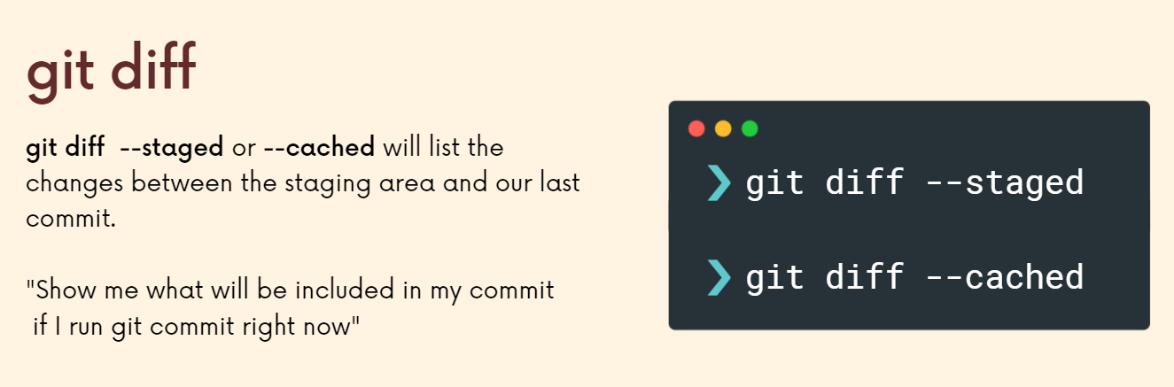

**4) Diffing specific files**

Another thing we can do is narrow down the diff to a specific file or files, so instead of just everything right, all unstaged changes, who are all stage changes are all changes since head whatever we're actually looking at, we can narrow it down and say only in this one file.

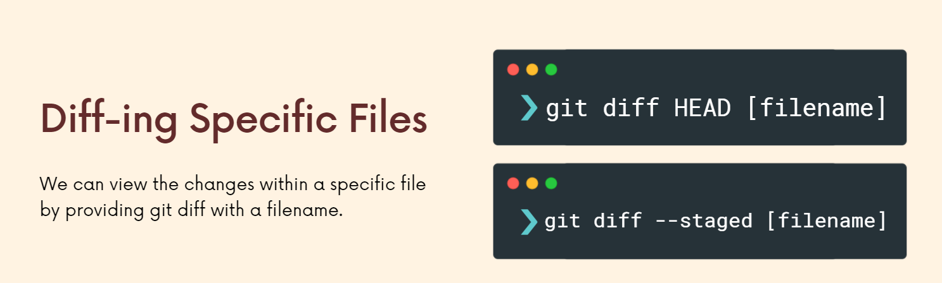

**5) Comparing changes between branches**

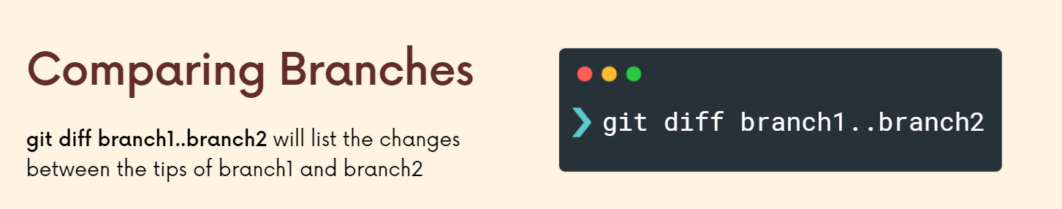

**6) Comparing changes across commits**

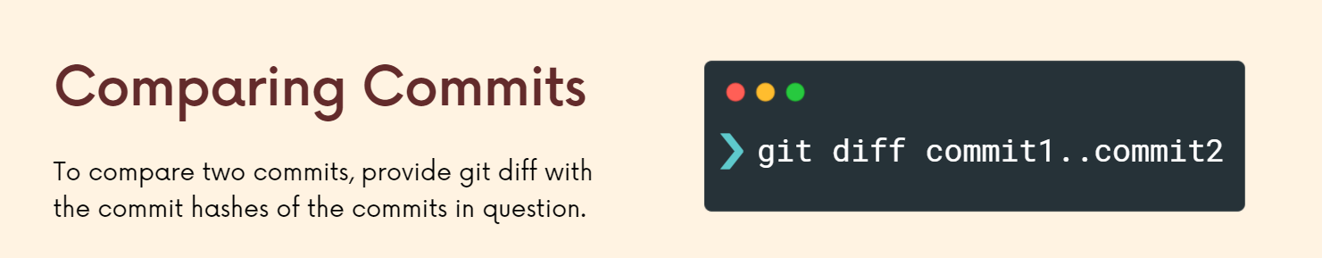

(Use commit hash by getting it from git log)

**\*\*\* All changes between all different files for two different branches or two different commits \*\*\***

**Section 9: The Ins and Outs of Stashing**

There are lots of times you might be working on something, but you're not done. You don't want to make an actual official commit, but you need to go somewhere else. You need to go to a different branch. A coworker asked for help. You realize that there's a really simple typo that you could fix in a different branch. You don't need to wait until you make a commit on your current branch because we can stash changes.

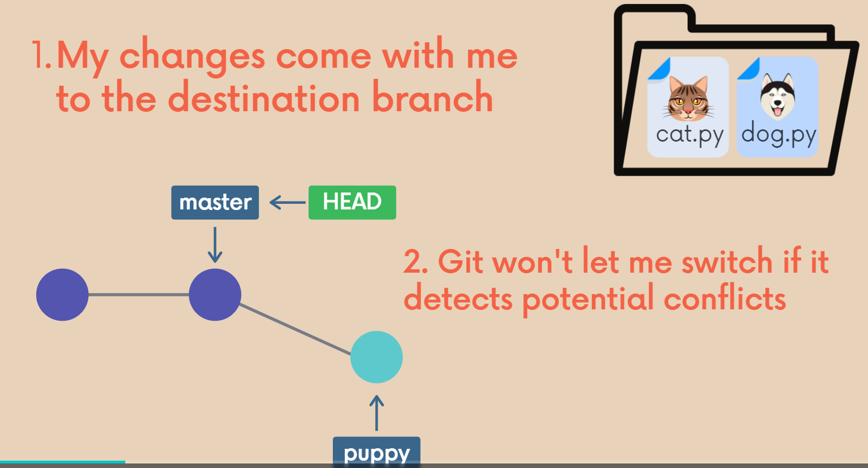

There are 2 cases:

1) I don’t make commits and GIT allows me to switch branch and carries the changes with itself. (Eg main branch has an empty css file but in a branch we add bg color as purple and without committing it we switch back to main then there wont be a conflict and git will allow us to switch to the main branch however, it carries the purple colour with it. However, if I committed that purple color in the other branch and then went to the main branch then the purple colour wouldn’t have been carried to the main branch).

2) GIT doesn’t allow me to change branch due to conflict. (Eg if after branching I make change in a particular line in the main branch and then make a change in the same line in the branched version of it (note that since branching was done before changing the line in the main branch, it contained the old version) and then try to switch branch then GIT will tell me to either commit it first or data will be overwritten) **Earlier we got conflict due to merging a specific branch but now we get a conflict due to applying something from the stash (eg conflicting titles)**

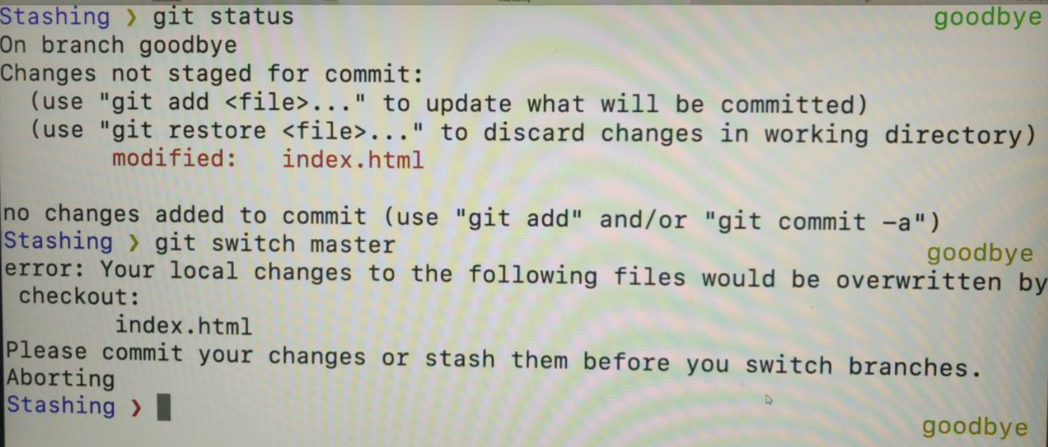

***So this is a common scenario, or at least somewhat common where I need to switch over. I need to go back to this master branch for whatever reason. Imagine it's a much more complicated project. I need to switch over to some branch. Doesn't have to be master, but I have work that is uncommitted on my current branch and git, it's not going to let me switch or I don't want the changes to come with me. Like I didn't want those purple changes to come with me when I switched to Master. So this is where git stash comes in. If I don't want to commit, I'm not ready to make it commit. It's unnecessary. I can use git stash to sort of pause to save my changes without actually committing them.***

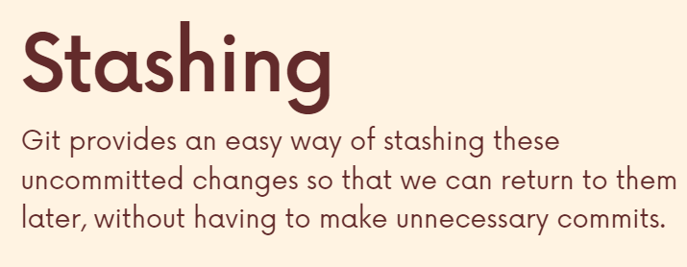

If we are halfway through a feature and we just need to change the branch for a second or so but we don’t want to commit this feature yet then in that case stashing can be useful.

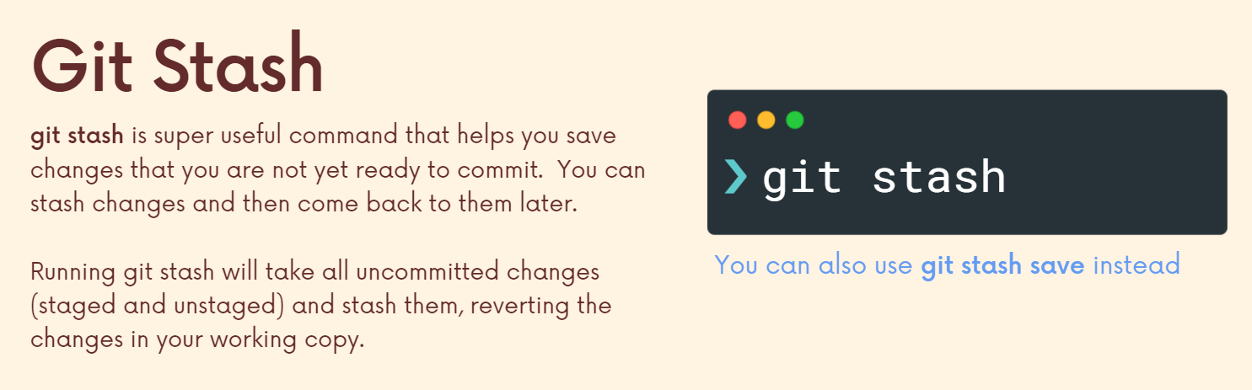

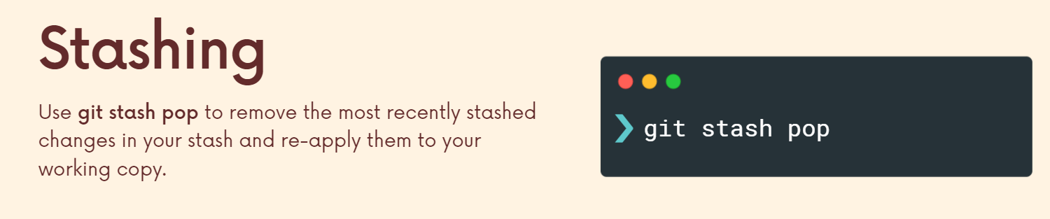

If we are on a branch and we change color to purple and then call git stash, then our current branch color will revert back from purple to the previous color and we can safely switch branches. To get back the purple color we just have to pop.

**Stash Apply**

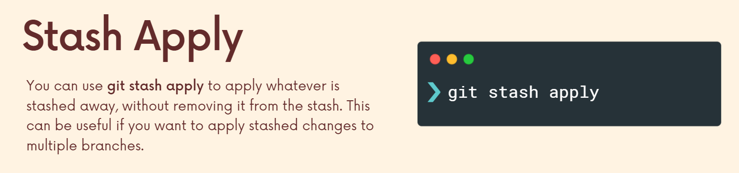

Instead of git pop we can use git apply which will take whatever's in the stash and apply it in the same way that Pop does. Except with apply the stash stays in the stash. In other words, the changes are still in the stash and we can apply them in multiple places versus with pop. Our changes are removed from the stash after they're applied. So I'll demonstrate this. This could be useful if you wanted to have some stash changes that you need to apply in multiple places across different branches.

If we color a branch purple but then store it in a stash and go back to main branch and apply this stash then the main branch gets purple color. Then we can go back to the branch and apply stash again to get purple color there aswell. If we used stash pop to get purple color in main branch then our stash would have been empty and since when we did git stash to store purple color from branch, the branch lost its changes and since now after using pop our stash is empty, even after going to the branch we can no longer use git stash pop to get the purple color back in this branch since we already popped the stash once in the main branch.

This can come in handy if you need to apply changes across multiple branches. Compare that to pop, git stash pop, which removes the changes from the stash apply, keeps him in there, but also applies them.

**git stash list** will list all the stashes along with their ids which we can use to call a particular stash instead of popping them in the order.

**Stashing multiple items**

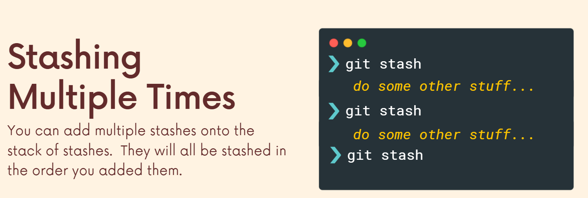

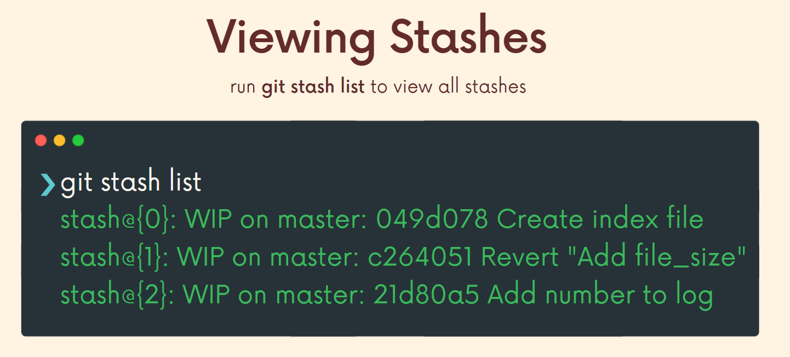

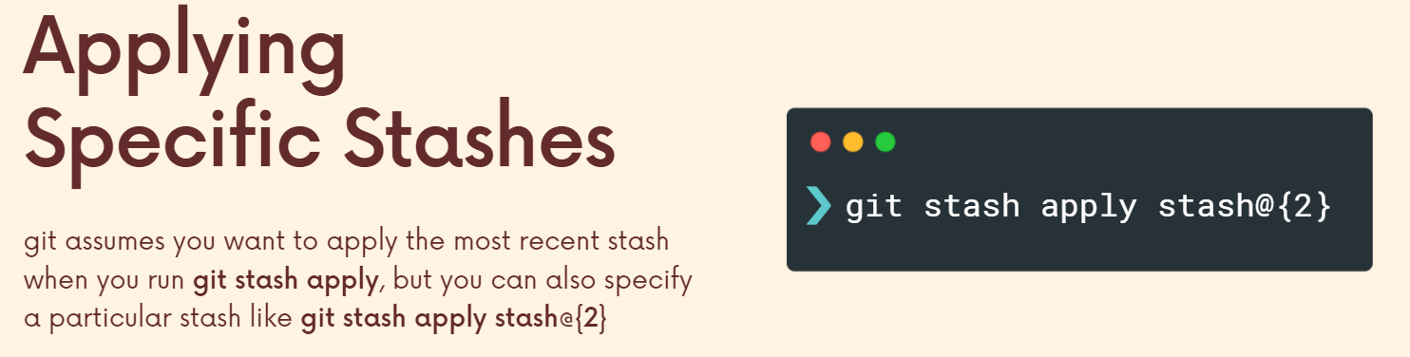

**Dropping Stashes**

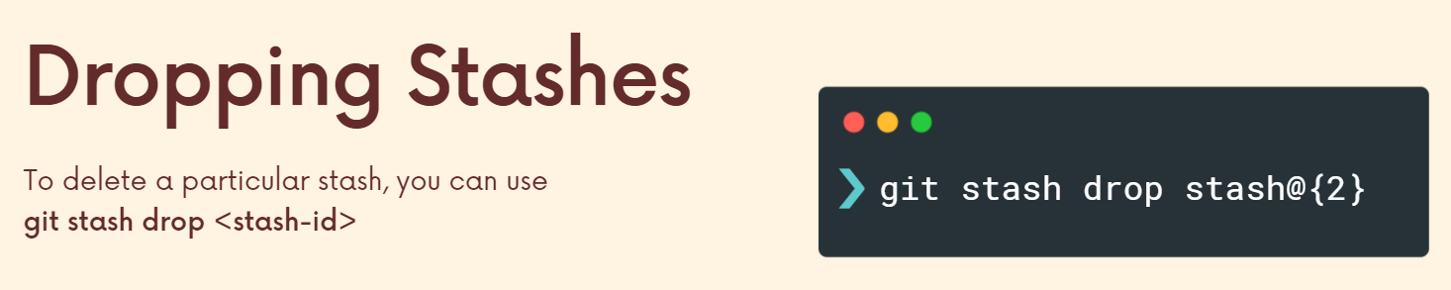

Pop removes the most recent thing from the stash and applies it but dropping will drop it.

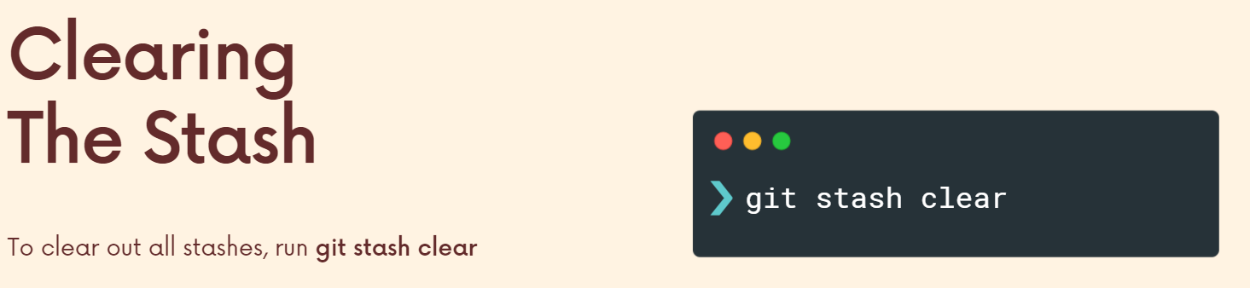

**Section 10: Undoing changes and time travelling**

**Checking out old commits**

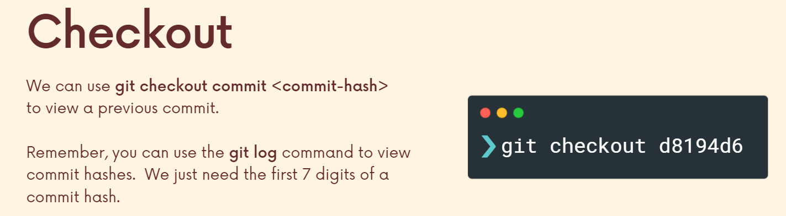

We see this message…

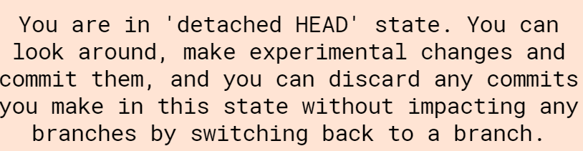

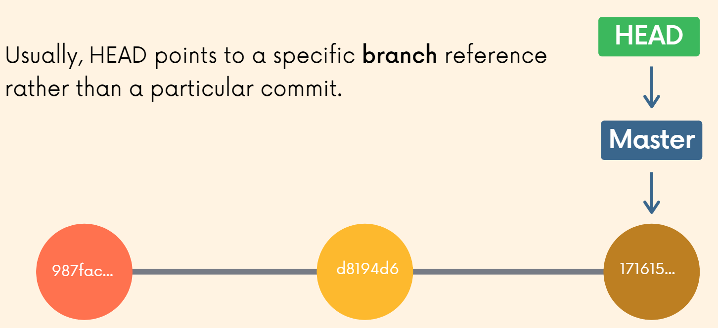

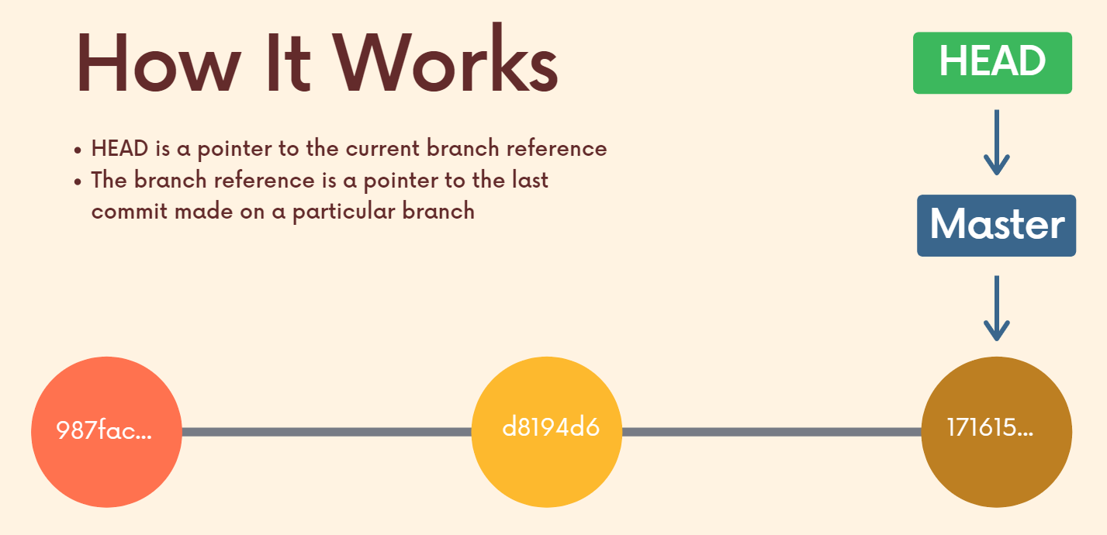

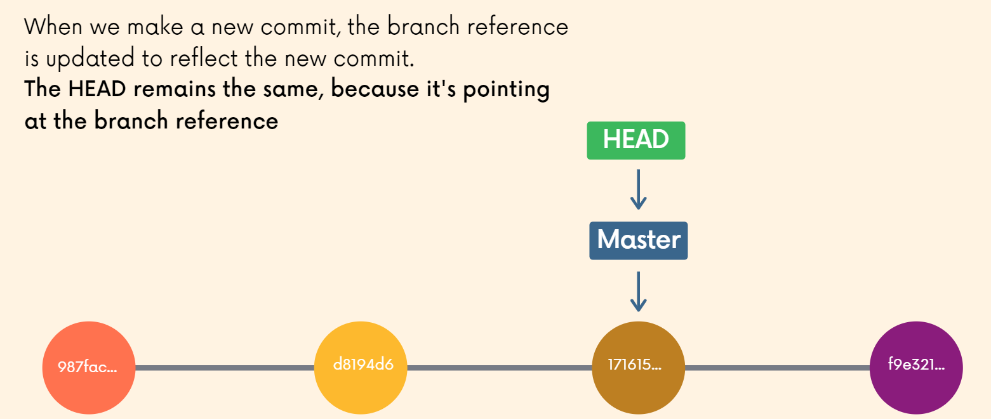

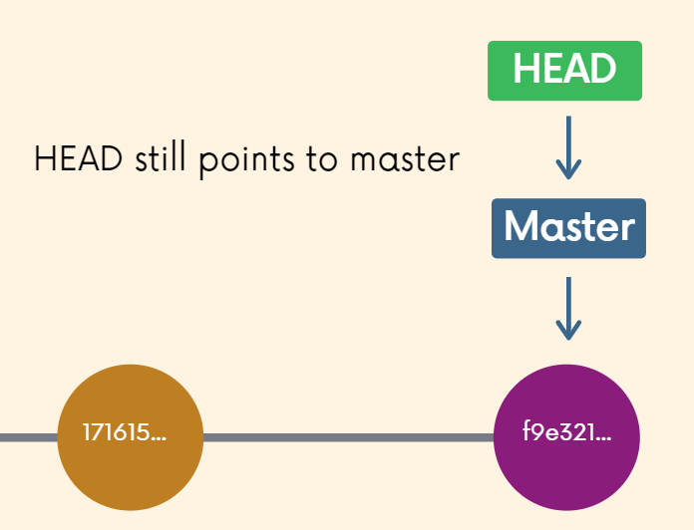

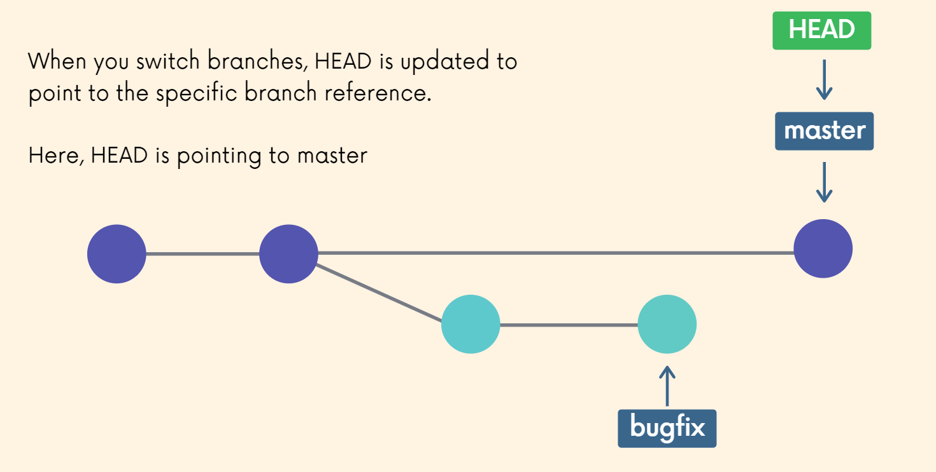

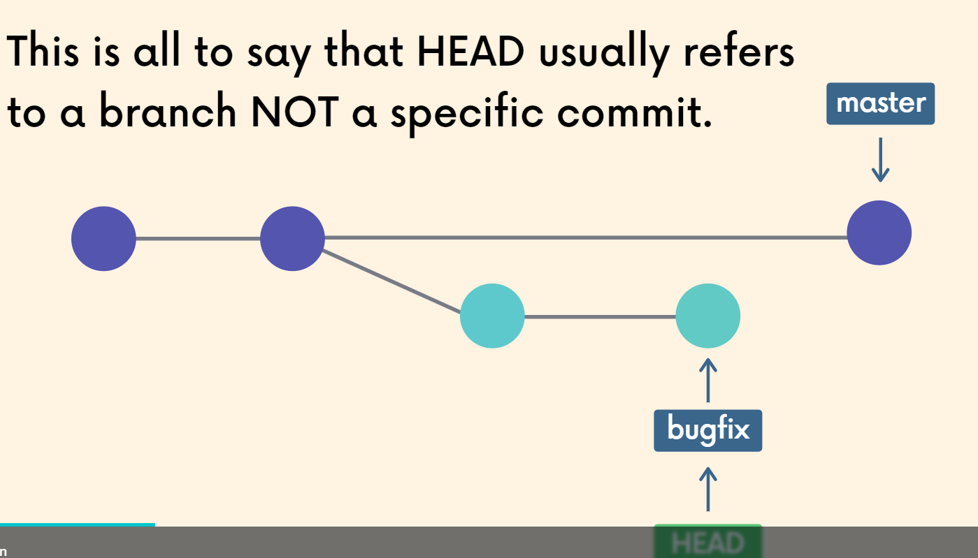

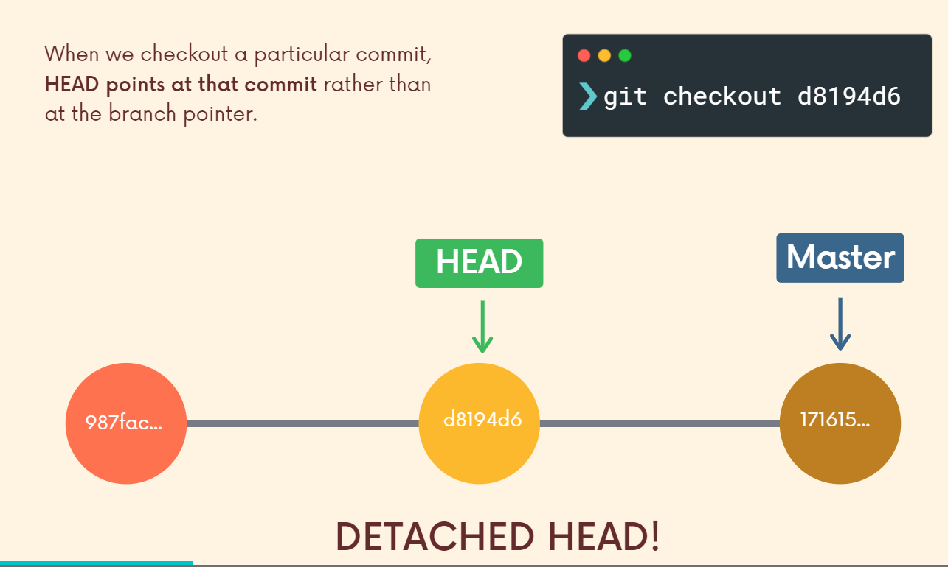

**Detached Head State**

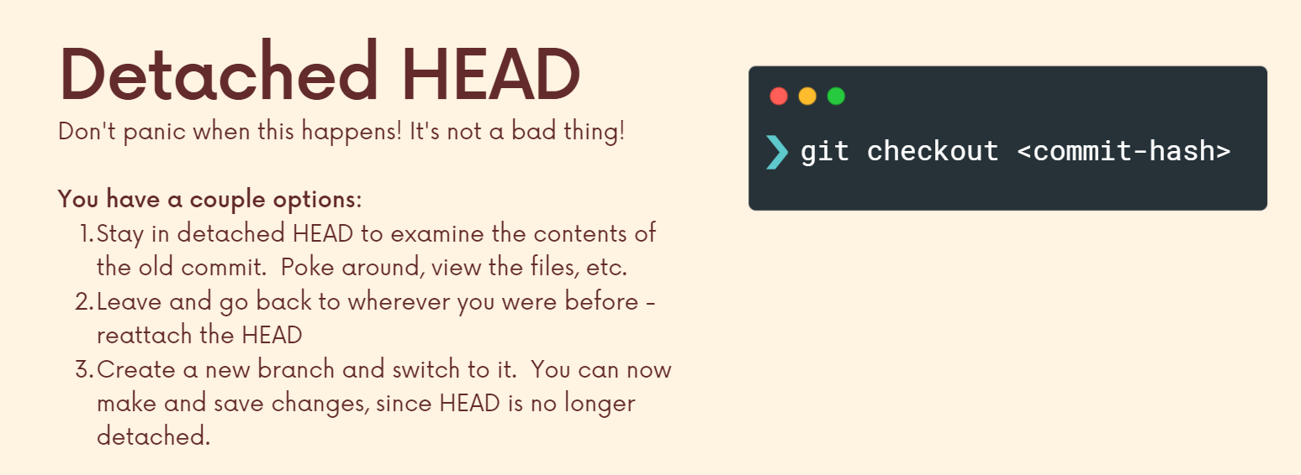

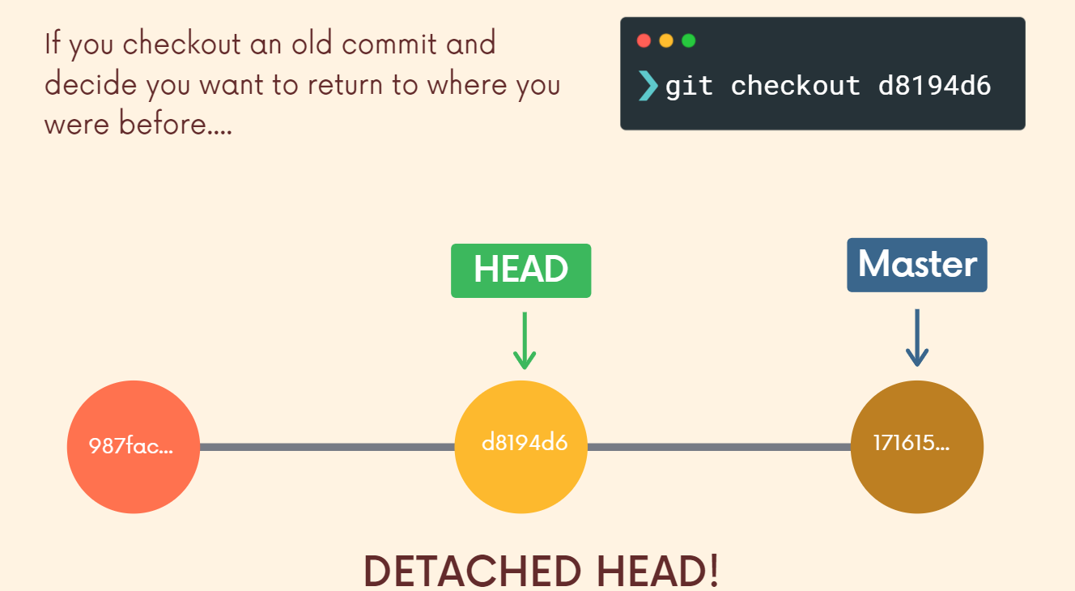

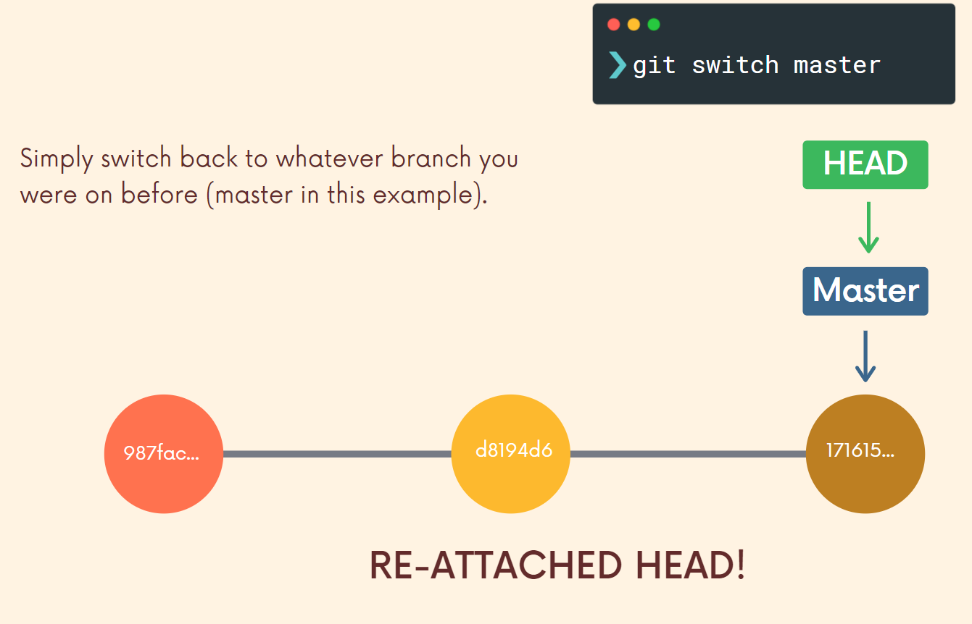

While on a previous commit if we want to make changes, we can simply make a new branch and head will now point to this branch reference and not a commit directly and now we can do work on this branch and later use **git switch master** to make head reference the master branch again and get back our previous work.

**Method 2 to go to previous commits**

If we want to traverse the last or second last commit and we don’t want to use the commit hashes, then we can still easily reference it using this approach.

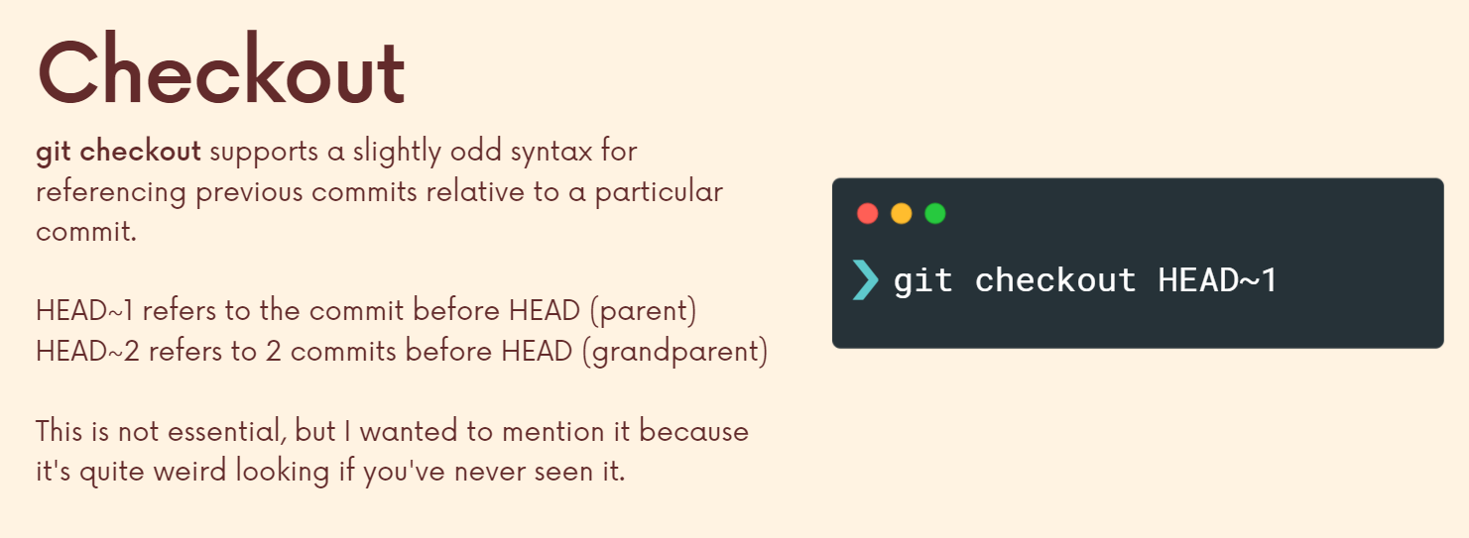

We will again be in detached head state since we checked out a particular commit (hence we are again on a commit and not a branch). Head will be pointing to the commit now (and not the master branch or any other branch).

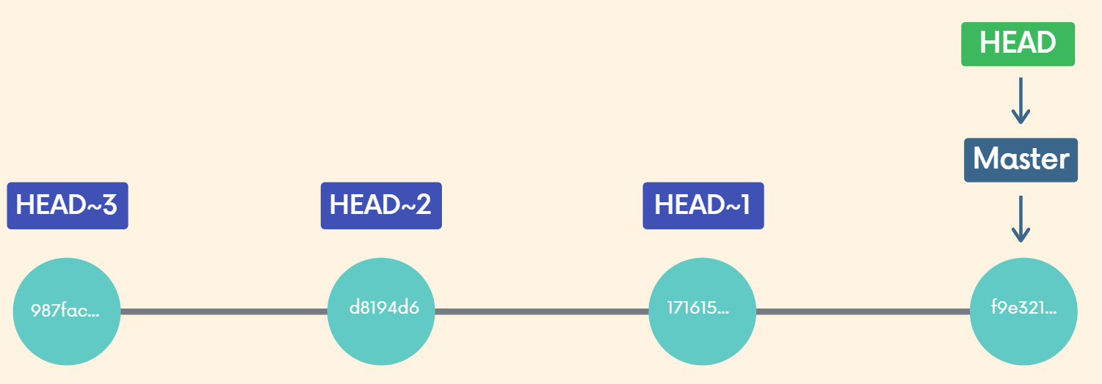

*OK, now if I want to go back to where I was, I want to leave detached head. One option is to just remember what branch I was on master and go back to master* ***get switch master****. The other option is get switch with a dash (****get switch -****) and that will just take me back to whatever branch I was on last. And that happens to be master.*

**Discarding changes with git checkout**

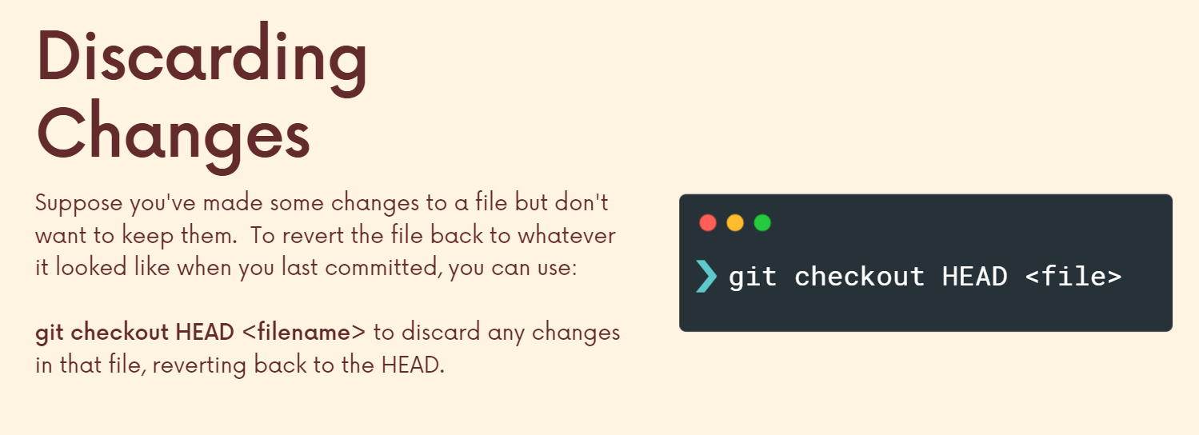

Git Check-Out head and then a file name or multiple file names will reset those files, contents back to whatever it looked like in your last commit or when you last committed, a.k.a. where Head is still referencing. And then there's a shorter version. Get check out Dash. Dash does the same thing. (Suppose after a commit we add 10 unwanted lines to code and don’t commit it yet and want to go back to the previous code/commit then either we can delete those 10 lines manually or use this approach because using this approach we are telling GIT to take whatever the contents of the file were at HEAD because HEAD is different from where we are right now. Right now we have unsaved changes but HEAD points to master branch which in turns points to the last commit and the master branch doesn’t move until we make a new commit.)

**Un-modifying with GIT restore**

Use 1

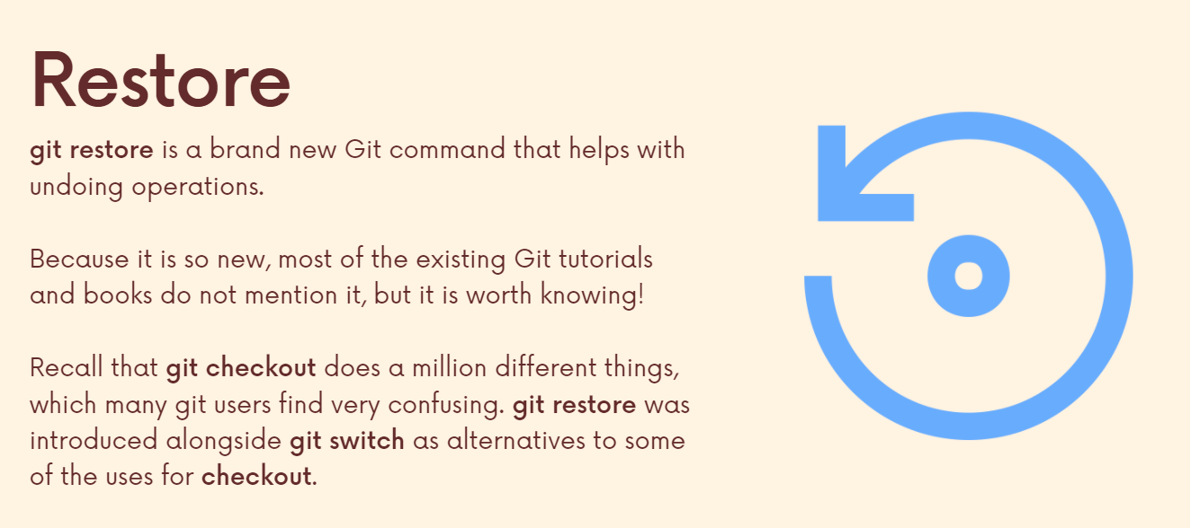

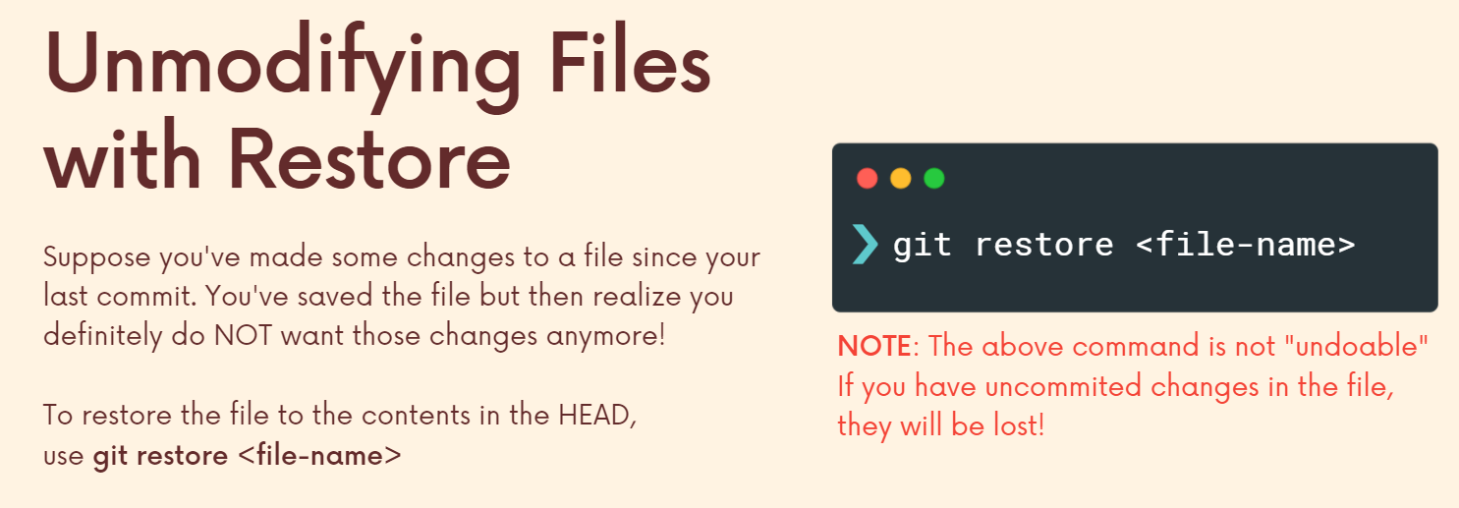

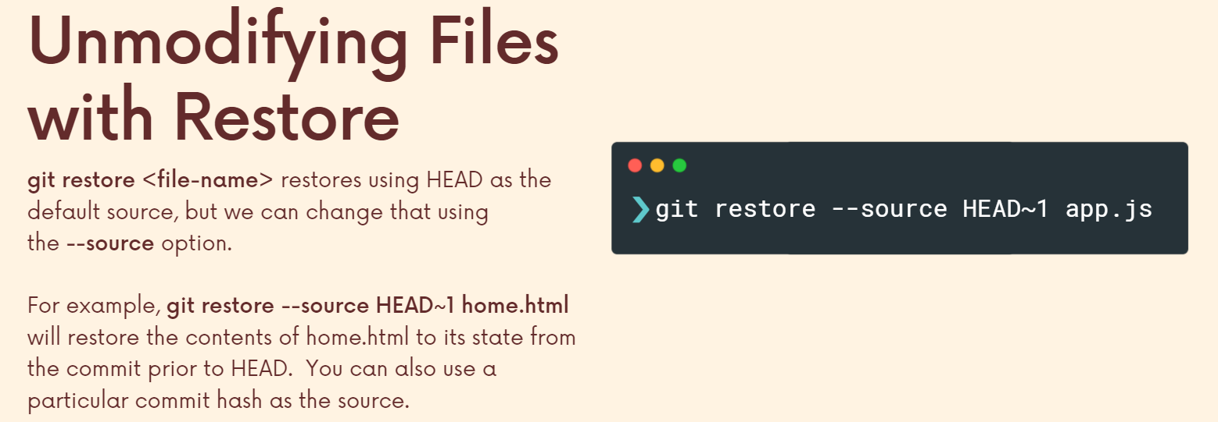

Use 2

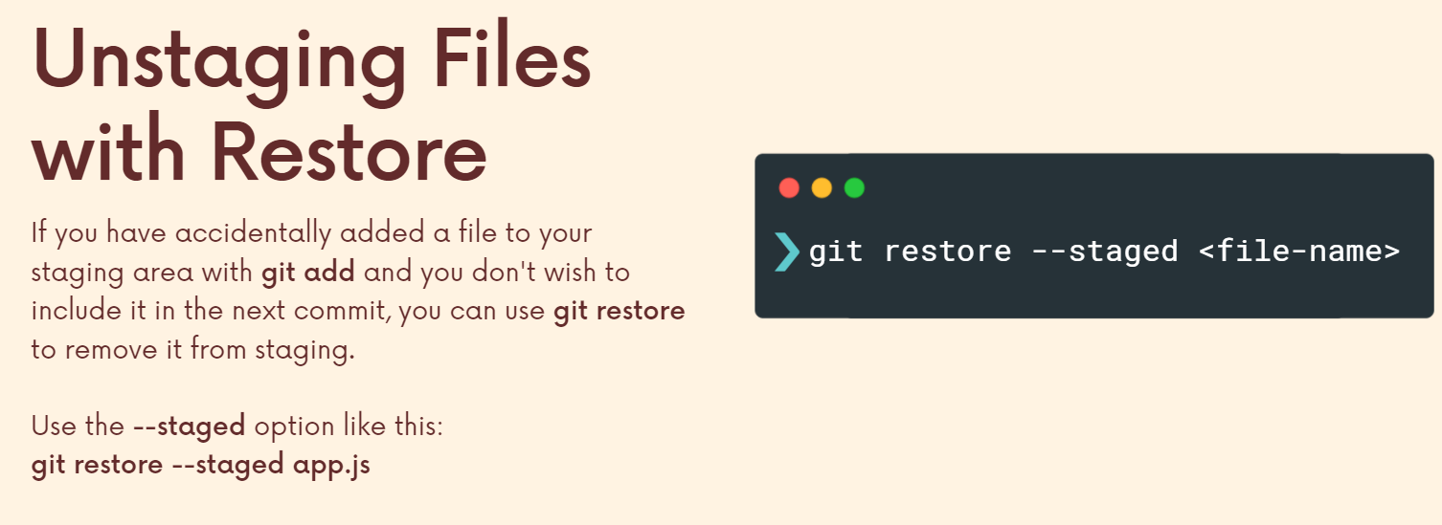

**Undoing commits with GIT Reset**

1) Basic reset: This will remove the commits and take us back to a previous commit we specified however, the changes we did would not be removed and will be carried with us to the previous commit. We lose the commits (after the one where we are going) however the work is still with us in our working directory.

This can be useful if we did some work on a wrong branch, maybe we wanna keep the work but move it to some other branch.

Eg we did work on master branch but then we went back 2 commits, made a new branch, staged and committed those changes there and then came back to master. Now, the work will be done on that other branch and master will have contents which it had till that commit point.

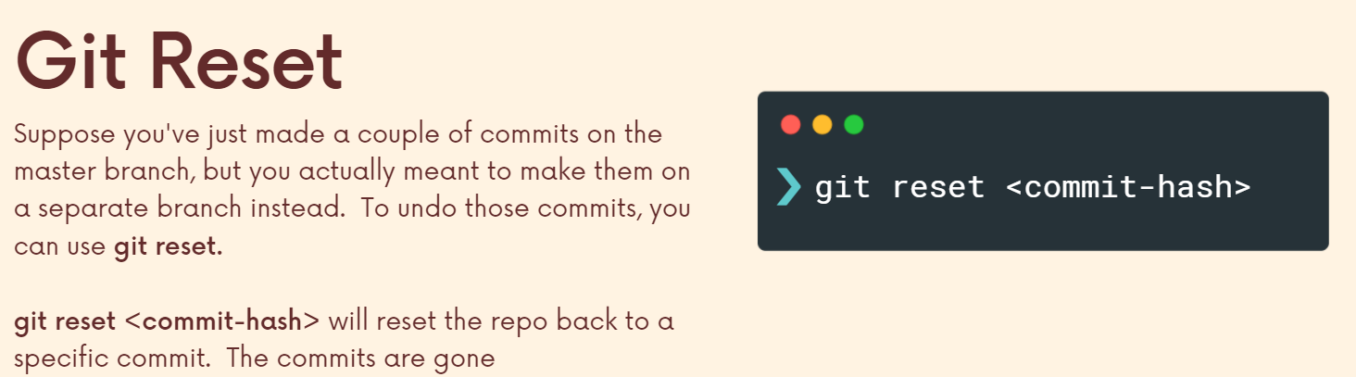

2) Hard reset: We lose the commits upto the commit hash and the changes are also removed from the working directory.

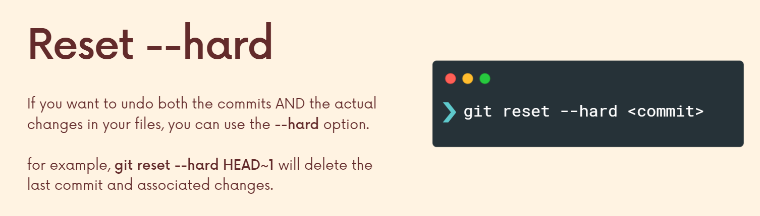

**Reverting commits with GIT Revert**

We still have the history of the commit (that we reverted) but its changes are reverted.

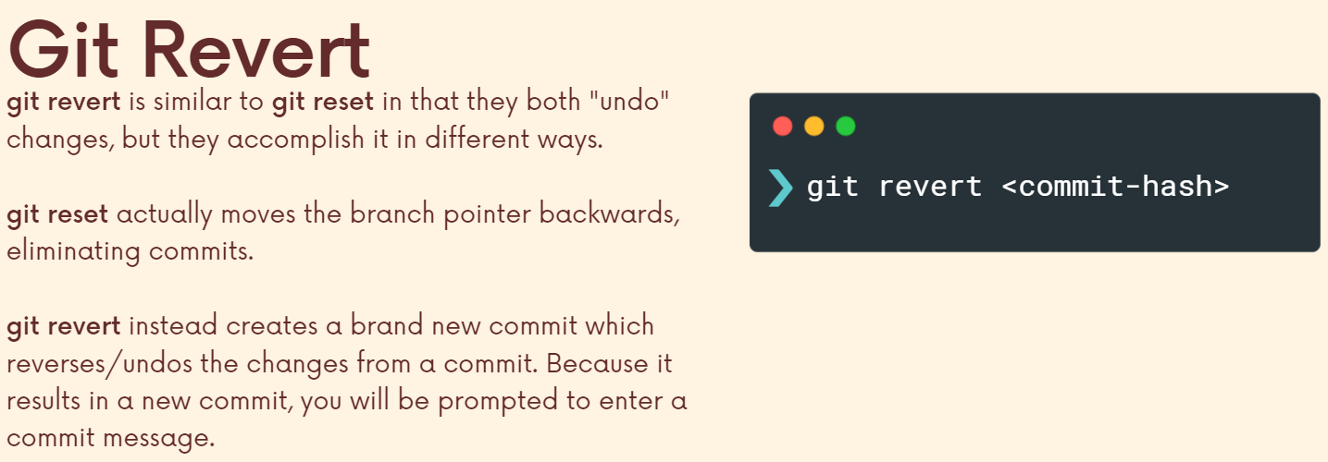

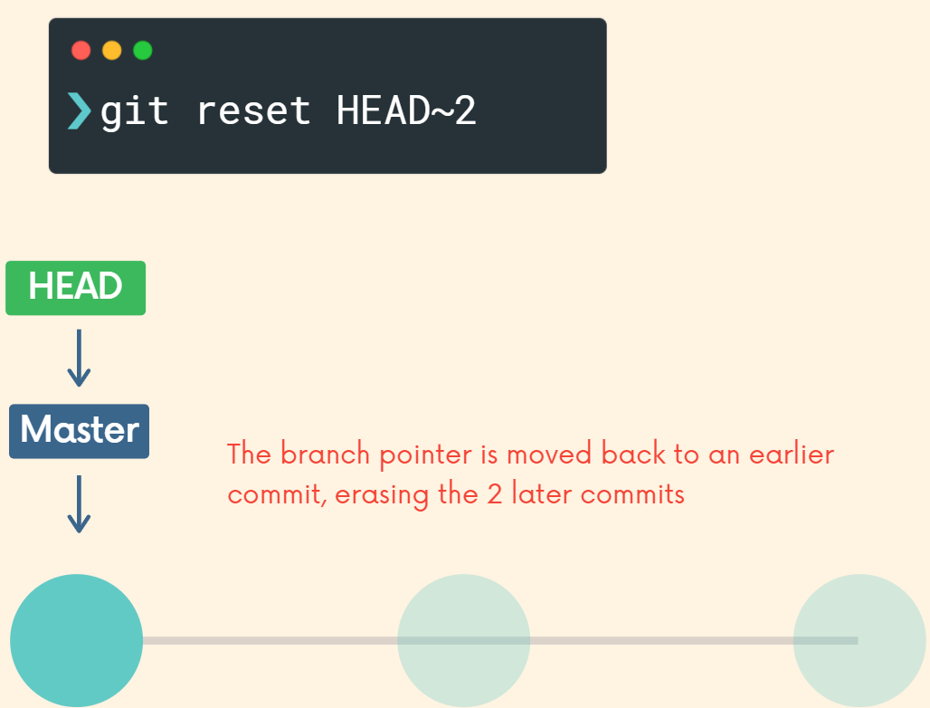

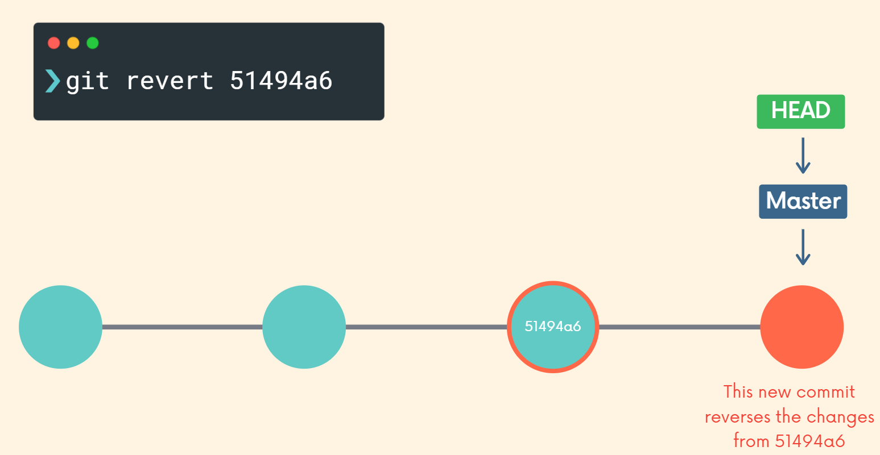

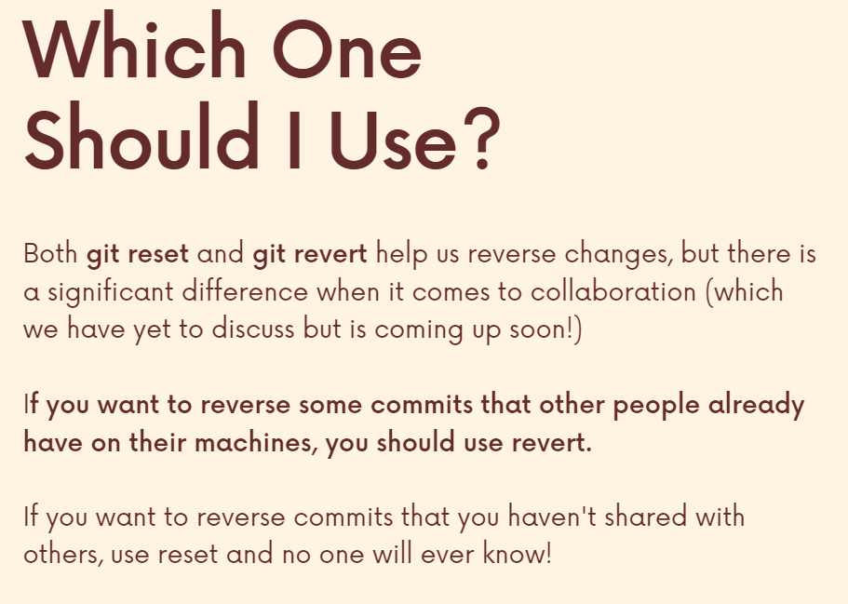

**Section 11: Github**

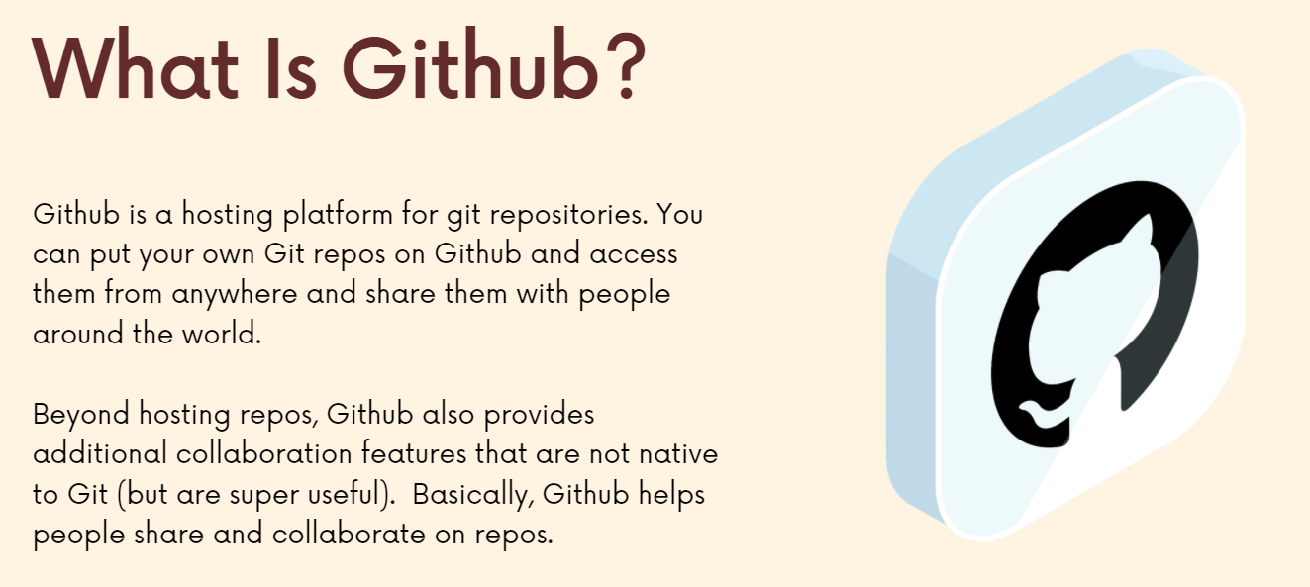

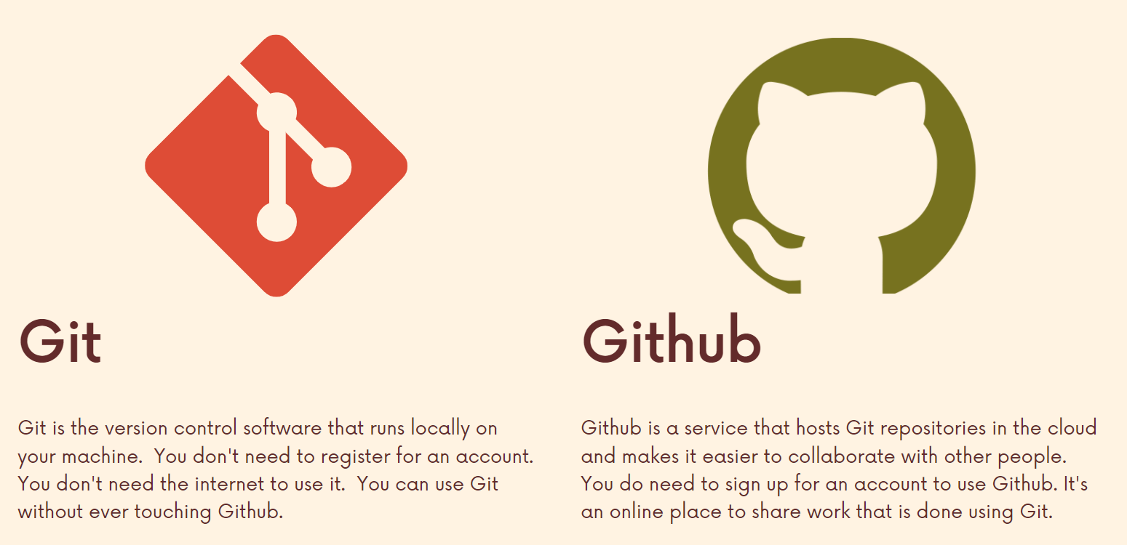

**Github is really useful if we want to collaborate or want to keep our code safe in the cloud.**

Other features are:

1) We can get to work on open source projects.

2) Get exposure

3) Stay up to date on repositories and upcoming changes

**Cloning Github Repos with Git Clone**

Whenever we are cloning make sure to not be inside a repository already (just like when we ran git init). And then wherever you run git clone, that is the place, that folder where Git is going to create a new folder for you.

Whenever we run git clone url, it creates a folder for us which contains a repository which has been initialized and has the full history of the project and that’s the reason when we clone, we make sure that we are not inside a repo already.

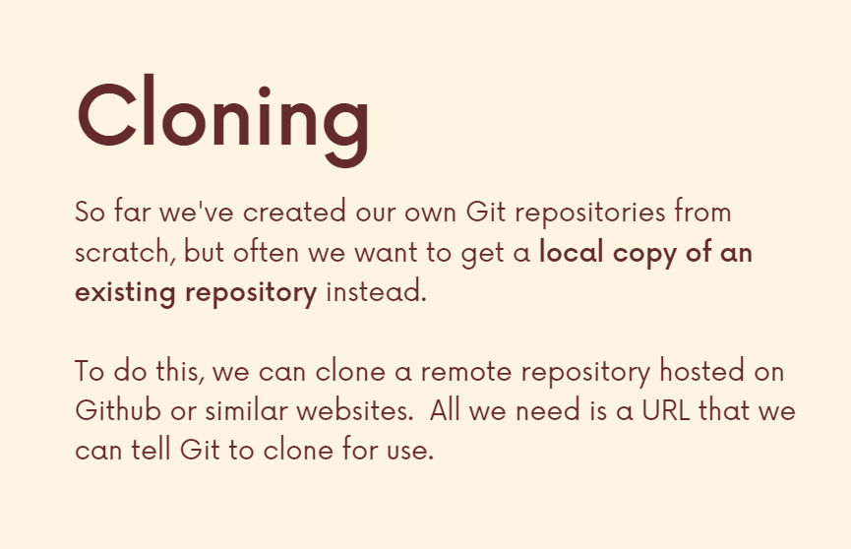

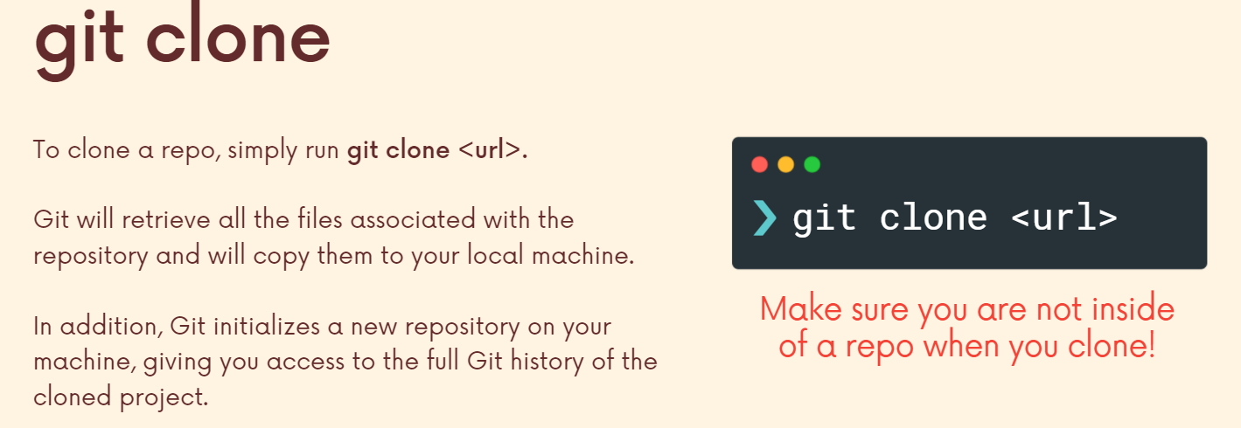

**Github is the widely used tool to host git repositories.**

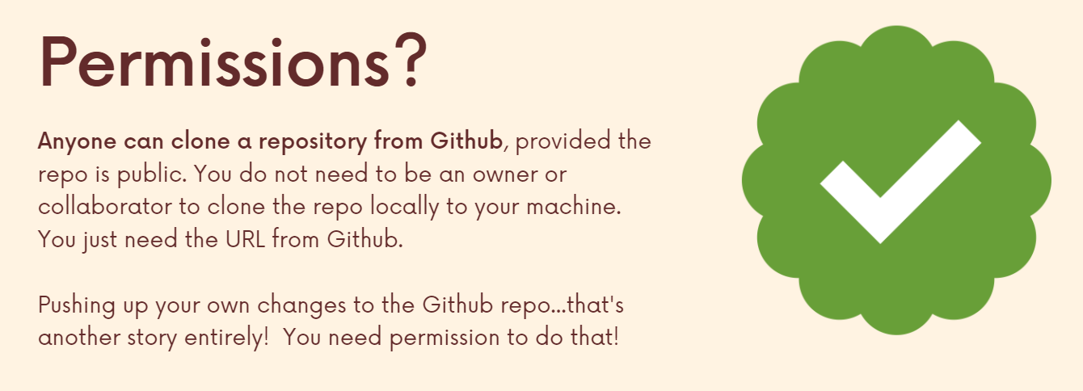

**We can use git clone to clone repositories from anywhere. It will clone any hosted repo.**

**Creating our first Github Repo**

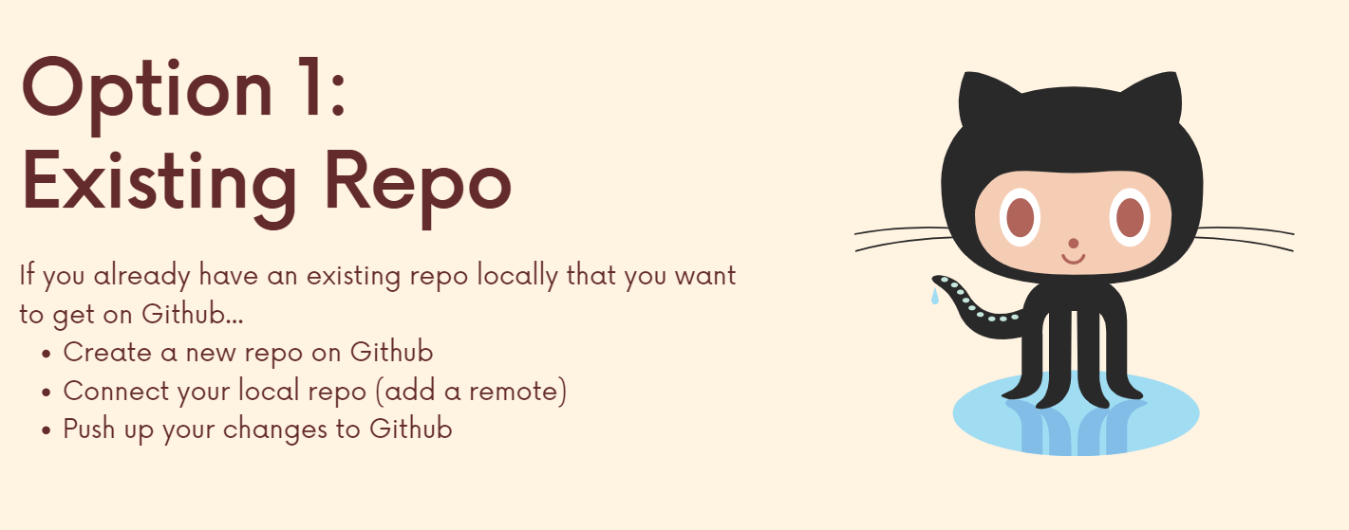

(Below) Instead of running git init, I can clone the empty repository from github. And if I do it that way, I don't have to manually connect my local repo to my GitHub repo because if I clone this repo from GitHub, it automatically is connected to that GitHub url. (Since the empty repo came from github, it knows about the url automatically and hence we don’t have to connect them in any way)

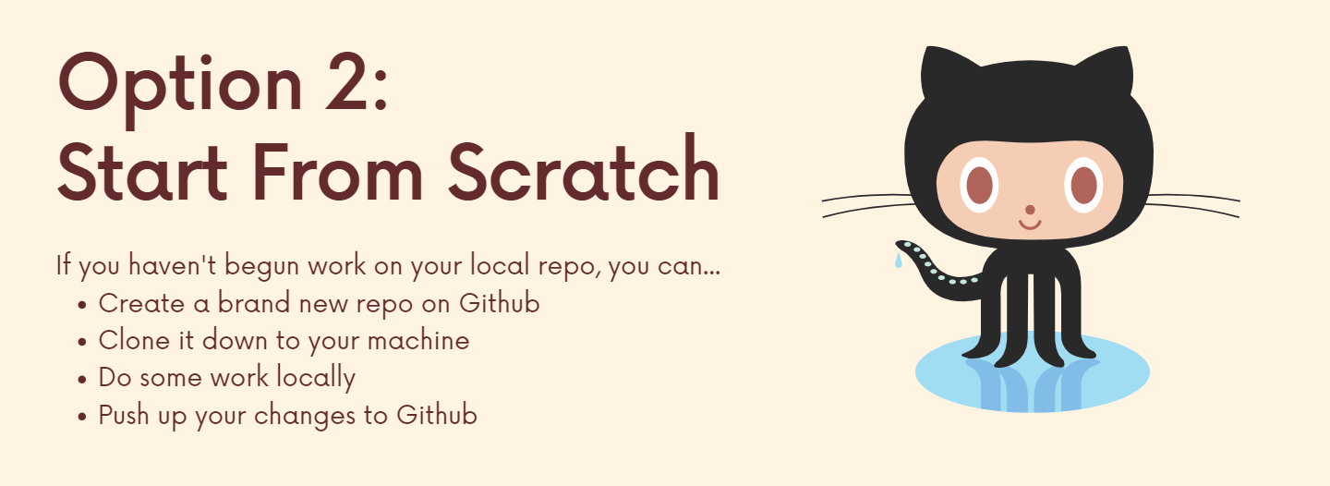

**Git Remote**

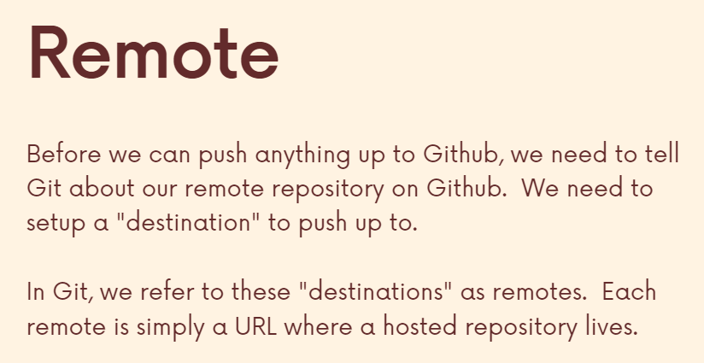

When we clone a repository and type **git remote -v** we get the name of the remote and the url from where we cloned our repository.

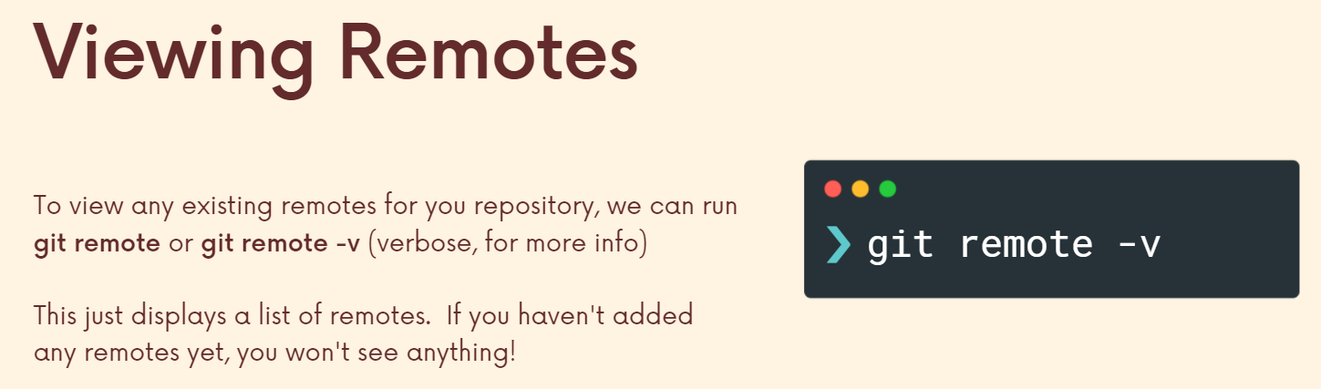

If we do not clone a repo and make our own repo instead, then initially it wont have any remote. However, we can add a remote of our own.

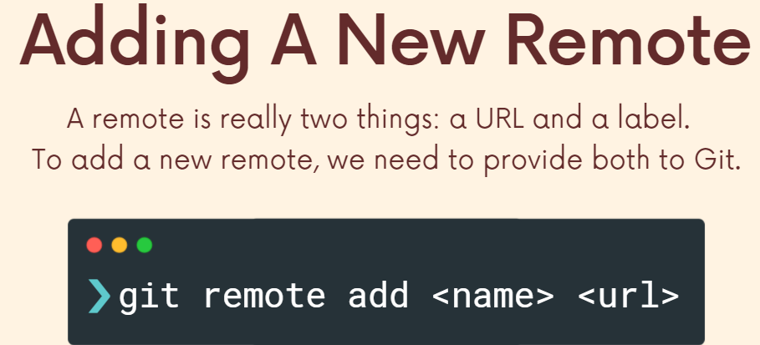

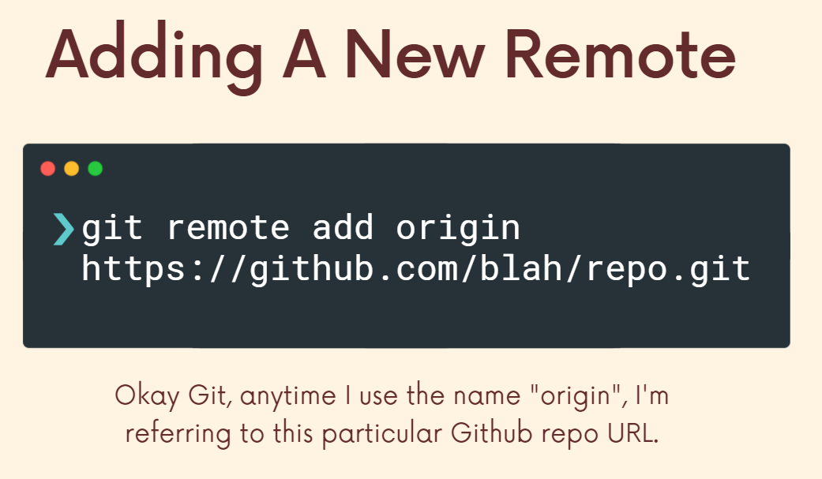

Similar to the way master branch is the default name for branches, origin is the default name for url (**conventional name for a remote**). **Hence, these remotes are used to tell our local git repo about a github url called origin (so that we can push code to it).**

**Pushing**

Following option 1 (we have existing repo) we have done:

1) Create a new repo on github

2) Connect local repo to it (add a remote)

Now the last step remains, i.e., push up changes to github.

I made an empty github repo and set my remote called Origin so that it points to this empty github repo. Now, we only need to push up.

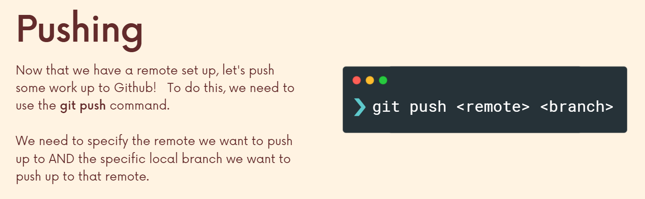

Origin is where we are pushing to and branchname is the branch we are pushing up.

If we have many branches, we can push any branch to github as required.

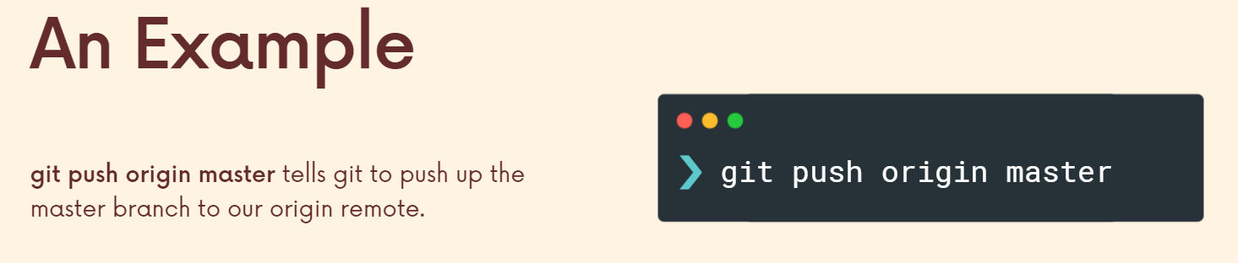

**Hence, I have successfully pushed up my local repo to github.**

**If we update a branch in local repo it wont show automatically in github unless we push that branch again and after pushing it, it updates the old branch.**

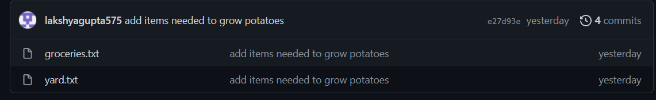

**Add items needs to grow…** this is the latest commit which effected each one of these files.

We can push multiple branches on github or when we finish a branch in our local repo, we just merge it with the master branch and then push the master branch up to github.

**Important Points**

When we first time push the master branch, github creates its own master branch (since there is no branch on github the first time). This happens whenever we create a new branch which doesn’t exist on github and push it to github.

The next time we update and push it, it takes the master branch from our local (if we just write **git push origin master** then it just pushes master up to master since the master branch already existed).

It is not necessary to push master up to master branch, we can push a different branch up to a different branch. For example if we make a change in **cats** branch but push it to **master branch** then the **master branch** will show the newly committed results.

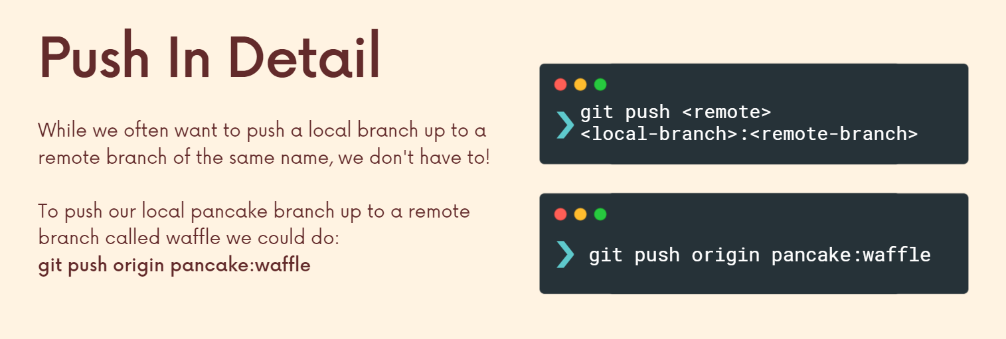

**Git push -u**

The upstream of a branch, a local branch is kind of like think of it as a connection, pointing to a remote branch. So if we have our master branch on our local machine, normally we want the upstream branch to be origin master or some master branch on GitHub. They are connected. And this enables me to do things like just run, git, push without having to specify origin master.

So when we run this **git pushed -u origin Master**, this tells git that on my computer locally in my repo. I want to push up the Master Branch to Origin Master. And I want you to remember that I want you to recall in the future that my master branch on my computer is connected to the Master Branch on Origin.

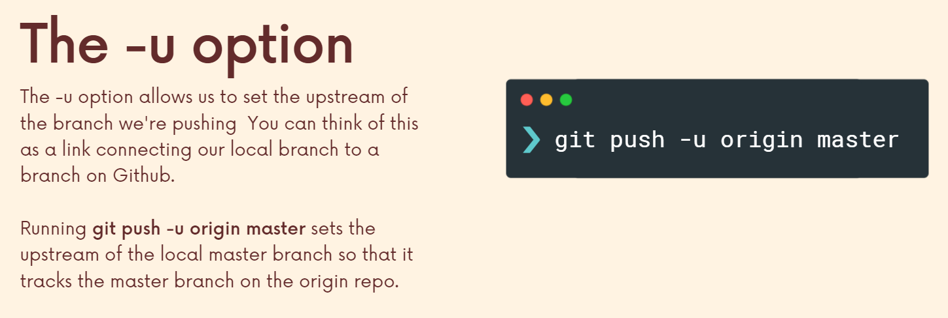

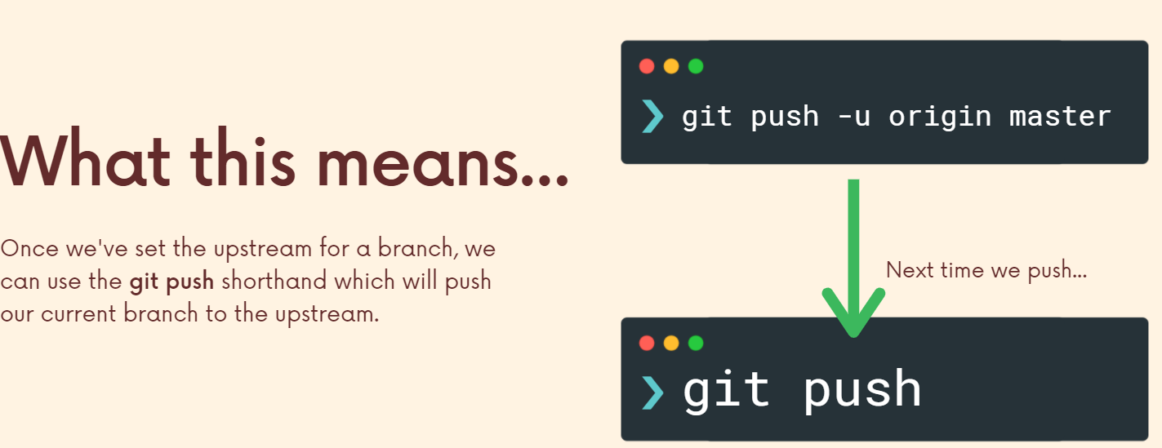

When we pushed a branch using **git push origin branchname** there was no need to be on that branch since we are specifying the game however, if we use this then we have to be on that branch.

Also, we are using this approach because 1) we can use the shorthand and 2) I want my dog local branch to be connected to the github dog branch. (even though we saw that we can push from one branch to something with a different name, that is not so common and hence normally we want them connected and so we use **git push -u**)

We can also use the last page colon syntax if we want to set the upstream other than something than the remote branch of the same name.

**Option 2…**

Remote is setup automatically when we clone.



So this works. If you haven't started your work on your project at all, you know, you want to use GitHub and, you know, you need to get repo on your machine, but you don't have an existing project to push up.

After making a file and committing changes to it if I refresh GitHub, nothing has changed whatsoever because I still have to push, as we've talked about. So that's the next step. I've done some work, not a whole lot, but I've done some work locally. Now we push that up. So it's the same exact workflow from this point forward. The only difference between what I showed you earlier is that we cloned an empty repo and started working in that repo versus our first approach was we've been working on something locally. We have a bunch of commits. I want to get those on GitHub so I'm not going to clone an empty repo. I already have my repo on my machine, so I make an empty repo on GitHub and then I configure a remote. So my local repo points to that GitHub repo.

**Section 12: Fetching and Pulling**

When we clone a repo from GIT, we get 2 pointers, **master and Remote Tracking Branch**, a remote tracking branch, a bookmark that holds the spot, the most recently known state of the master branch on Origin.

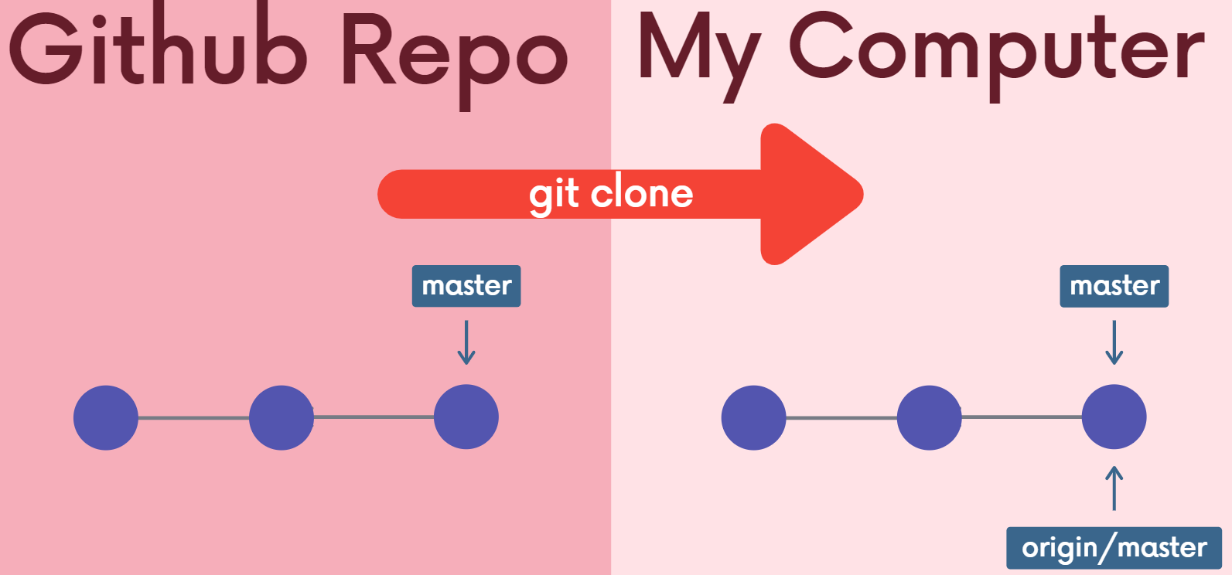

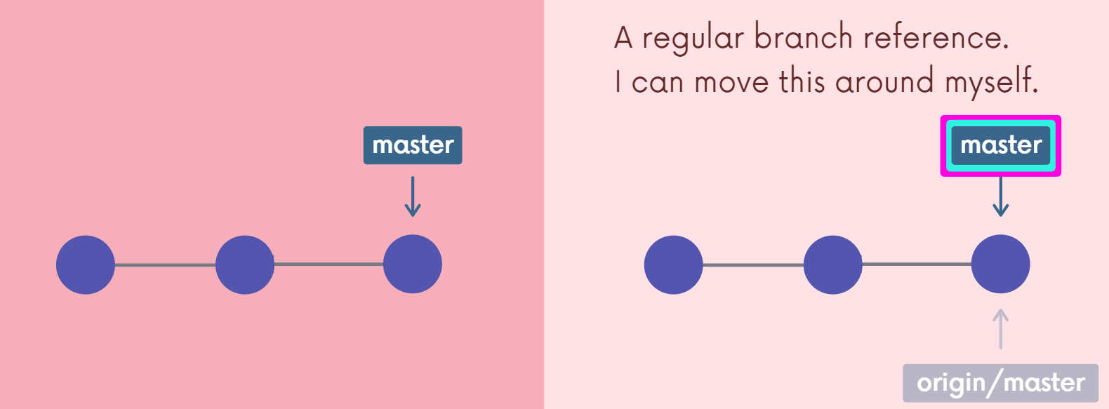

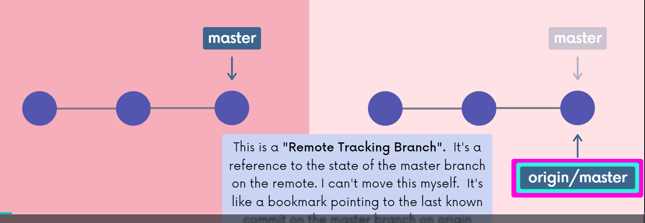

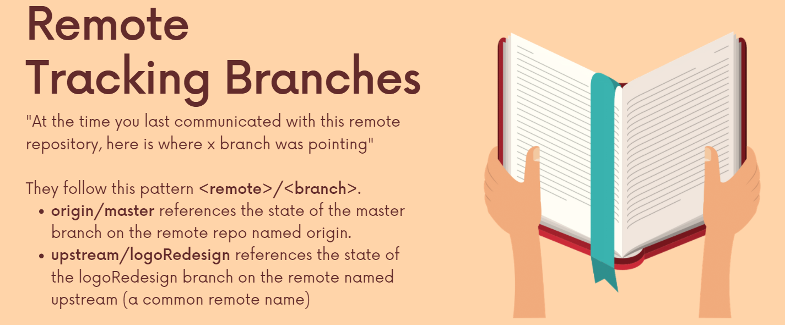

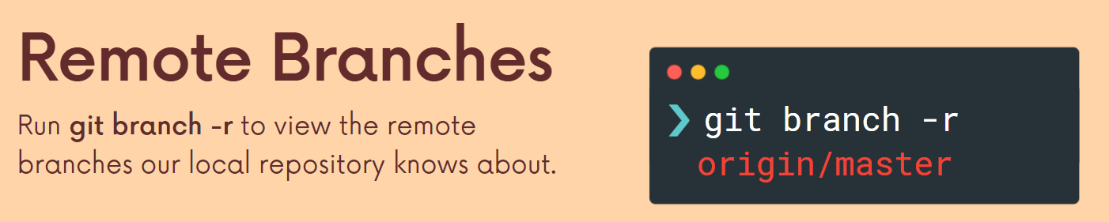

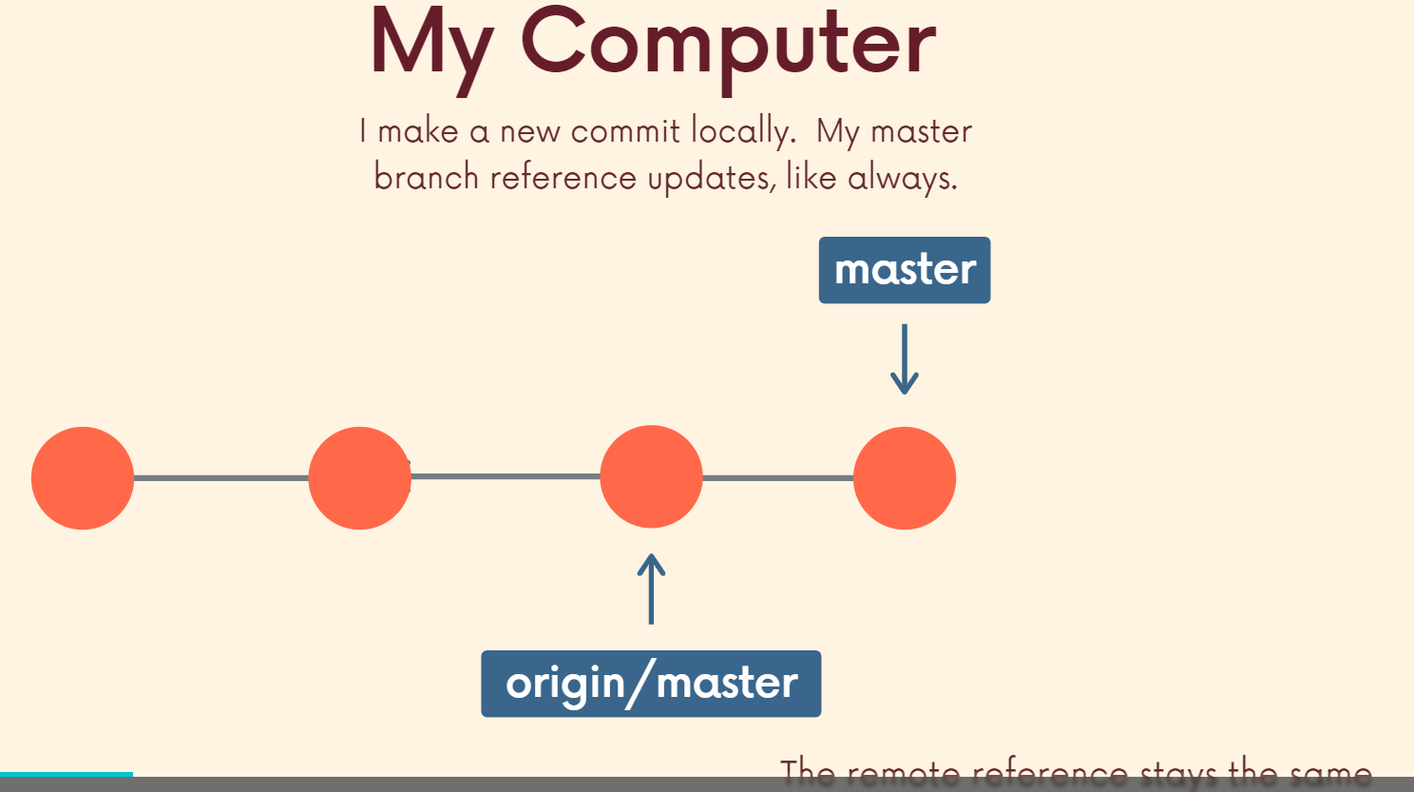

Origin master is the master branch on origin or whatever that GIT repo is.

When we make a commit to our repo and check git status, it tells us that we are 1 commit ahead of **origin/master**. Hence, this remote tracking reference is basically used to track how far ahead we are and it updates when we get new updates from the Github repo. Hence, this is a reference to where we were when we last communicated with github.

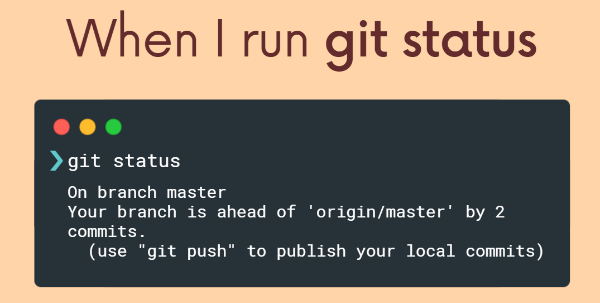

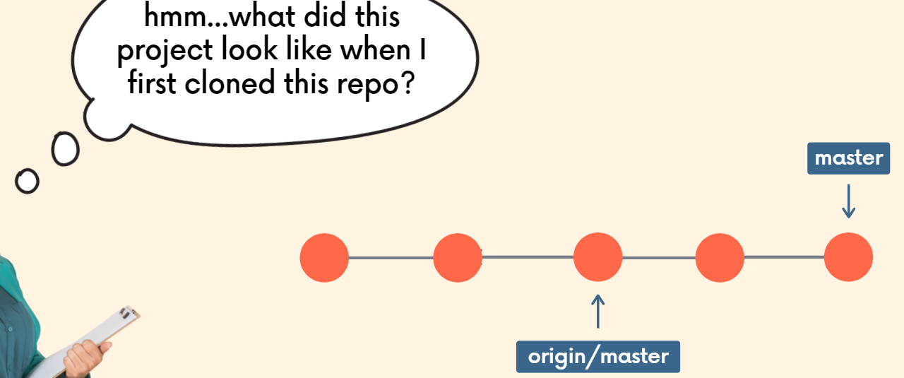

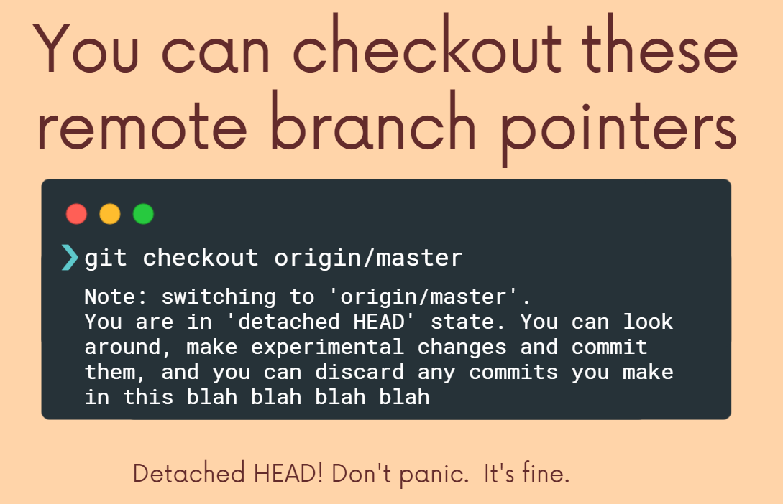

**Accessing branches from Github in local repo**

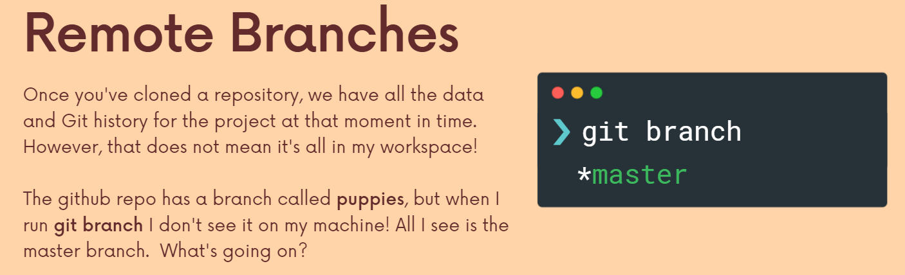

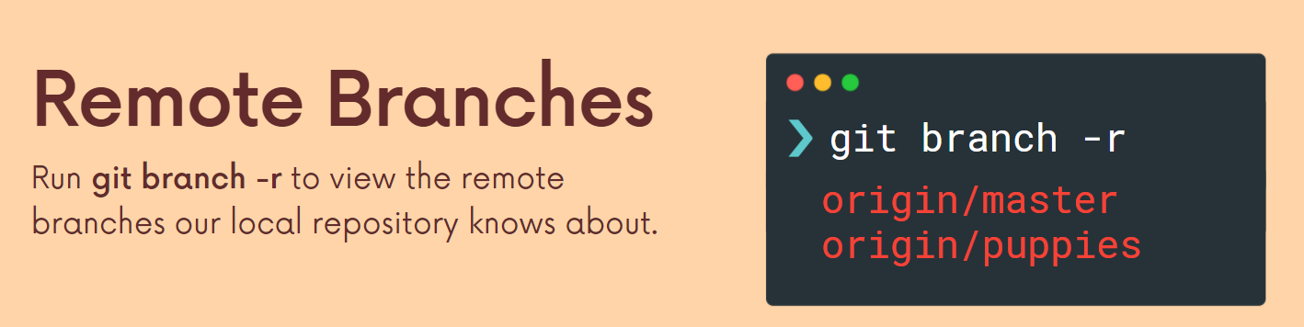

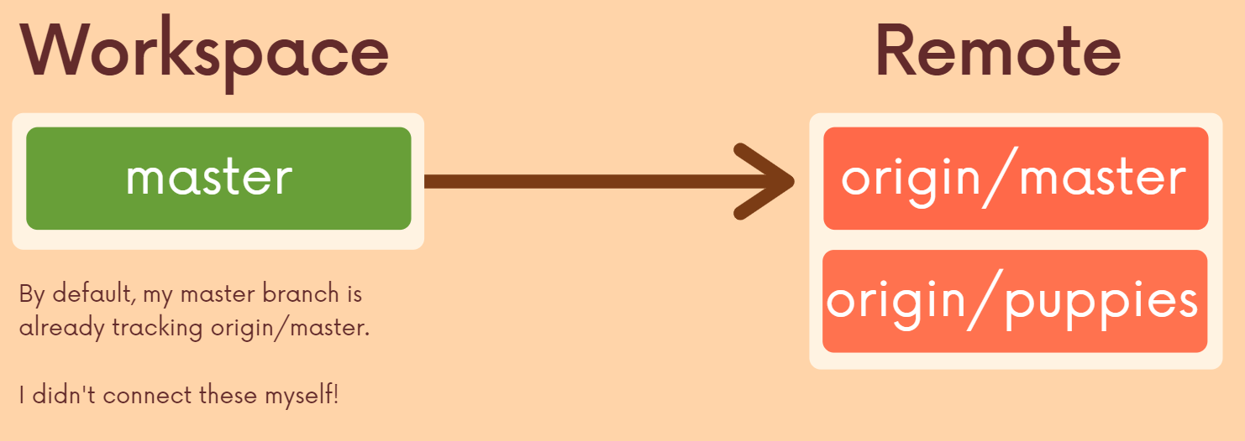

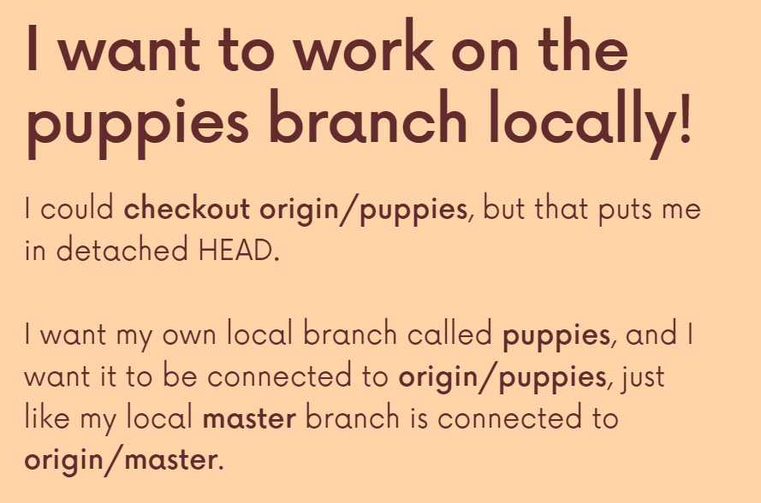

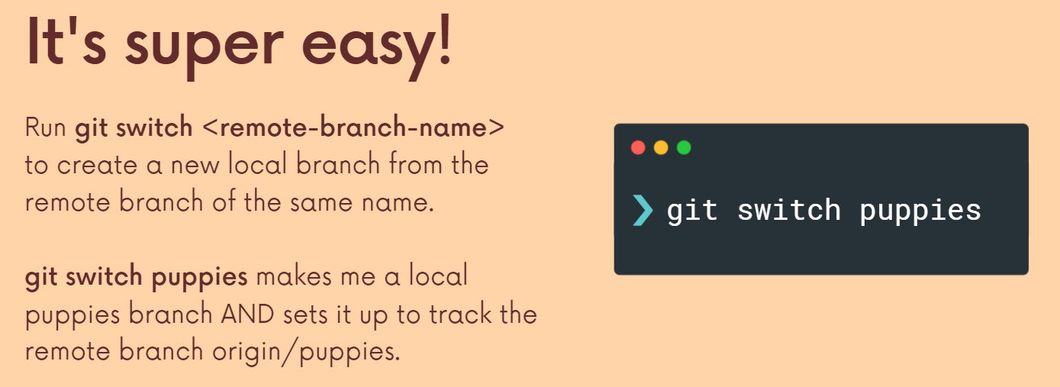

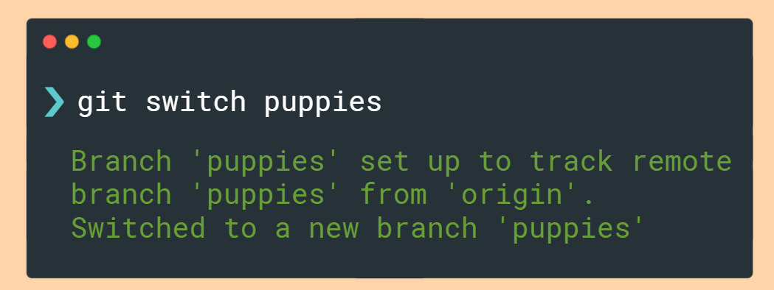

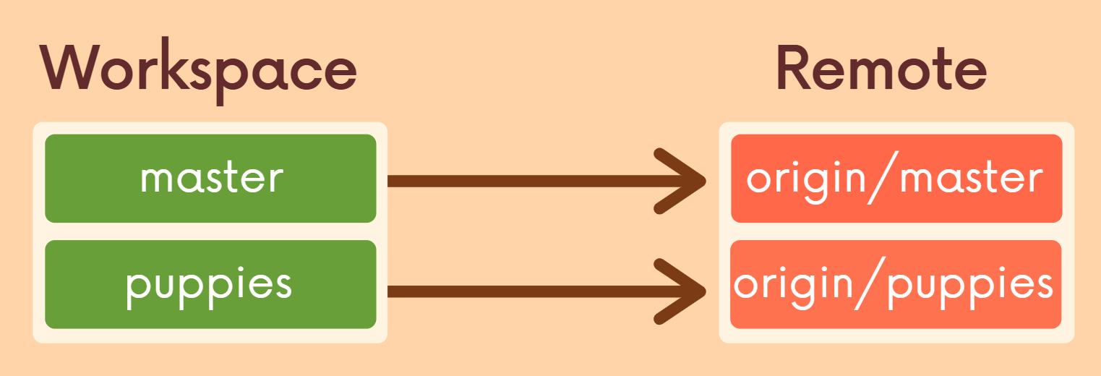

**Git Fetch**

Fetching allows us to get changes from some remote repo without actually integrating those changes into our working files so we can go take a look, see what changed, what's new on origin or on any other remote. And we could specify if we only want to fetch one branch from a given remote, otherwise it's going to fetch all branches.

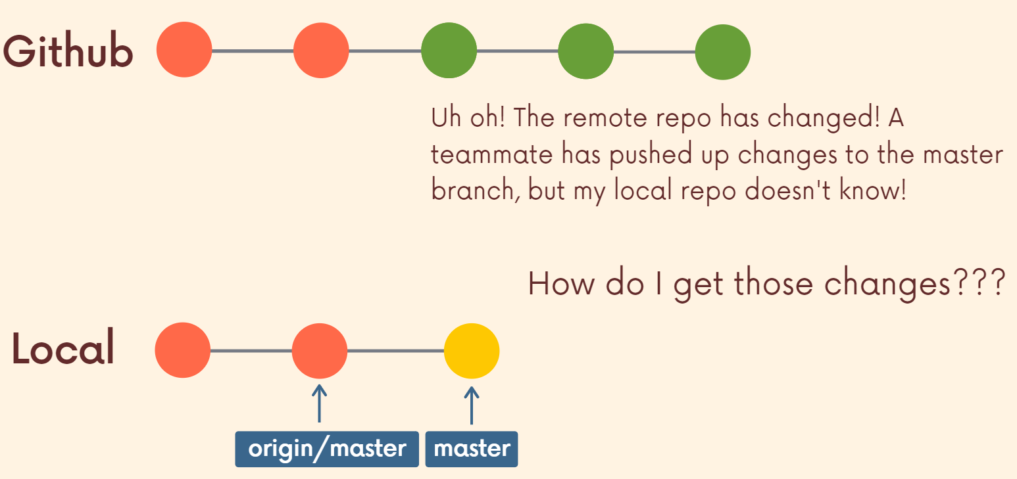

Bob has made 3 commits to the master branch in Github and our local repo wants to get those commits. This is where fetch and pull will play the roles.

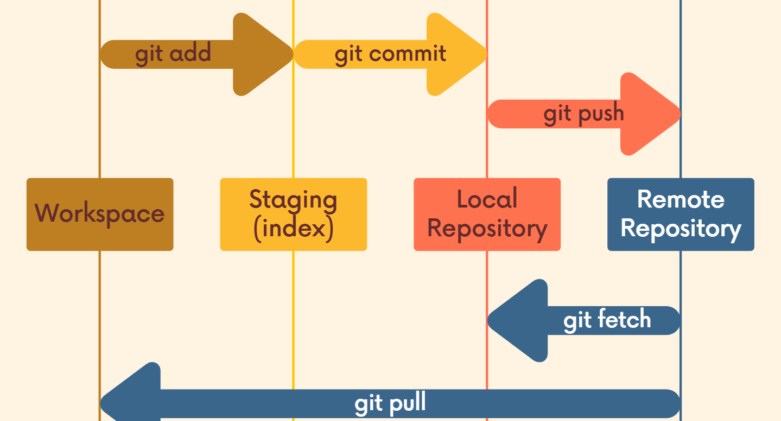

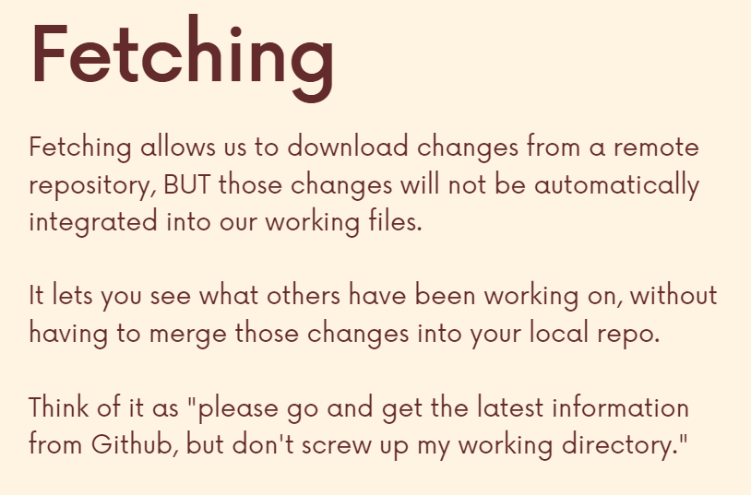

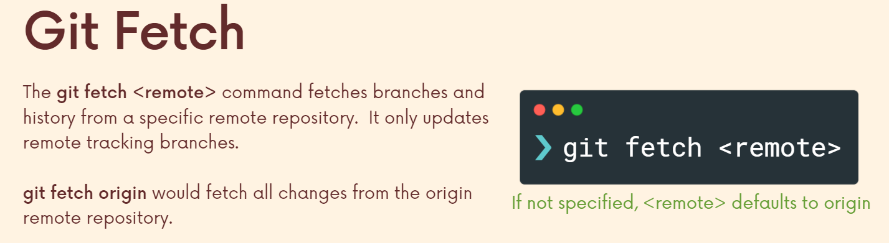

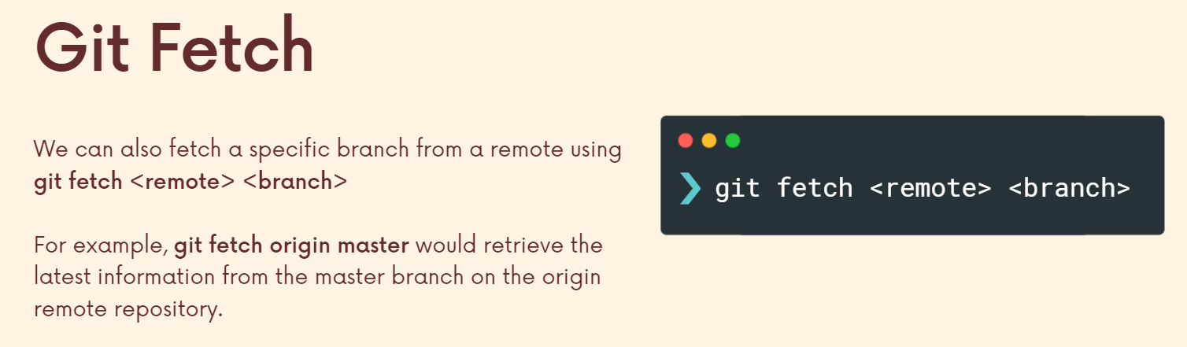

Used when collaborators push up changes from their own local repo and we need to access them.

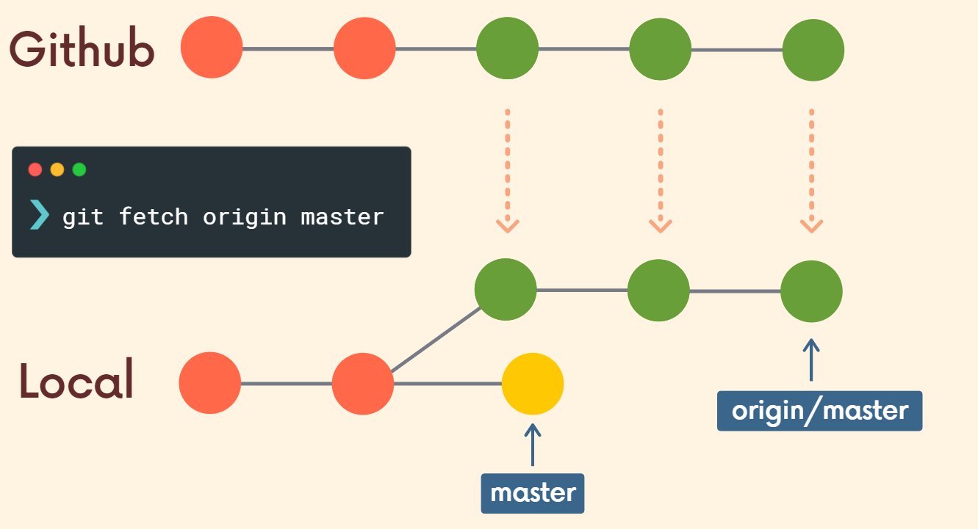

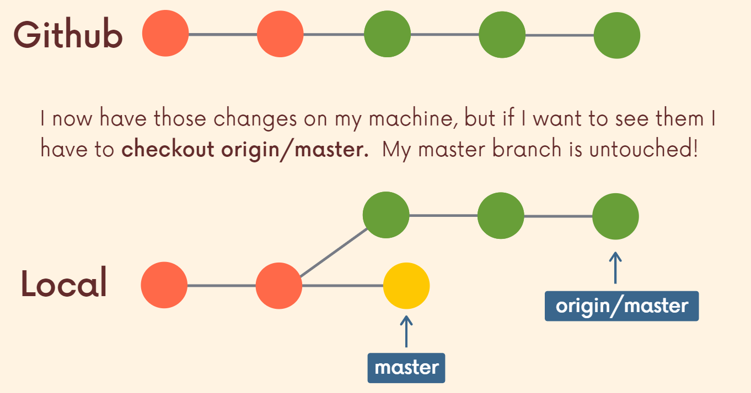

**Origin/master** is the **remote branch reference** which gets updated and we have access to it and can look up to origin/master to see what the files look like. However, the master branch in our local repo hasn’t changed in any way. Only the remote branch reference got updated. Hence, I’ve downloaded the changes on my machine but not integrated them into my working directory.

So let us say the collaborator pushes up some work on github and we need to integrate these changes in our working directory. Initially, we use **git fetch origin**, and **git status**, this will tell us that our pointer is behind the origin/master remote branch reference because someone updated in github. However, we still don’t have access to viewing those updates, we only know that something has been updated. Nothing has changed in my working directory however the origin/master is pointing to a new commit. In order to view the updates/new commit, we can type **git checkout origin/movies** and now we are in detached head mode and we can see the updates made by the collaborators and we can make a new branch from here. However till now the changes are only brought to the local machine but haven’t been integrated.

So using Fetch Gets the latest information about some remote repository, it just doesn't automatically integrate those changes into whatever you're working on.

**Git Pull**

The git pull command is similar to fetch and that we use it to retrieve changes from some remote repo. But the big difference is that pull will actually update our head branch. It updates our working directory. Whatever changes are retrieved or pulled down from GitHub or some other remote repo will be integrated into our local repo and our working directory. So, think of it as OK, get go and download the latest comments from GitHub and immediately update my working directory.

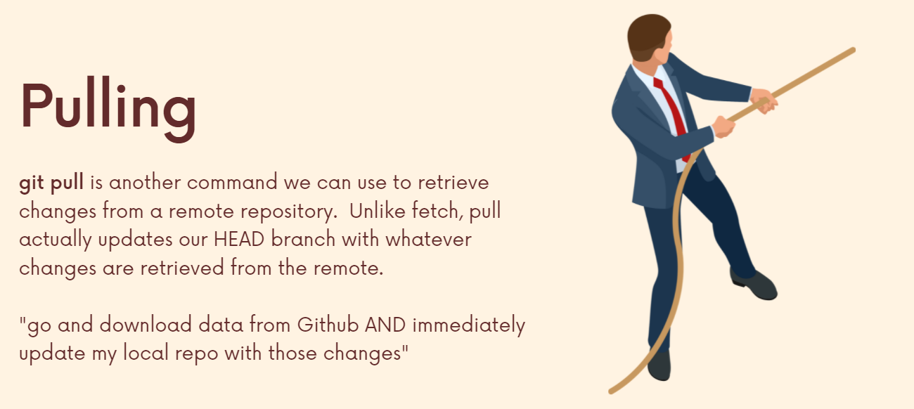

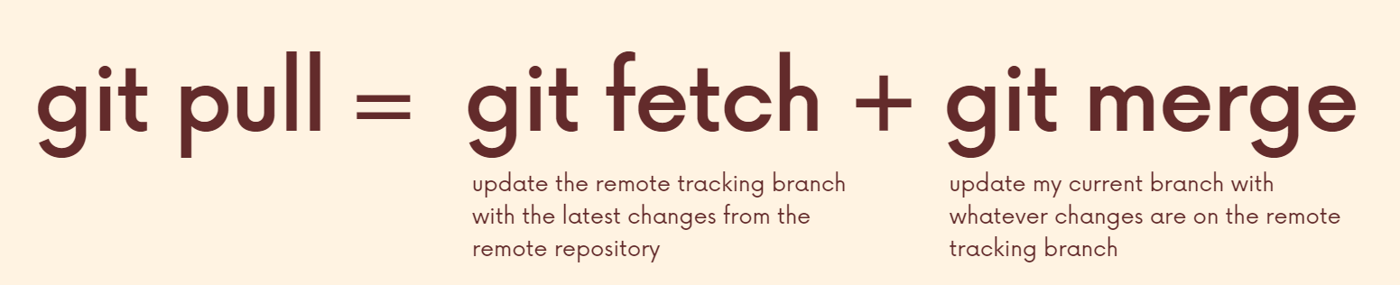

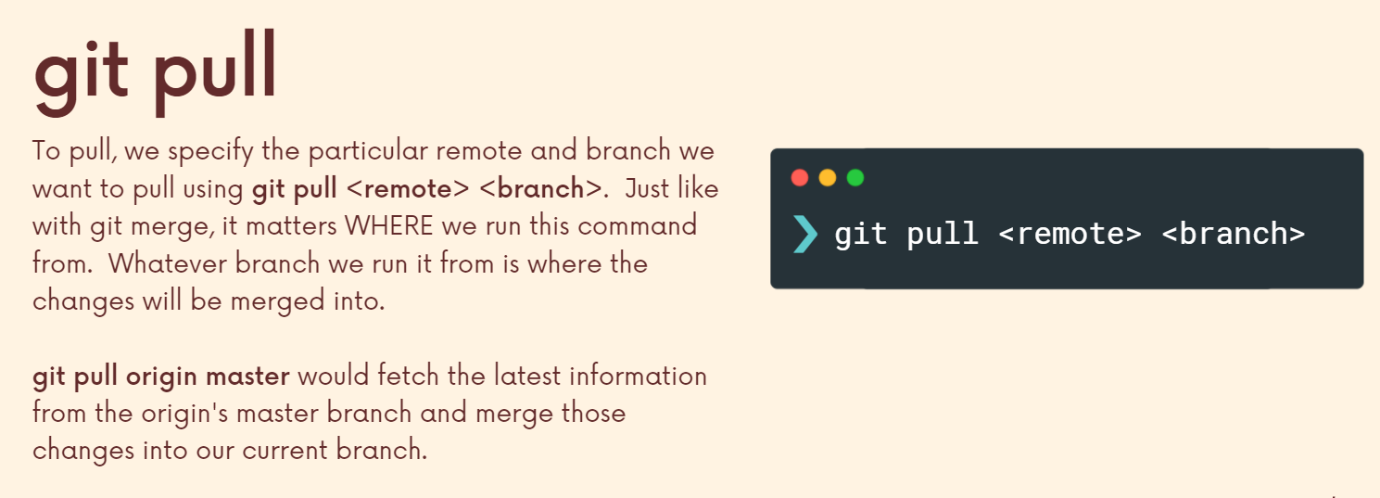

Next is that merge conflicts can arise and often do if you're working on something that somebody else also pushed some changes to. Lets see how to resolve them.

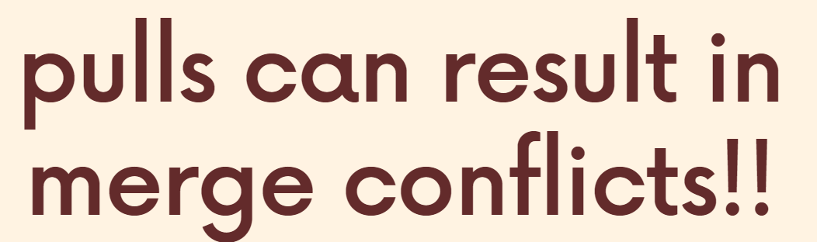

Sometimes you might have some work locally that is not on GitHub and GitHub might have some commits that you don't have locally. So, when you pull down, there may be conflicts.

Let us say I made a coffee.txt file on a branch in my local repo and bob did the same on github. Now, when we want to push our changes, it is best practice to first pull and see if there has been any updates on github or any conflicts we need to resolve. Now, when we pull down, we get conflict and we can simply resolve it in vscode. Now we commit these changes. If we check gitStatus, we will be ahead of our github file (**origin/food**) by 2 commits (one because of our own coffee commit and one of the new commit when we resolved the conflict). Now, we push these to our github branch **(git push origin/branchName)**.

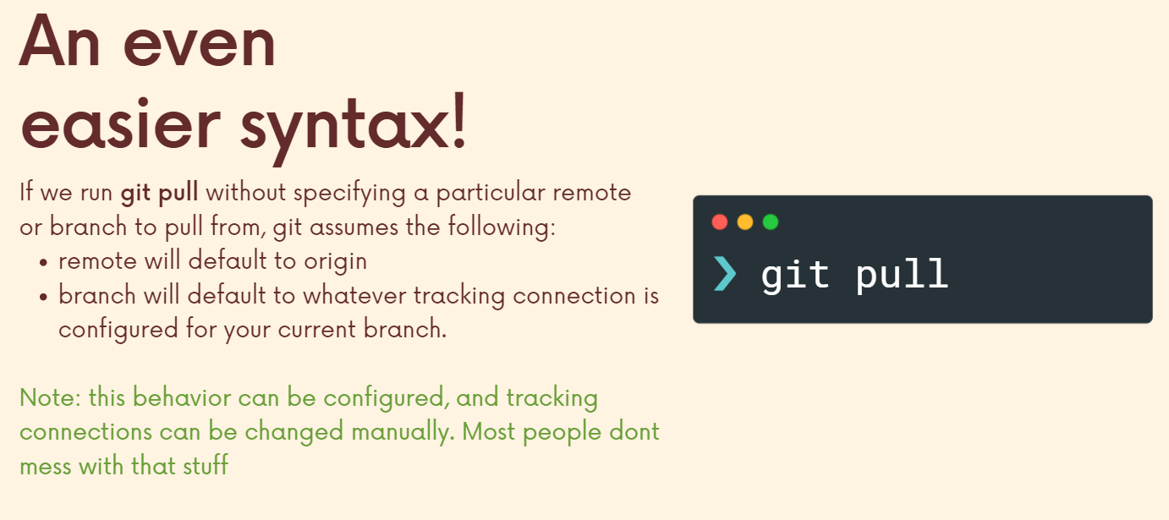

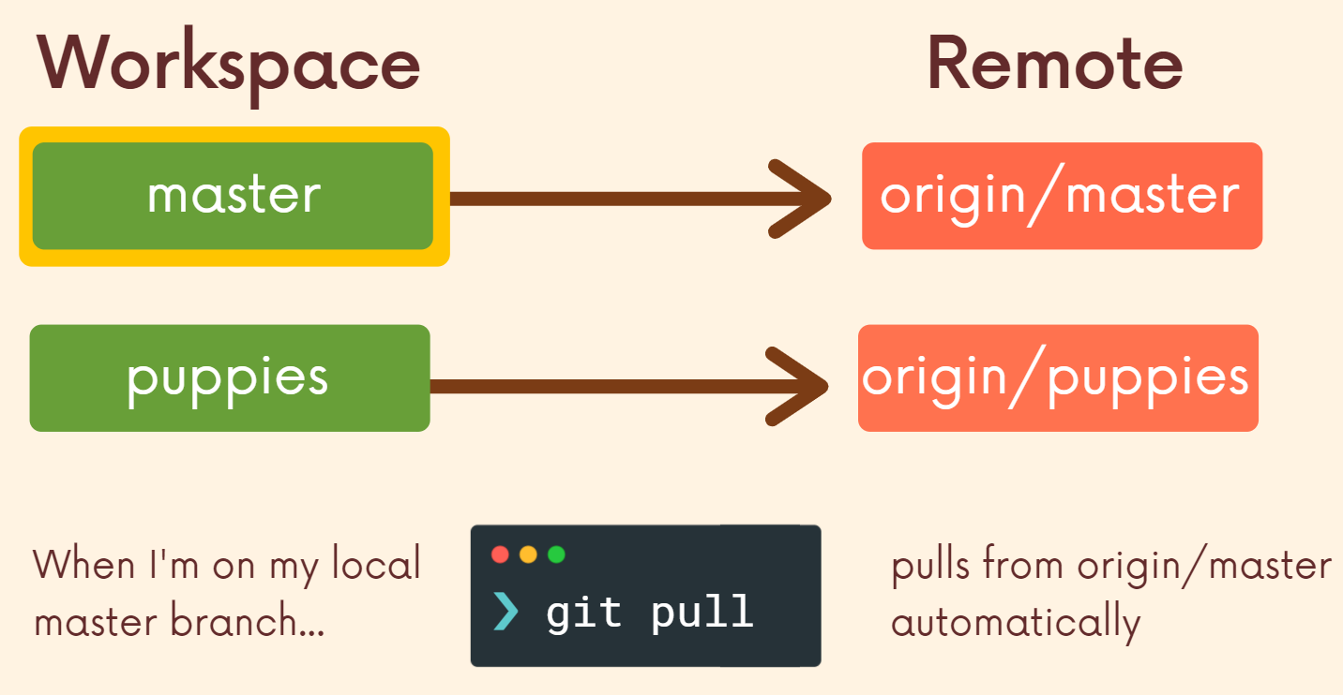

***Now, when we fetch, we're getting changes from a remote repo, but they're not integrated into our workspace. When we pull, we get those changes from the remote repo and then they are merged into our current head branch where we pull from matters.***

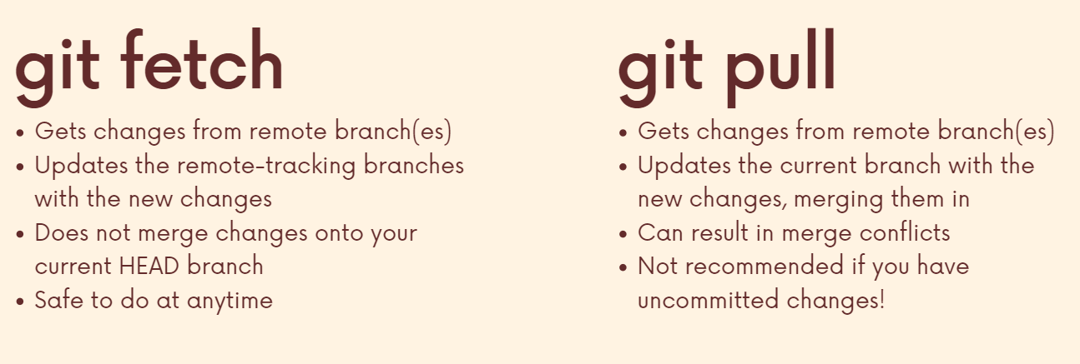

**Section 13: Github grab bag: Odds and Ends**

**Public vs Private Repos**

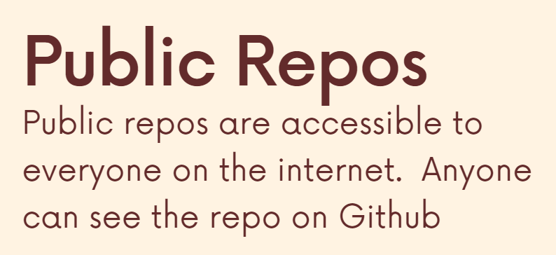

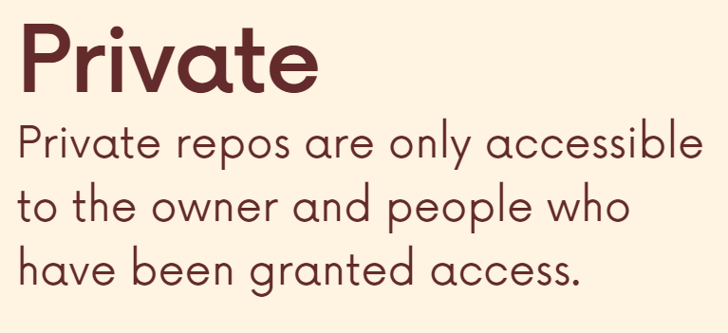

**Adding collaborators**

Allowing other users to push changes to the repository (earlier when we made the repo public anyone can clone, view the repo but cant push changes to it).

The owner is the only one who sees settings. If I go to collaborator’s side, that doesn't exist. So that is an important distinction. Being a collaborator, it's not like you can do everything right. You can't delete the repository. You can't invite your own people here. You can't delete other people or remove their privileges. With different levels, different tiers you definitely can have those features like organization and enterprise tiers. You on GitHub, you can have multiple owners. Permissions are different.

**ReadME and Markdown**

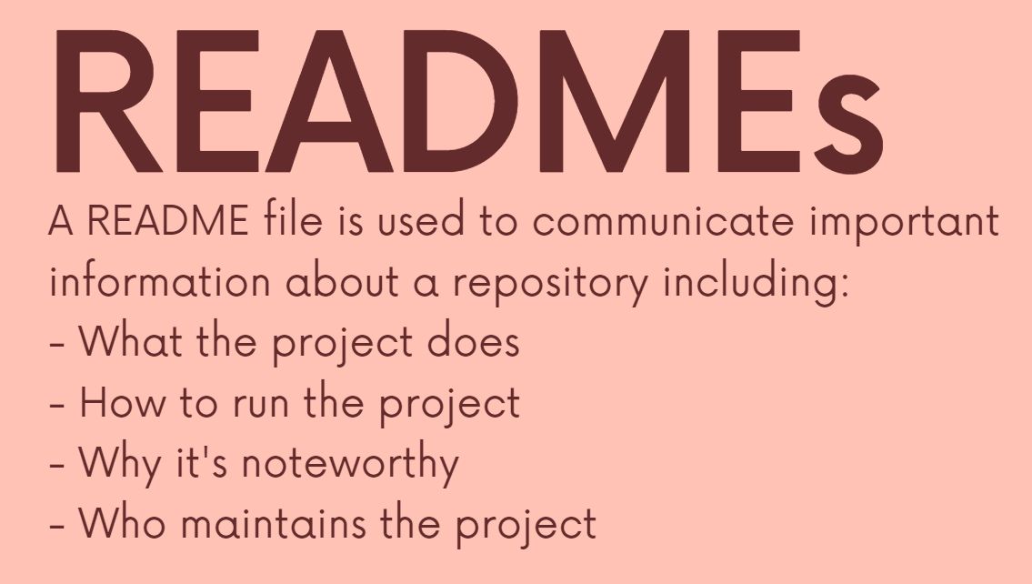

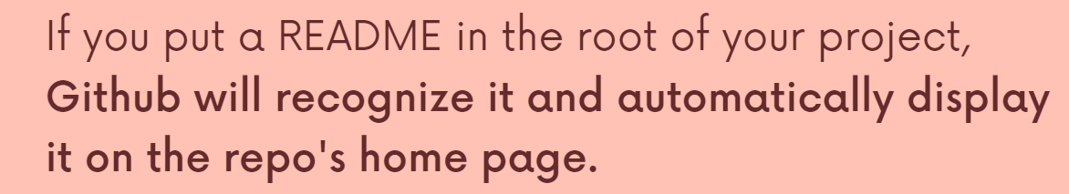

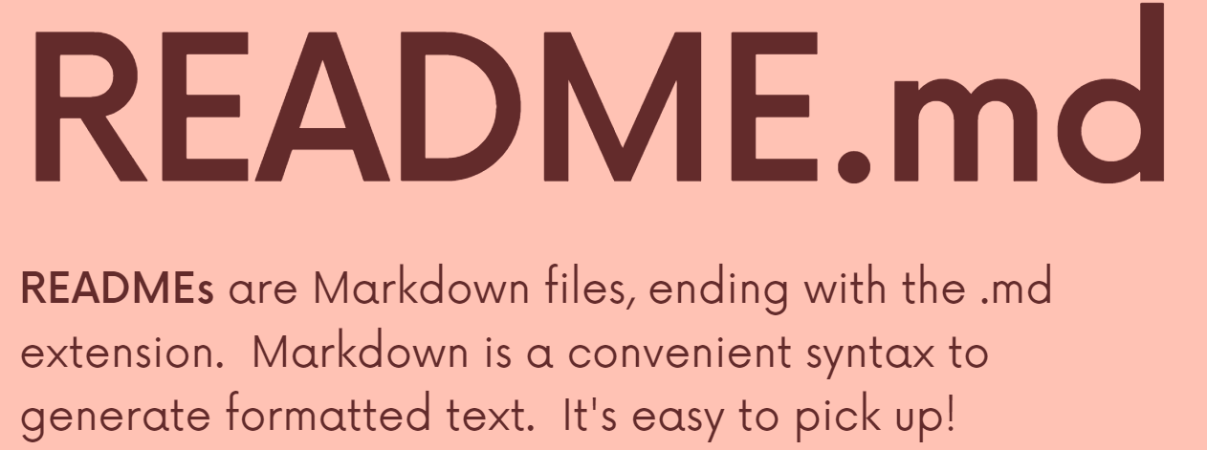

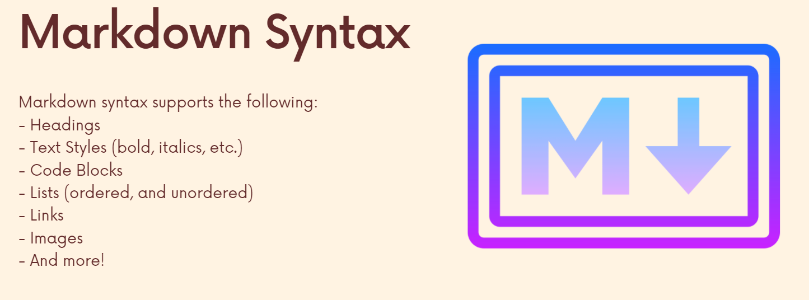

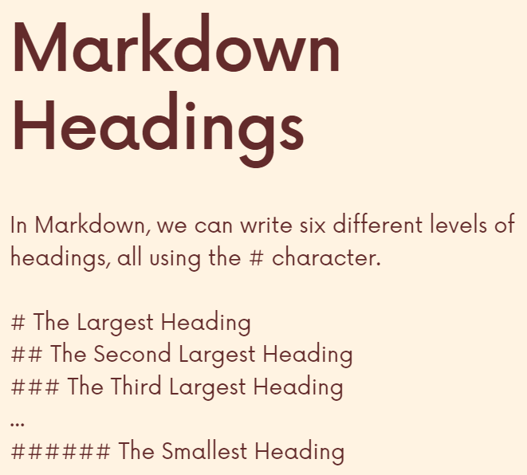

**Github Gists**

If we just want to share a piece of code and avoid creating the repo and all then we just use gists.

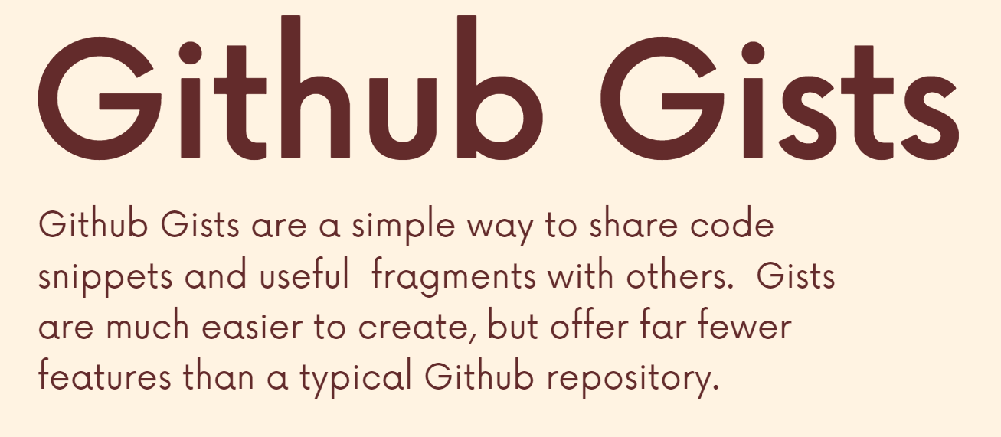

**Github pages**

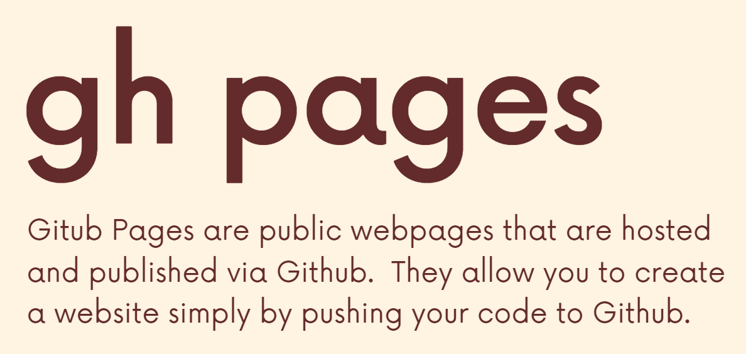

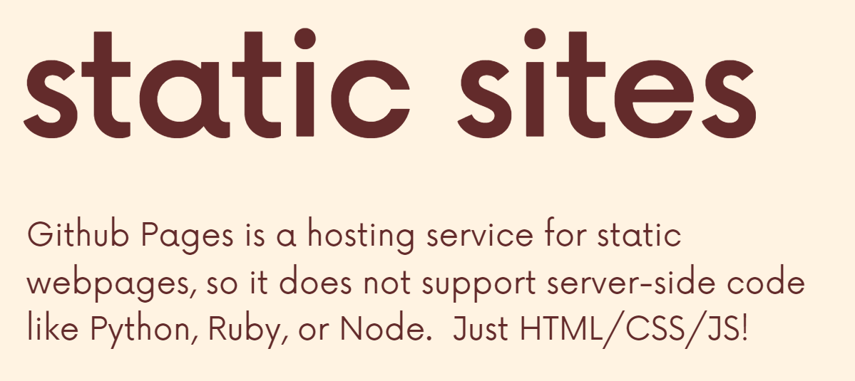

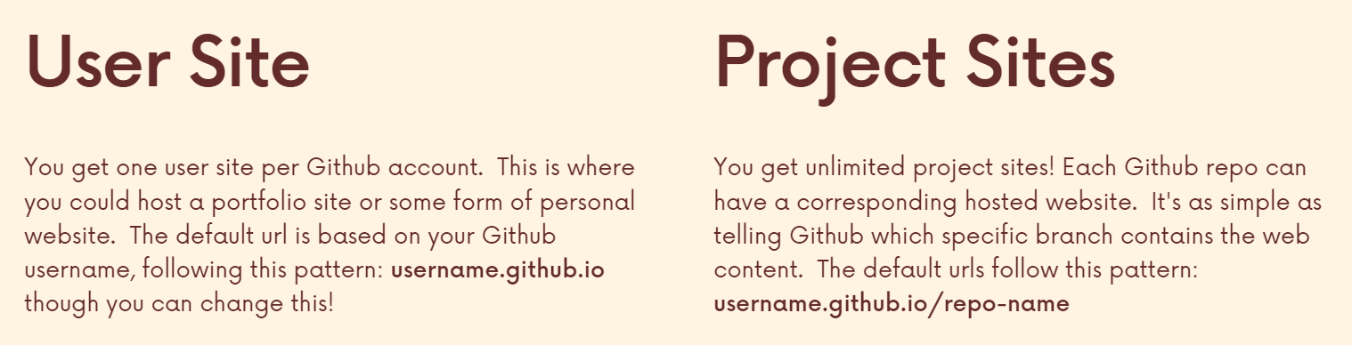

**Section 14: Git collaboration Workflows**

**Centralized Workflow**

The problem with centralized work flow is that if 3 people pulled from Github at a particular time and after that 1 of them committed 2 changes in his local repo and then pushed it back to github then when the 2nd person makes a local commit and tries to push it, he first has to pull the latest one from github. Similarly, if a person has an error and wants to push it so that his co-workers can check it, he has to pull the github and then push which will make the tip of the main branch error-faulty for everyone.

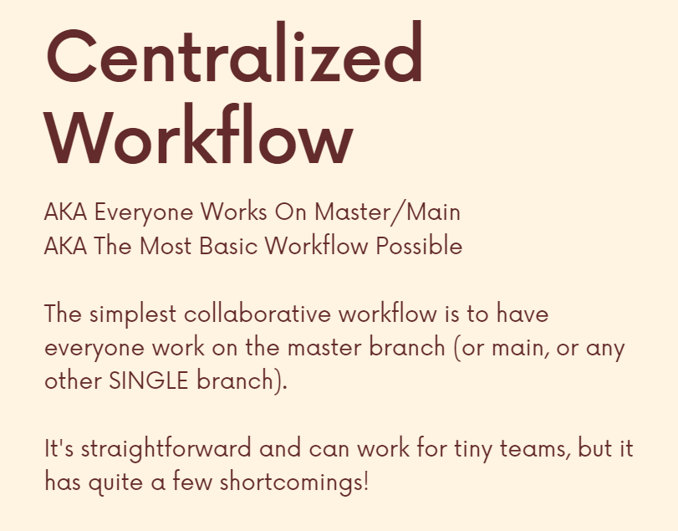

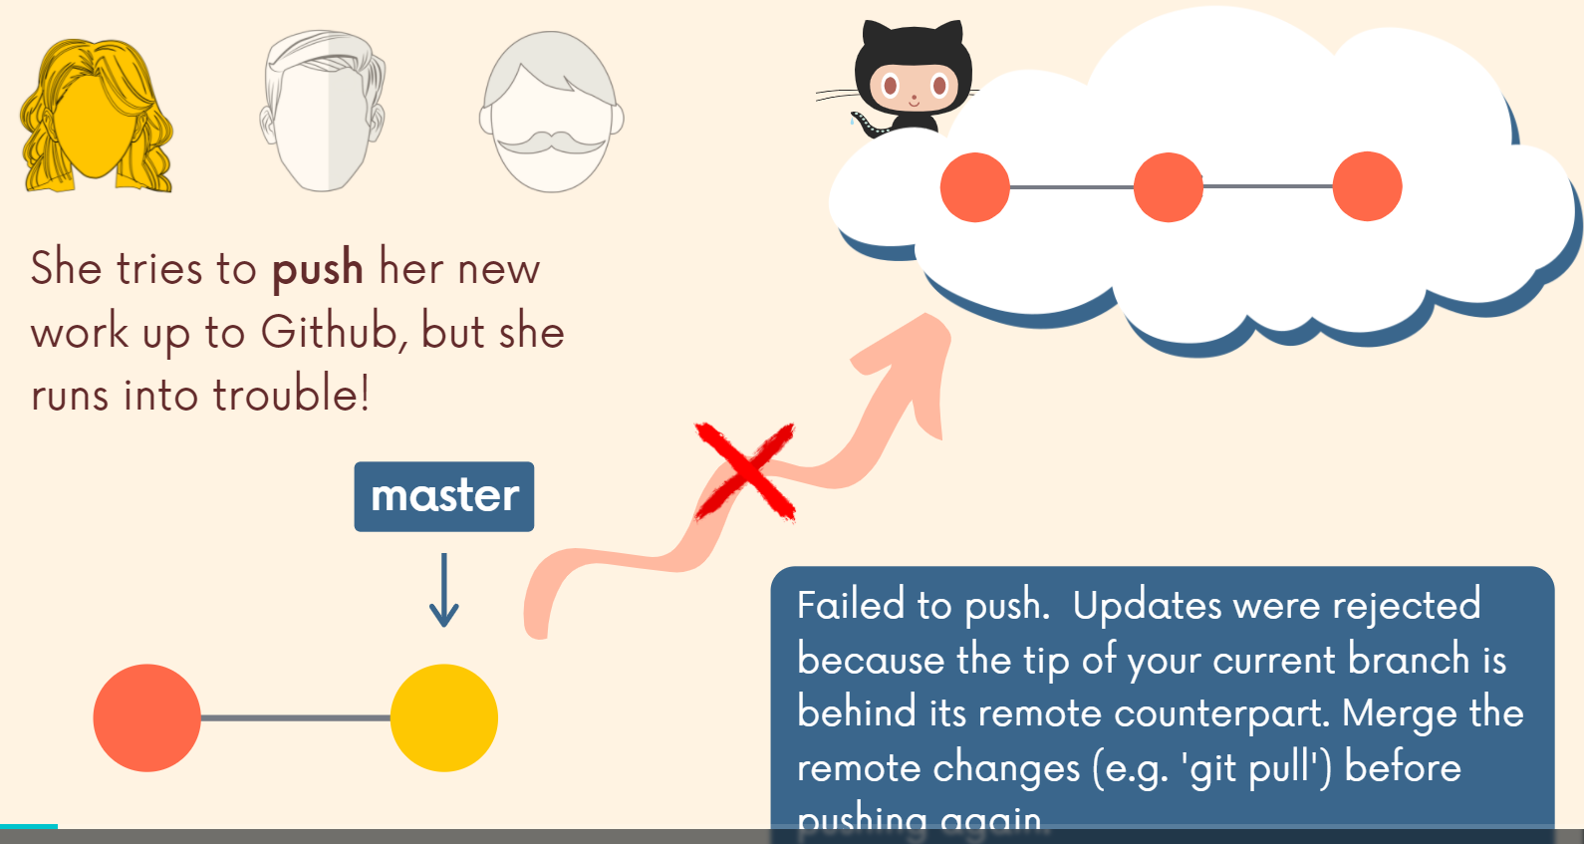

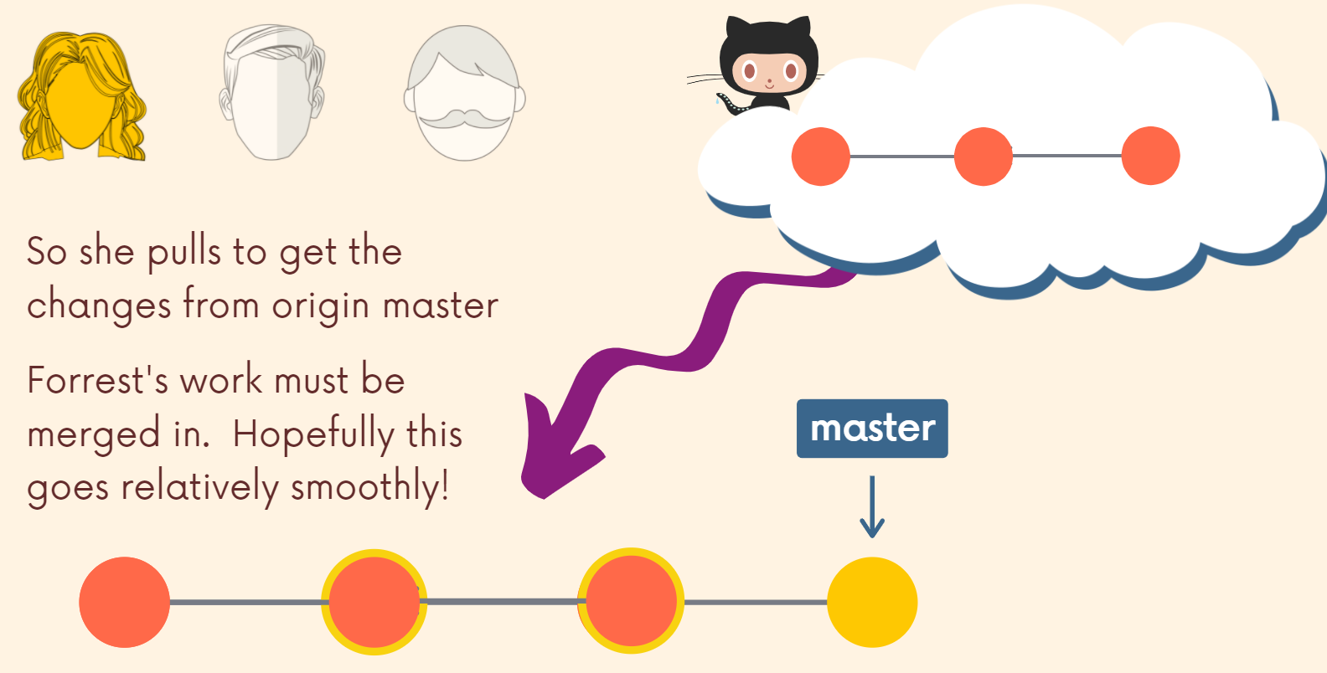

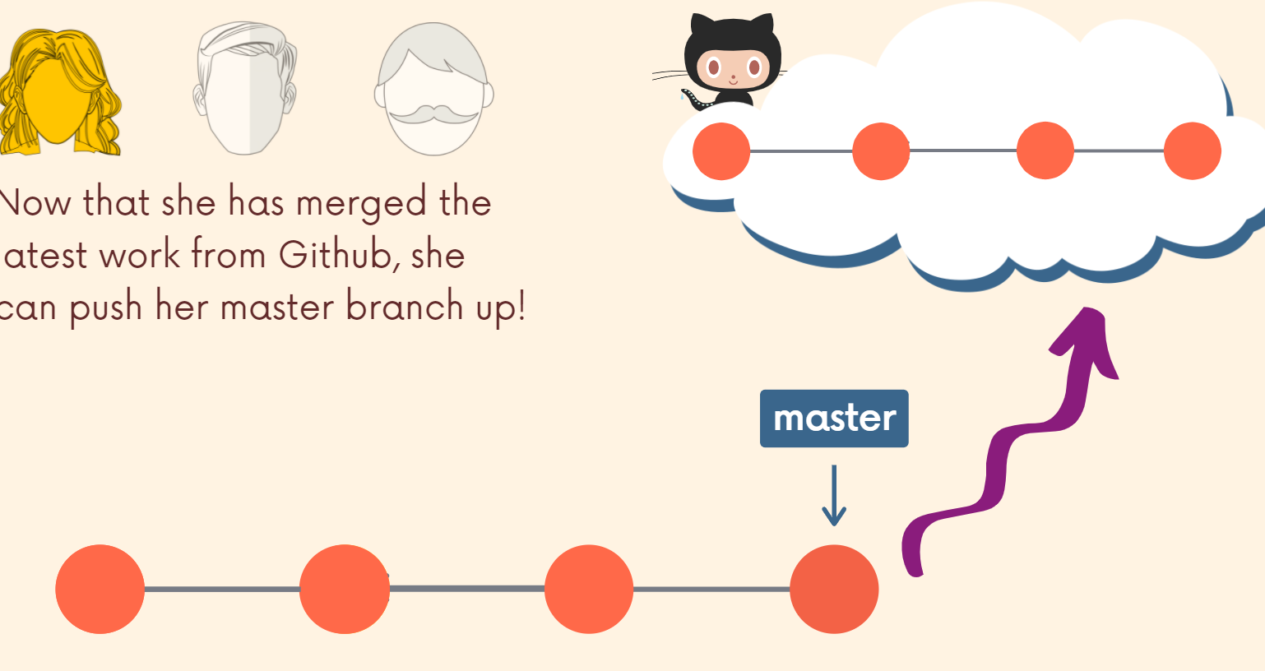

Also if someone has a problem with the code then: (branch tip has error now since he pushed error containing code)

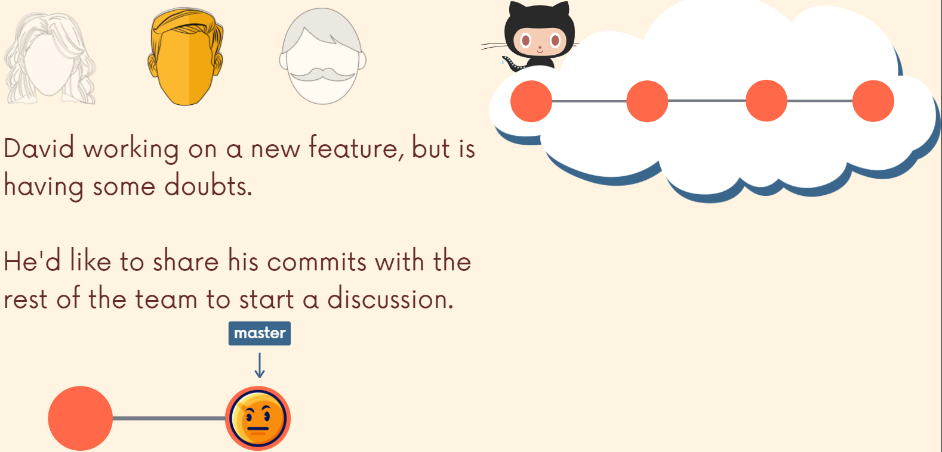

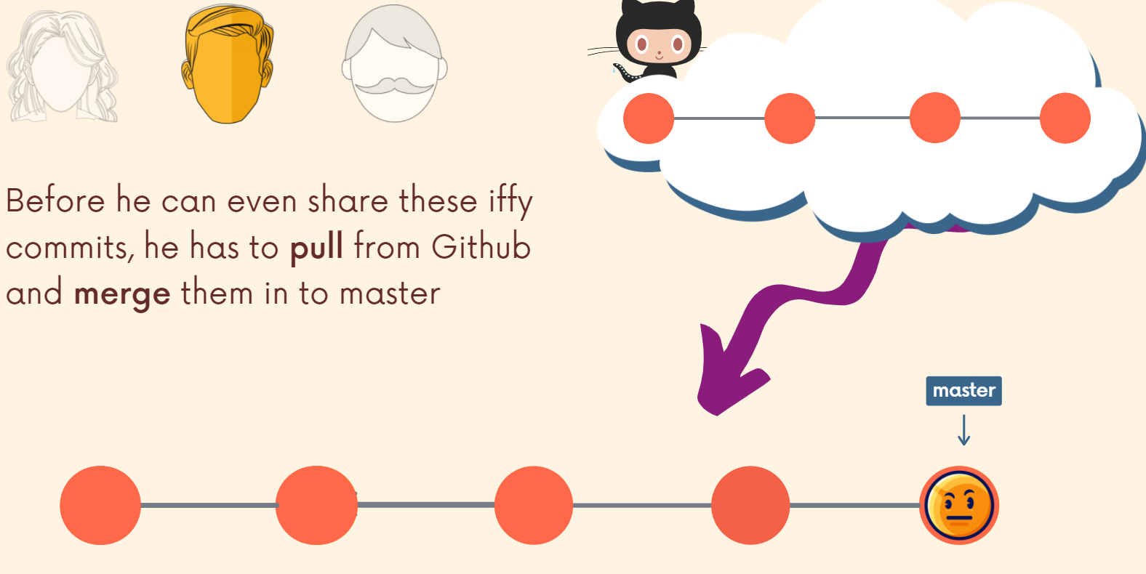

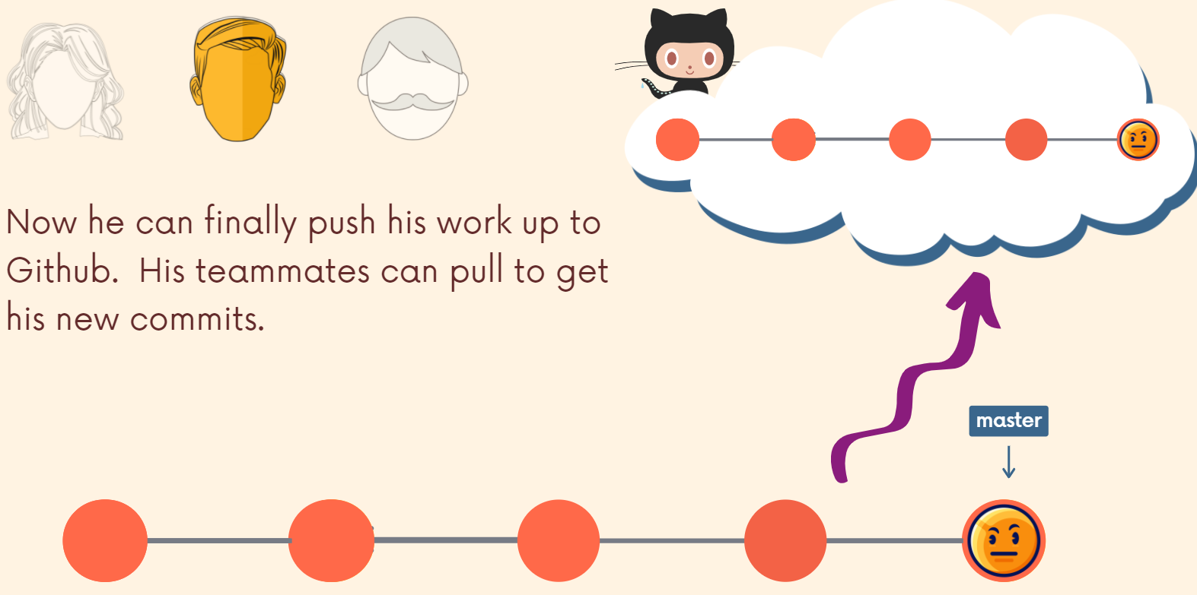

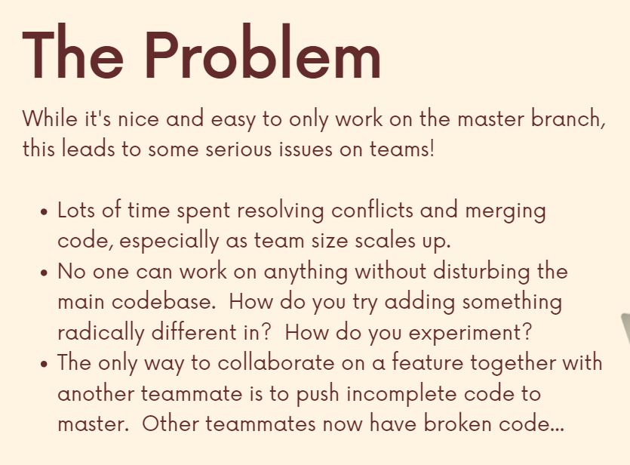

**Feature Branch Workflow**

If the centralized workflow is everyone works on master, the feature branch workflow is nobody works on master or main. You always work on a feature branch. This is a very, very common pattern. Rather than working directly on the master branch or the main branch or any centralized branch, all development, whether it's something tiny or some massive new feature or a redesign or a bug fix, all development should be done on separate branches. So part of this means treating the master or main branch as the official project history, the sacred branch that we don’t touch and we only perform work on these branches and merge them to main when appropriate.

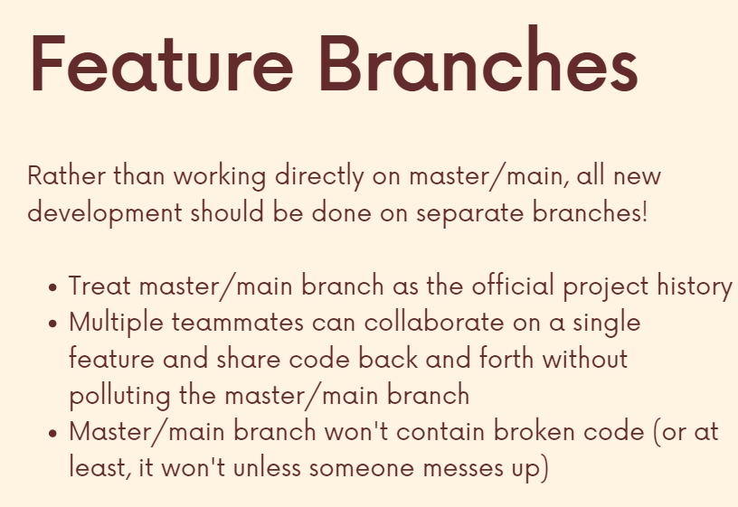

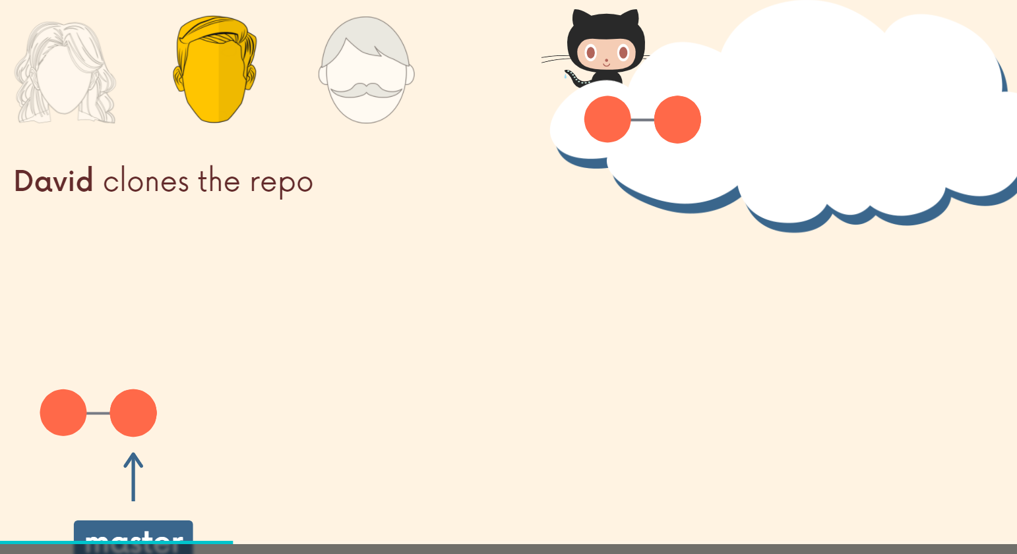

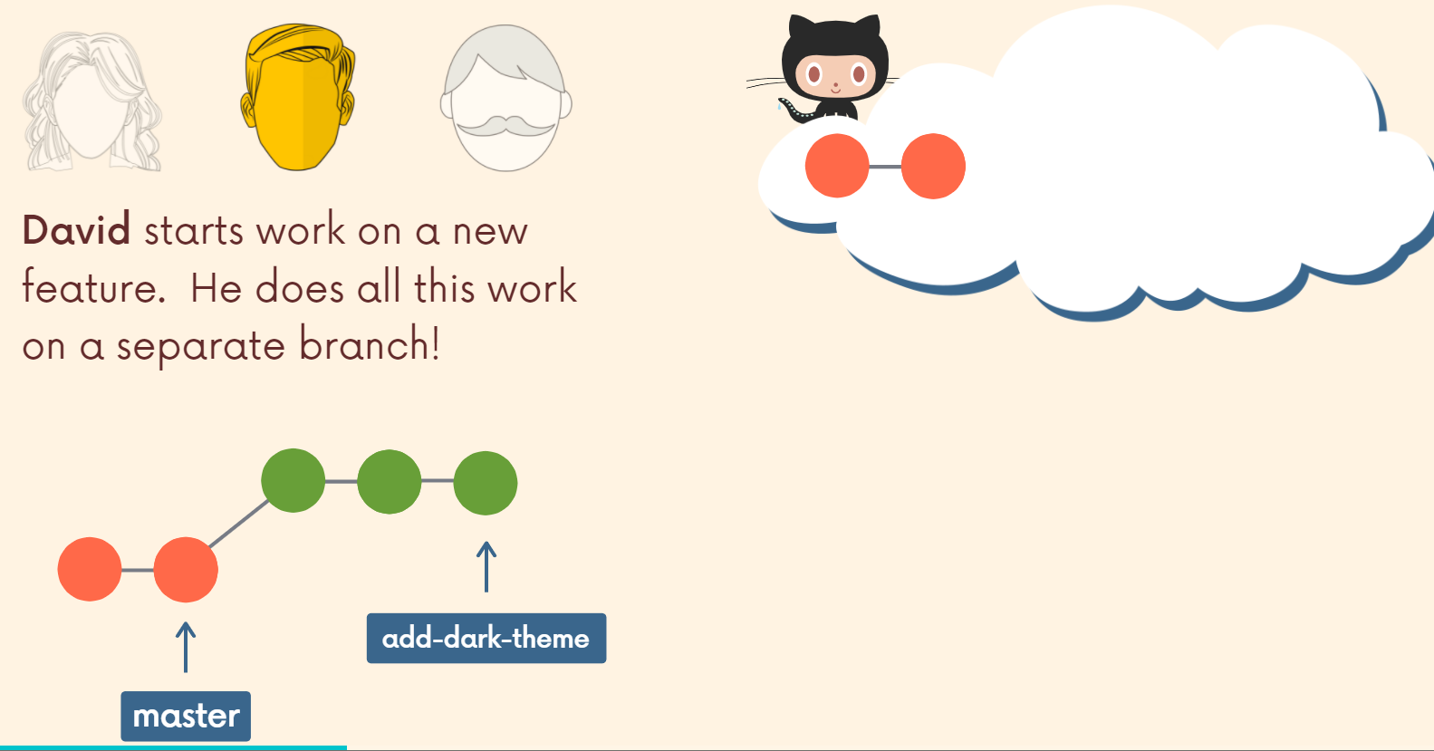

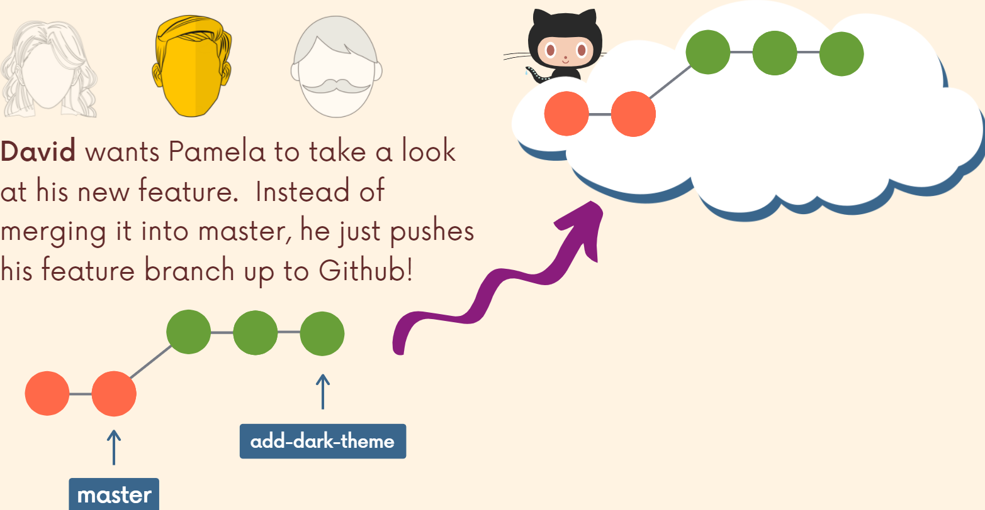

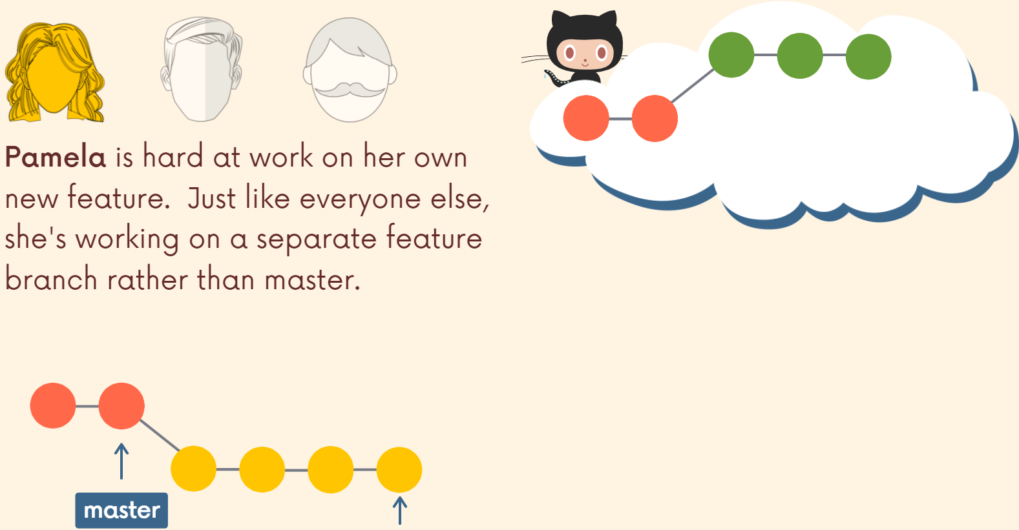

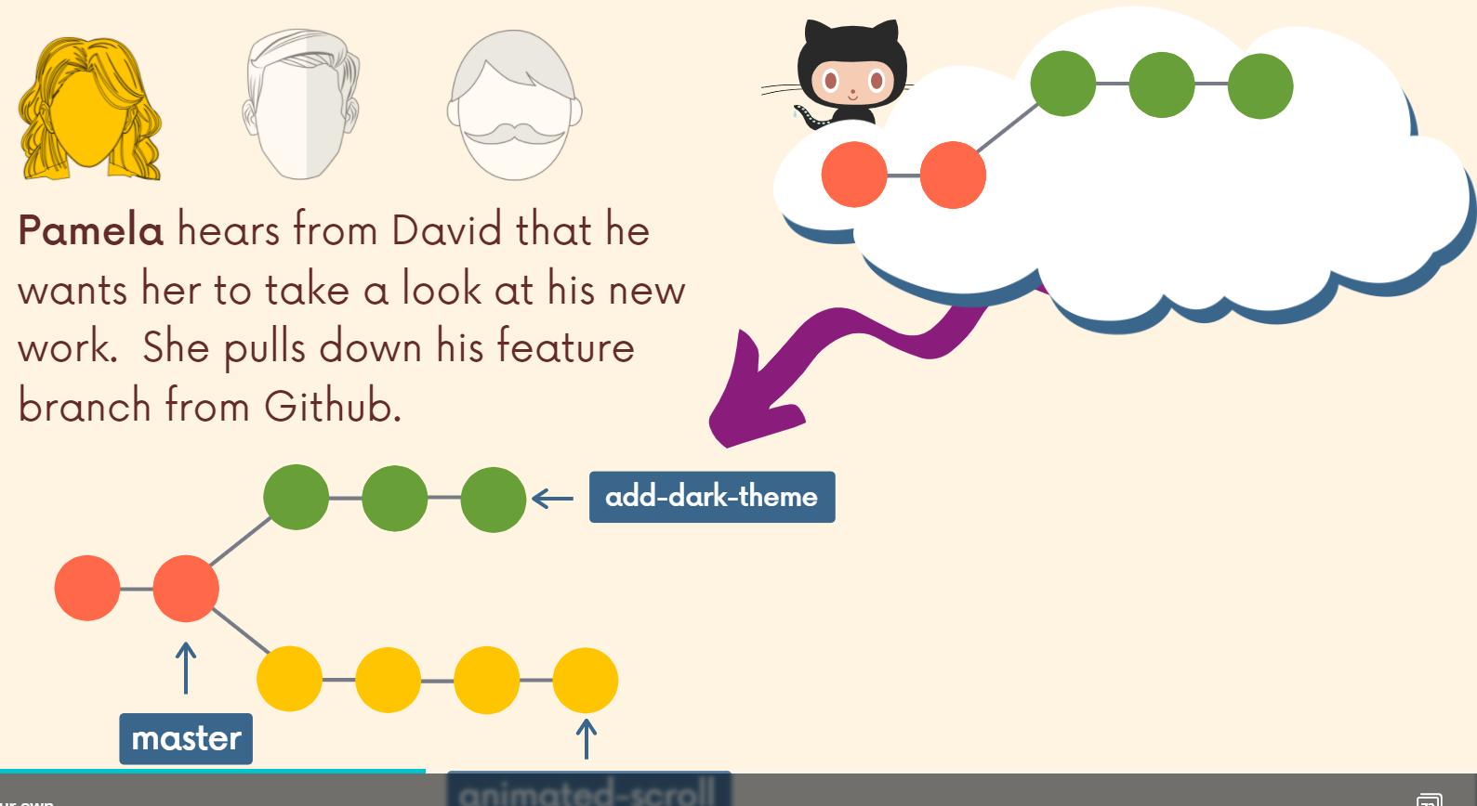

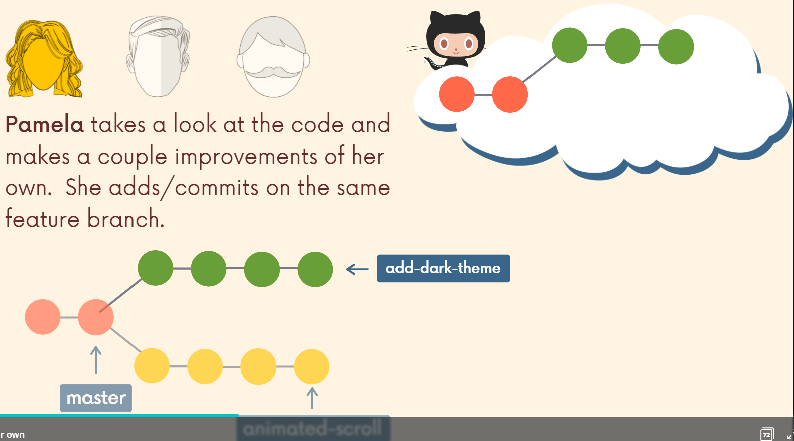

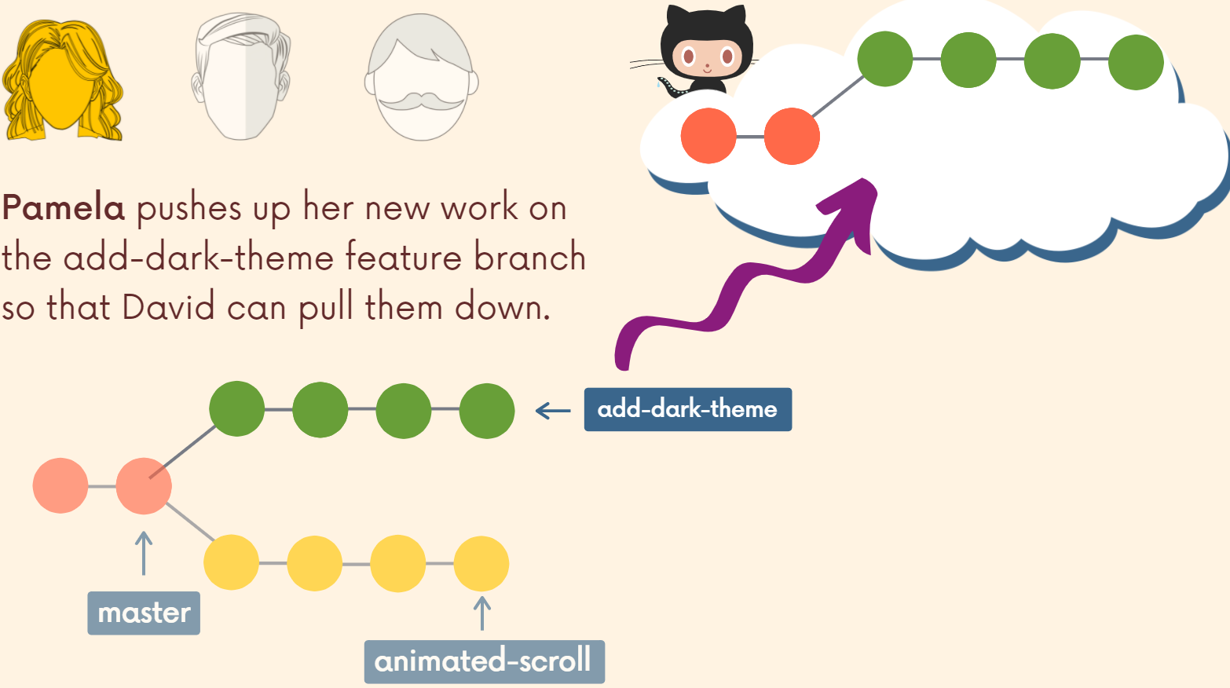

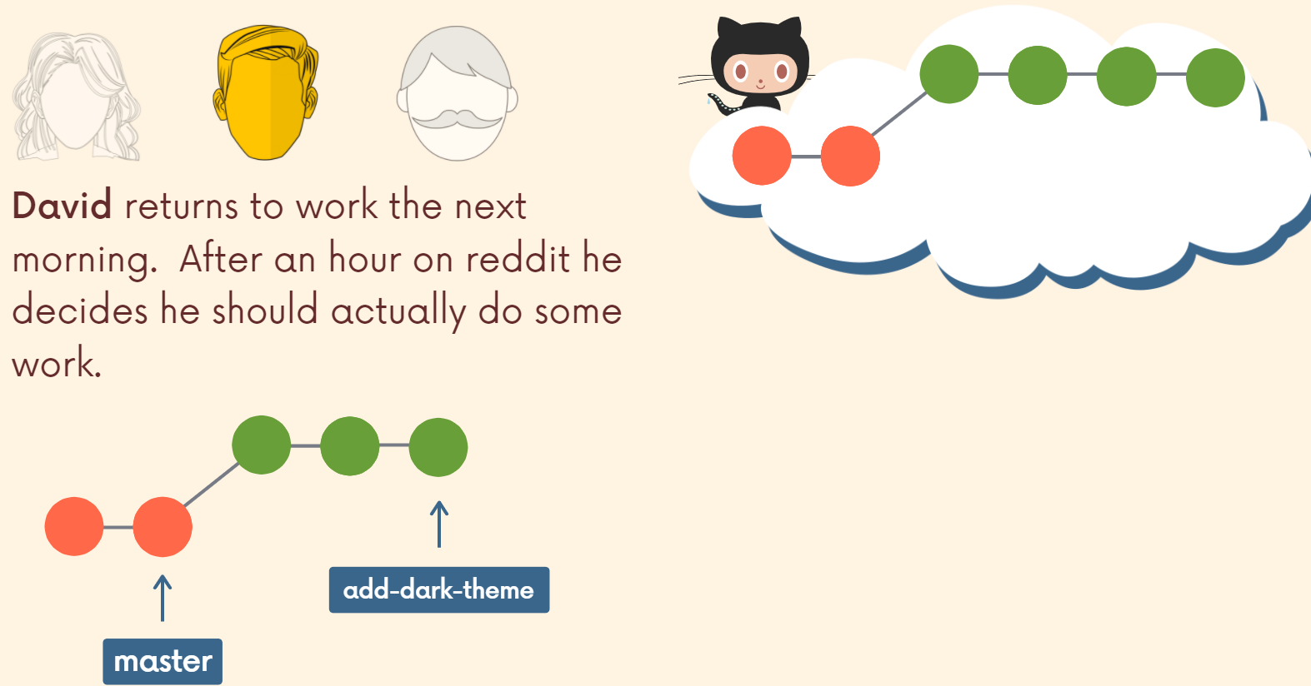

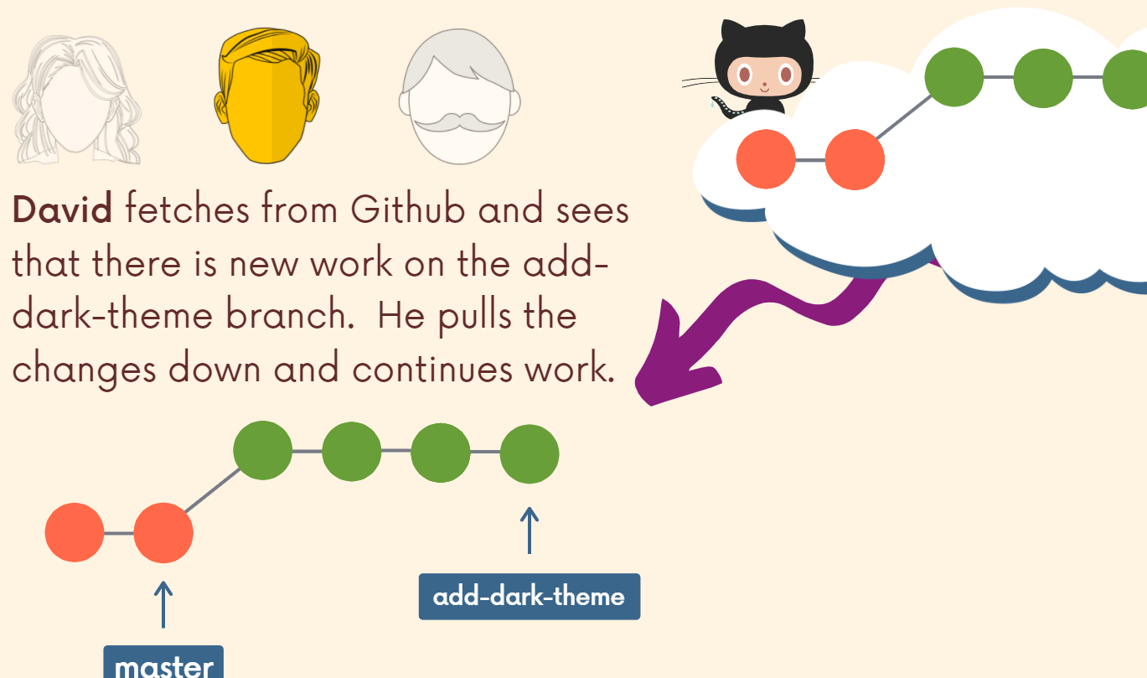

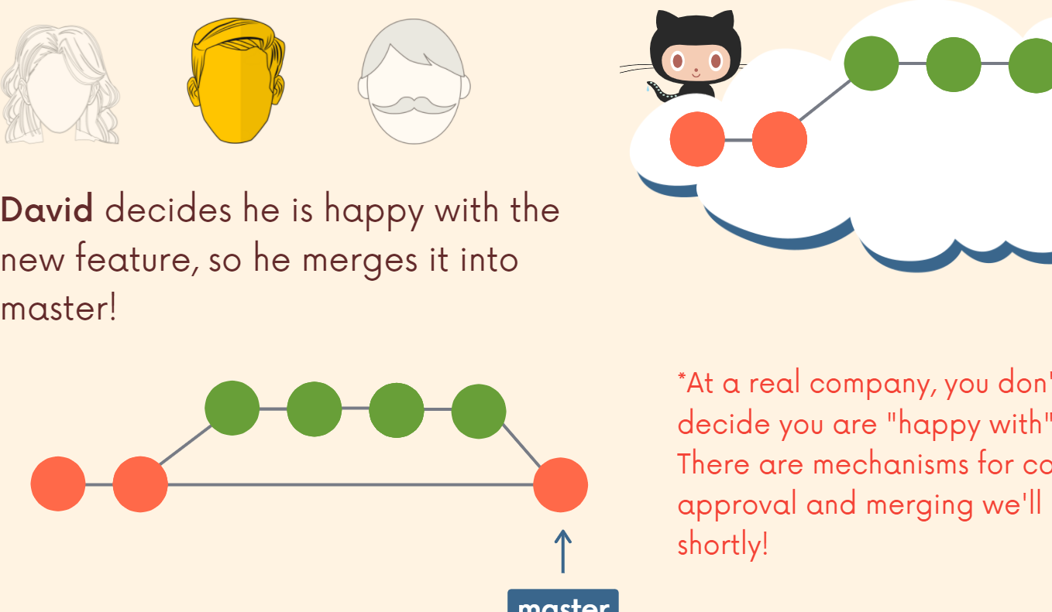

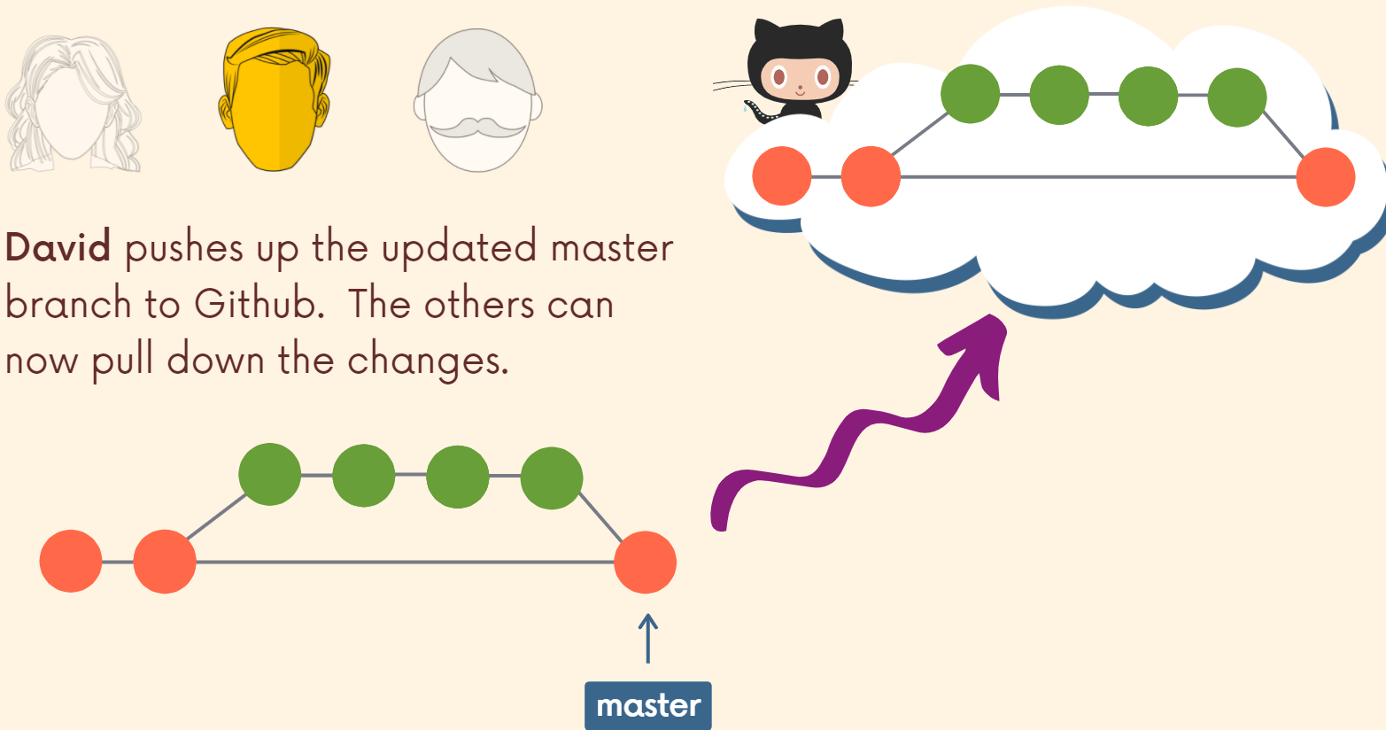

So that's the main idea, master or main or whatever you want to call it, you treat it as a branch that is not to be screwed with. It's the official project history. All work is done on separate branches and then those branches can be either abandoned or eventually merged back in to the official project history, whether that's master or main.

So that's the basic idea. We're working on branches that allows us to collaborate more freely. We can experiment, try radical changes. We treat the main or the master branch or whatever branch, some branch as the important golden child branch that we don't want to screw up. So we make feature branches, we make all sorts of branches. It doesn't just have to be for a new feature, but we make branches that we work on.

**Merging Feature Branches**

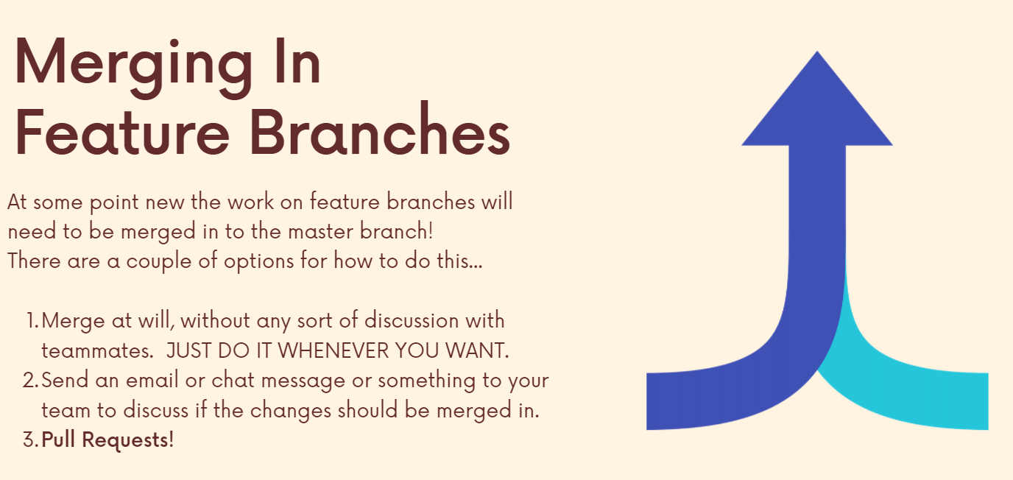

**Pull Request**

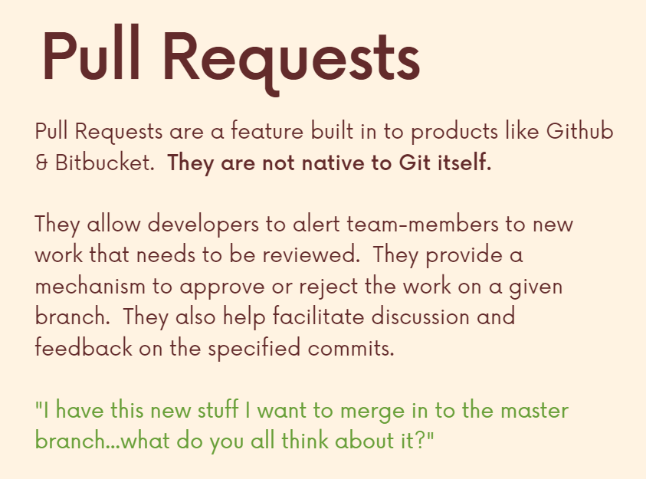

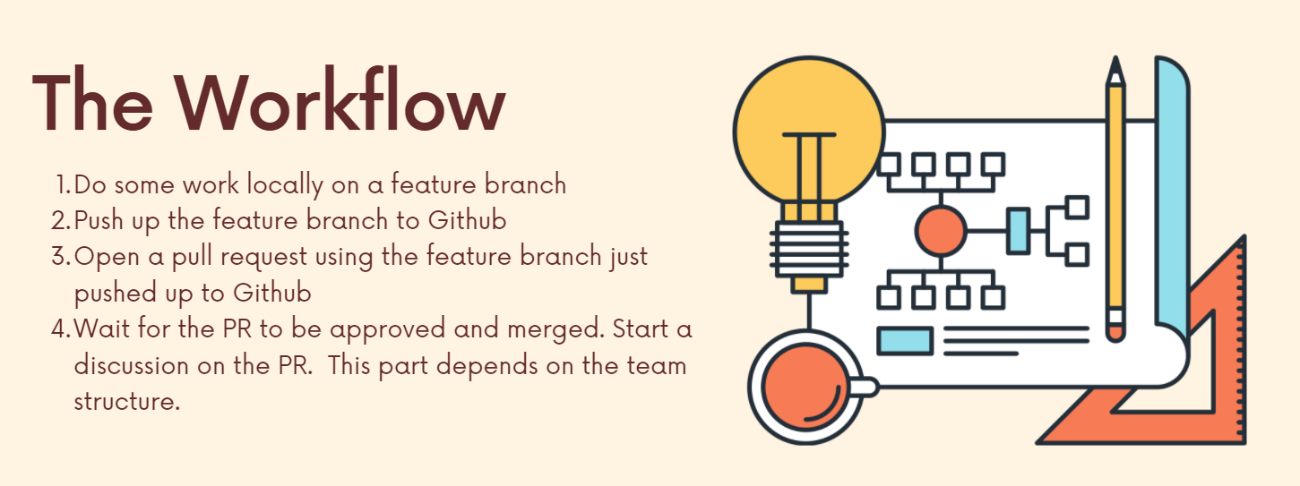

**Fork and Clone**

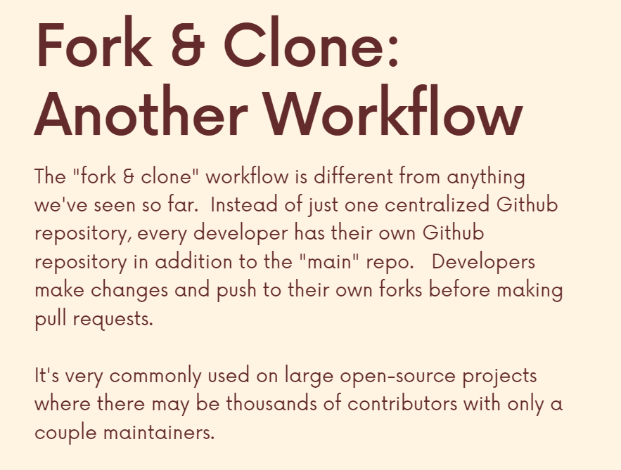

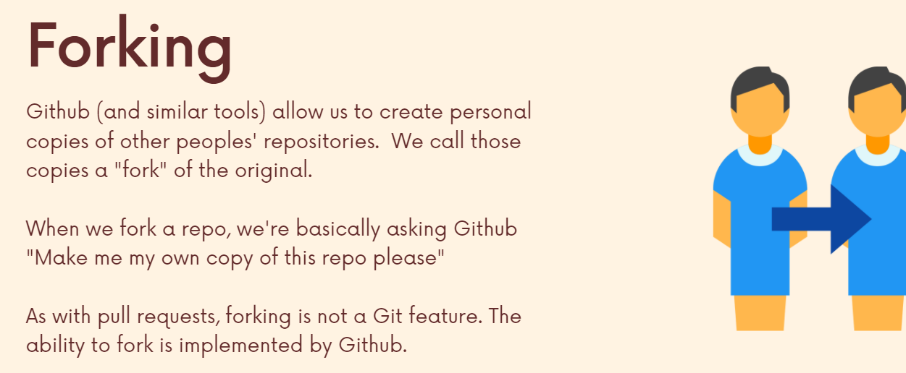

Forking is making a copy of the original repository and then we can do whatever we wish on this forked repo of ours.

Forking does is it makes us a copy of a GitHub repo on our GitHub account. Right. It just makes a copy that we have access and permission to do whatever we want with. But that doesn't mean we have it on our machine.

We can clone a repository from github and then get it on our machine locally and perform some commits on it. However, we wont be able to push these back since we are not a contributor. Hence, if we wish to display our own code on github, we first fork it, then clone it and then we can push changes to it (because we own the forked repository).

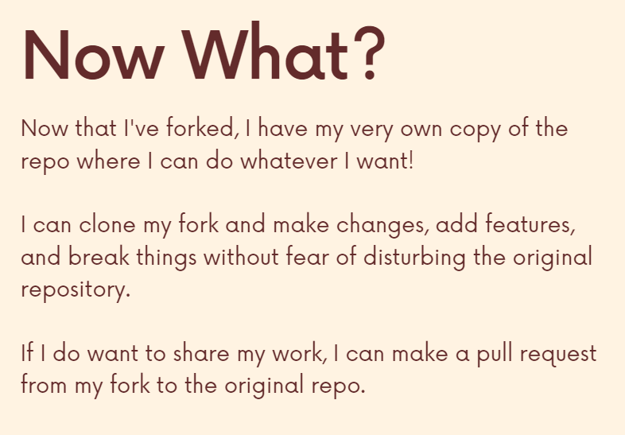

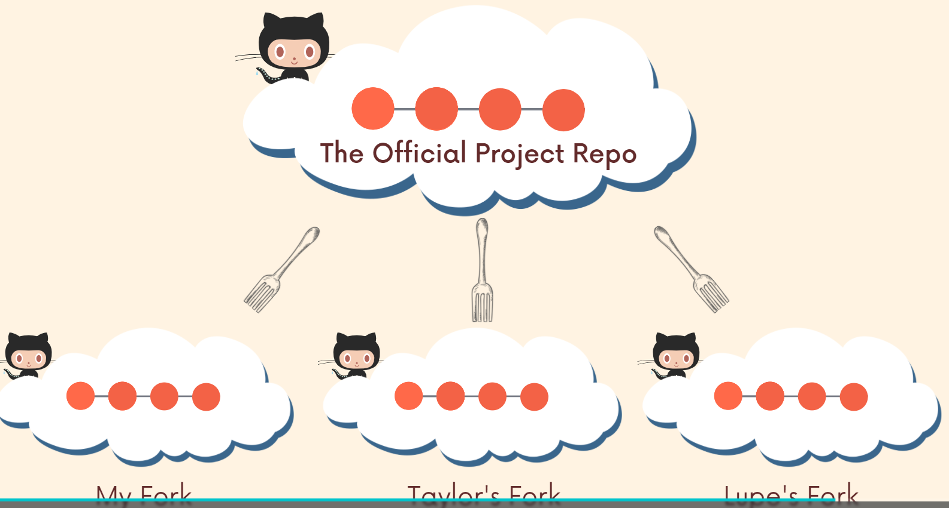

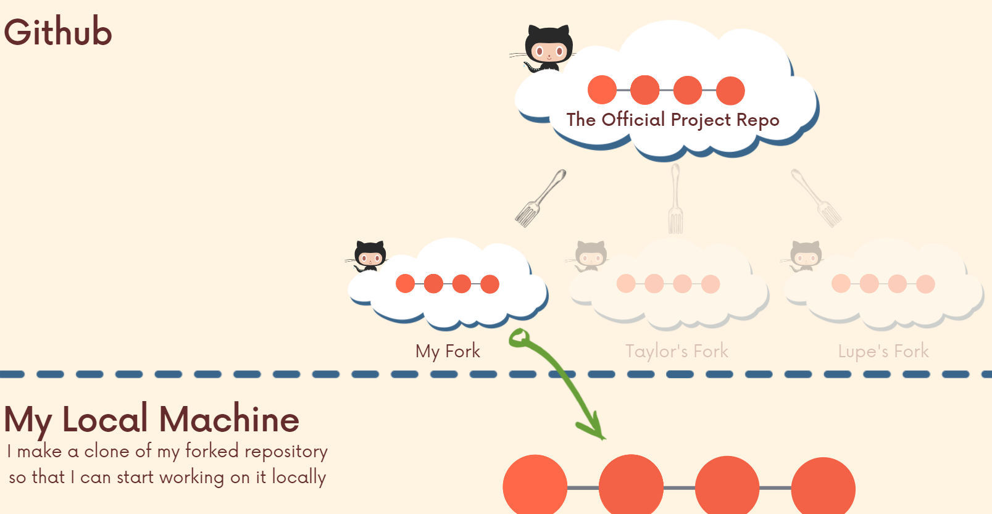

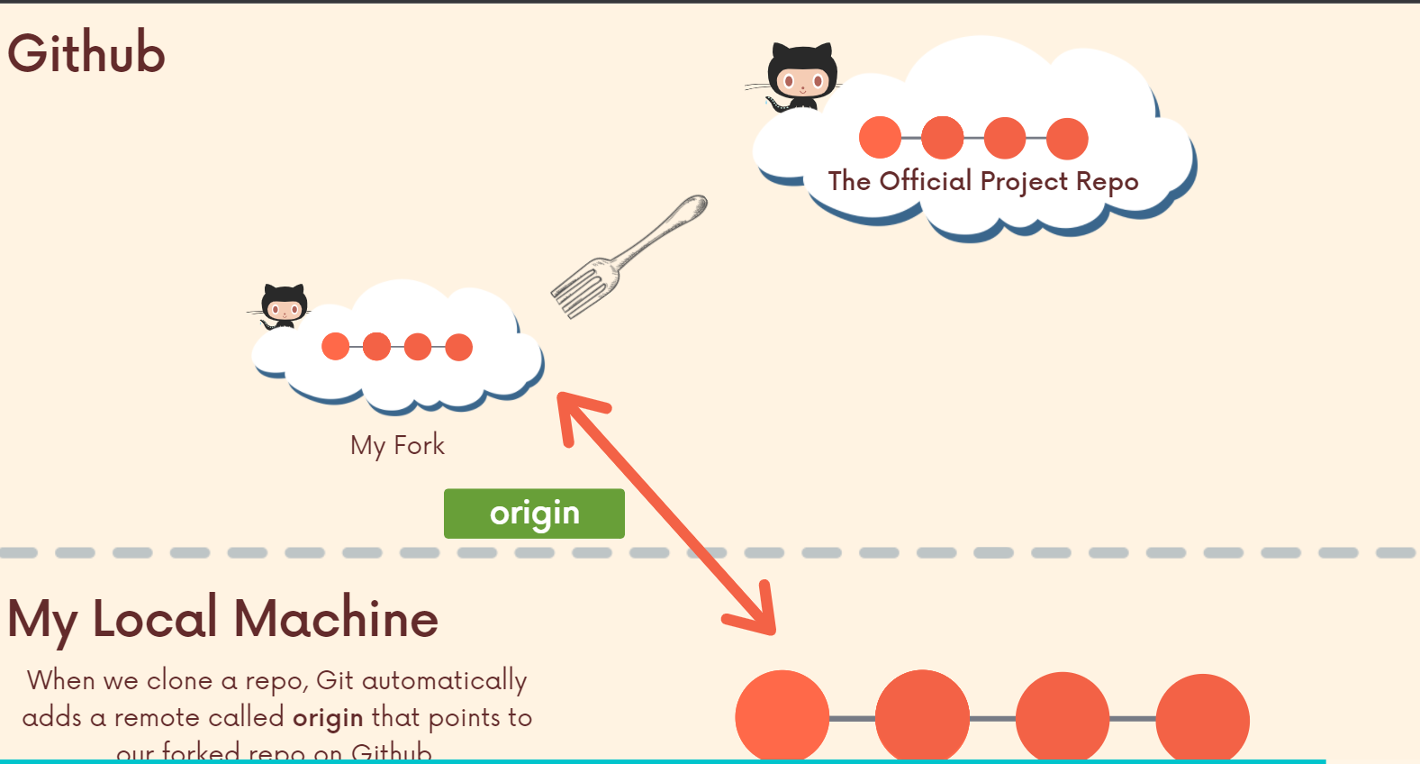

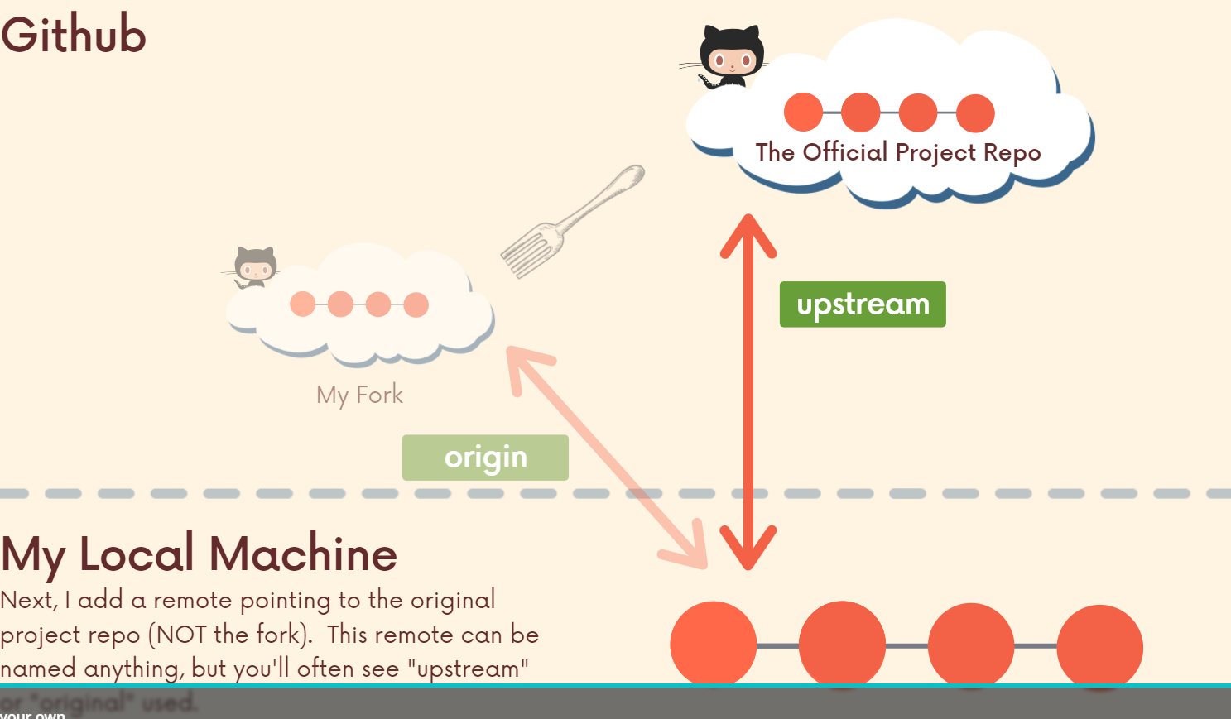

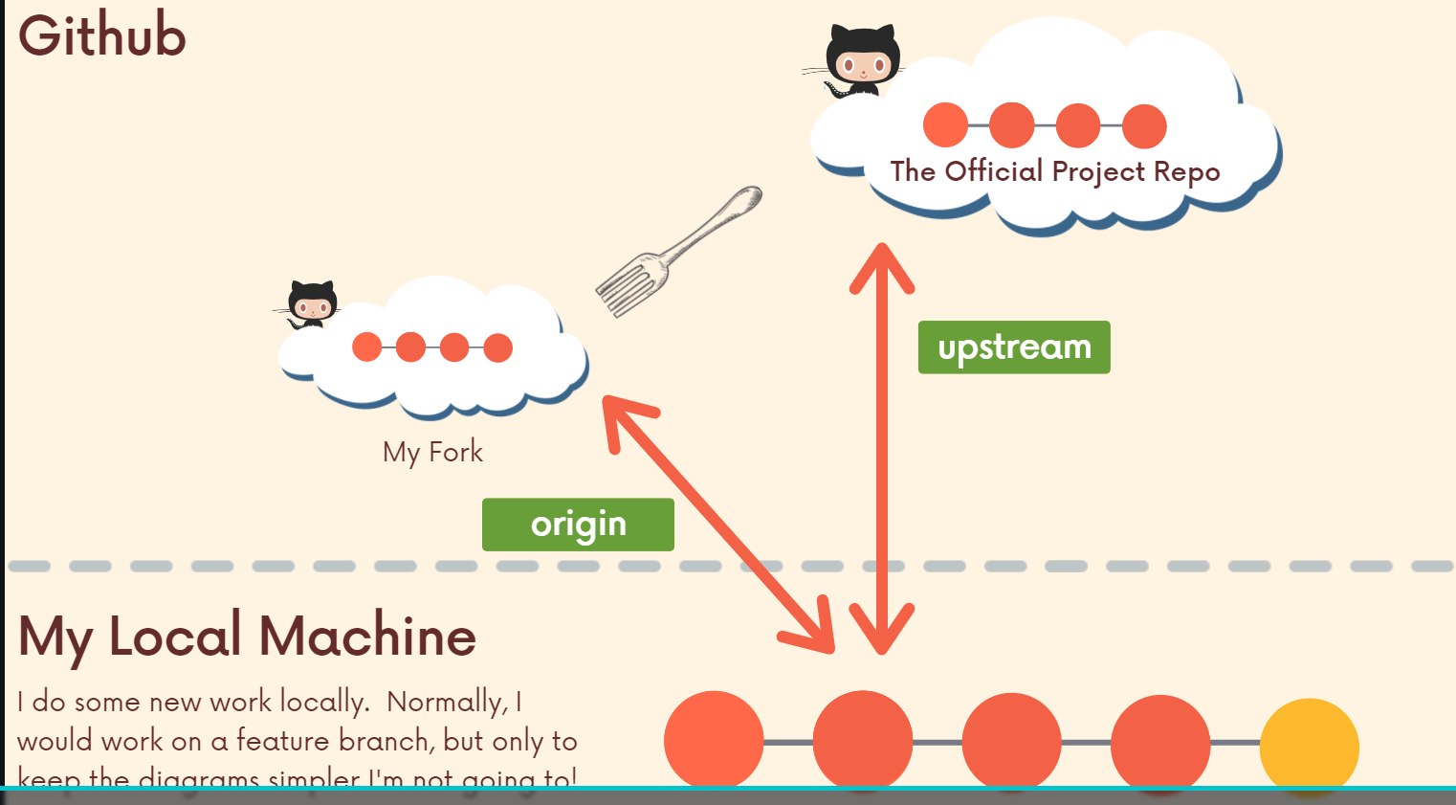

We have set up 1st origin remote so that we can push changes to our own forked repo. However, we have set up a 2nd remote so that we can get the latest commits (if done) on the open source original repo (even if I cant push up to the original repo, I can pull changes down from it).

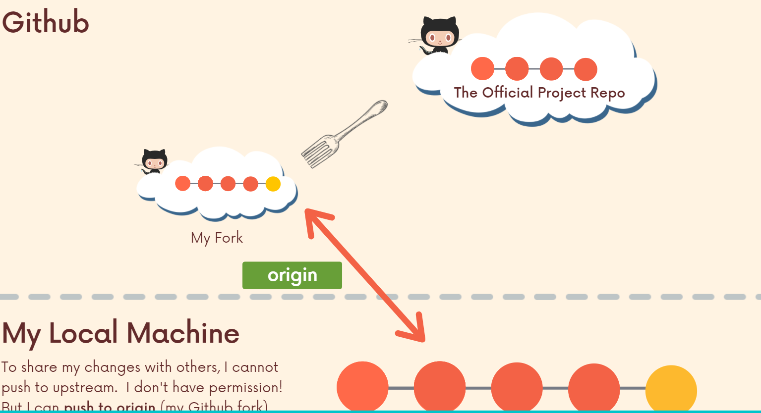

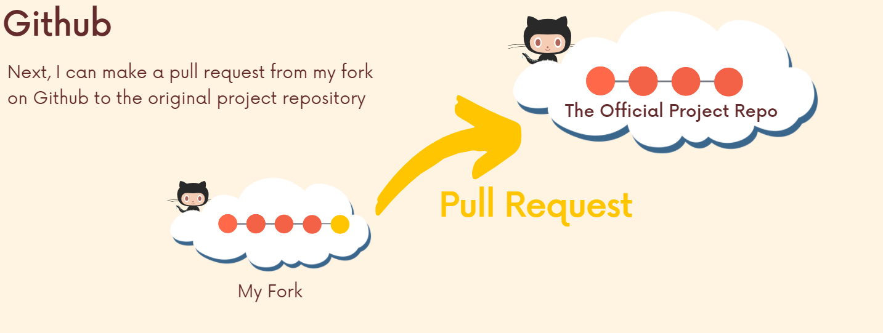

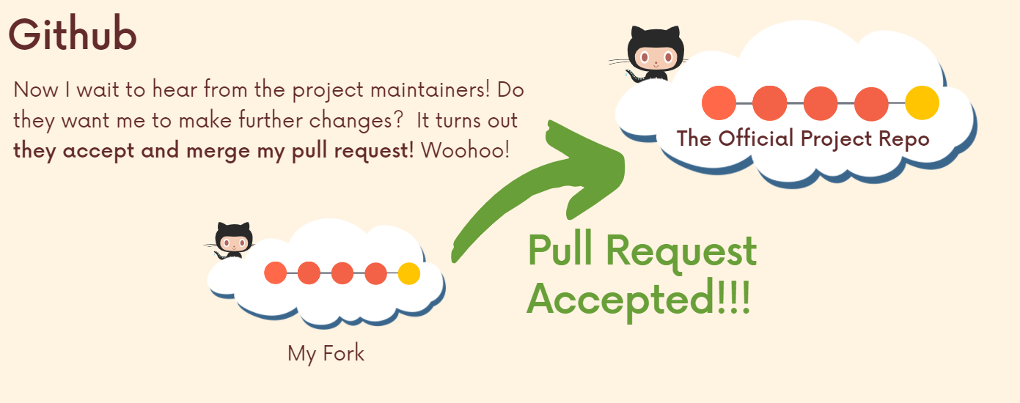

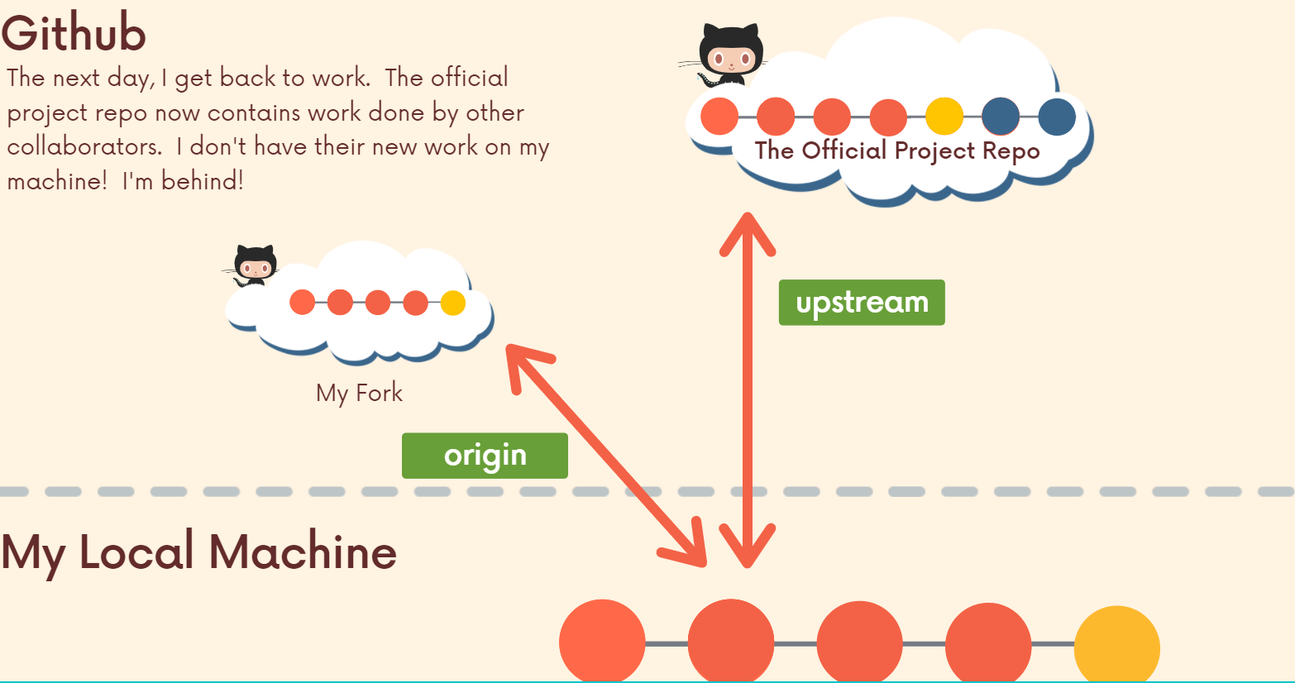

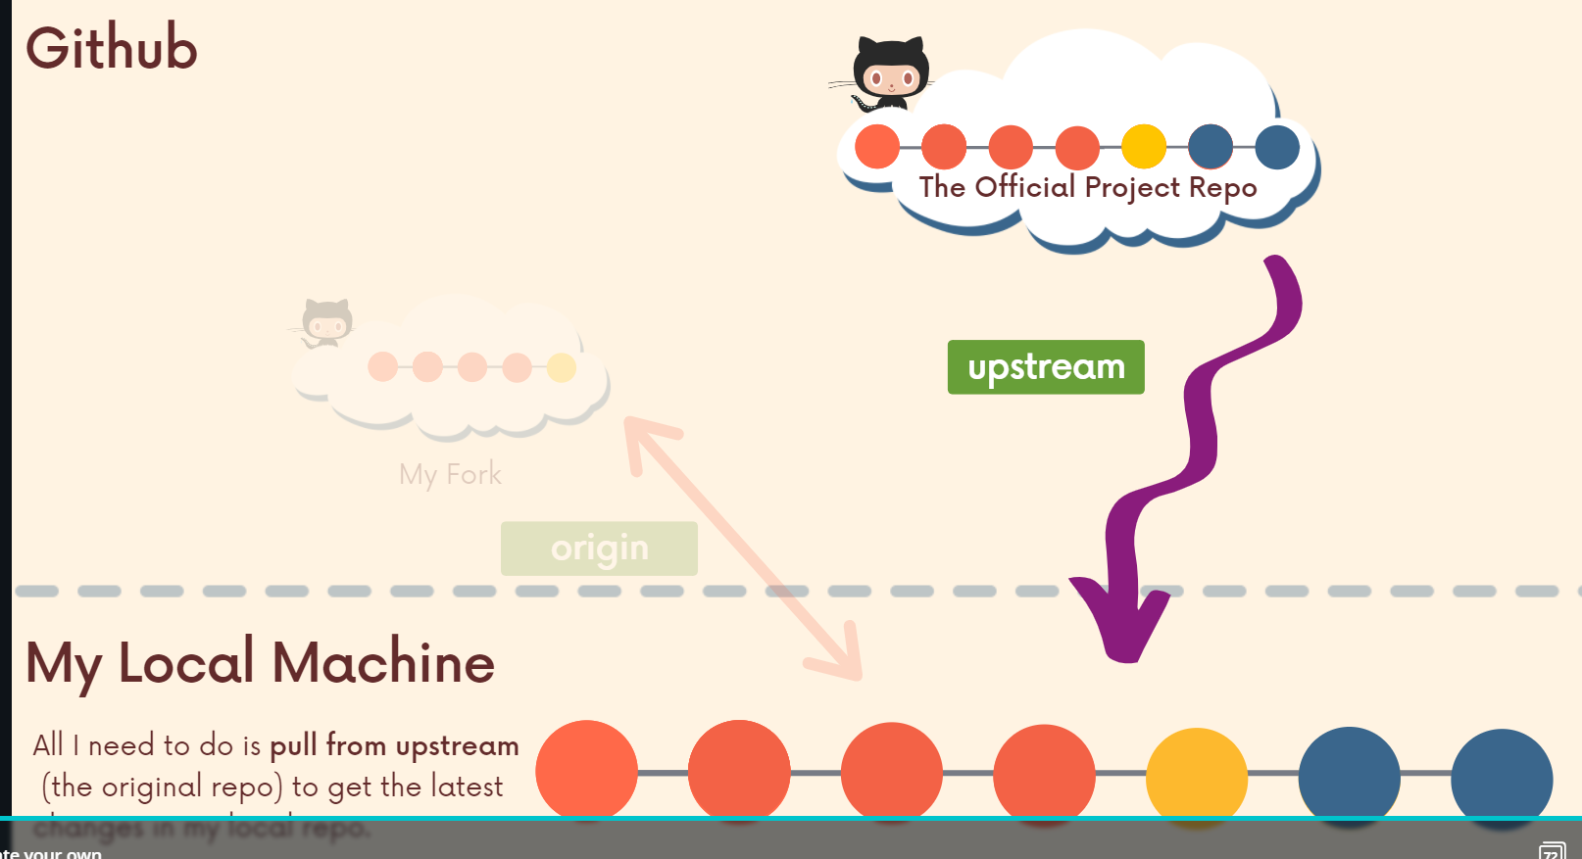

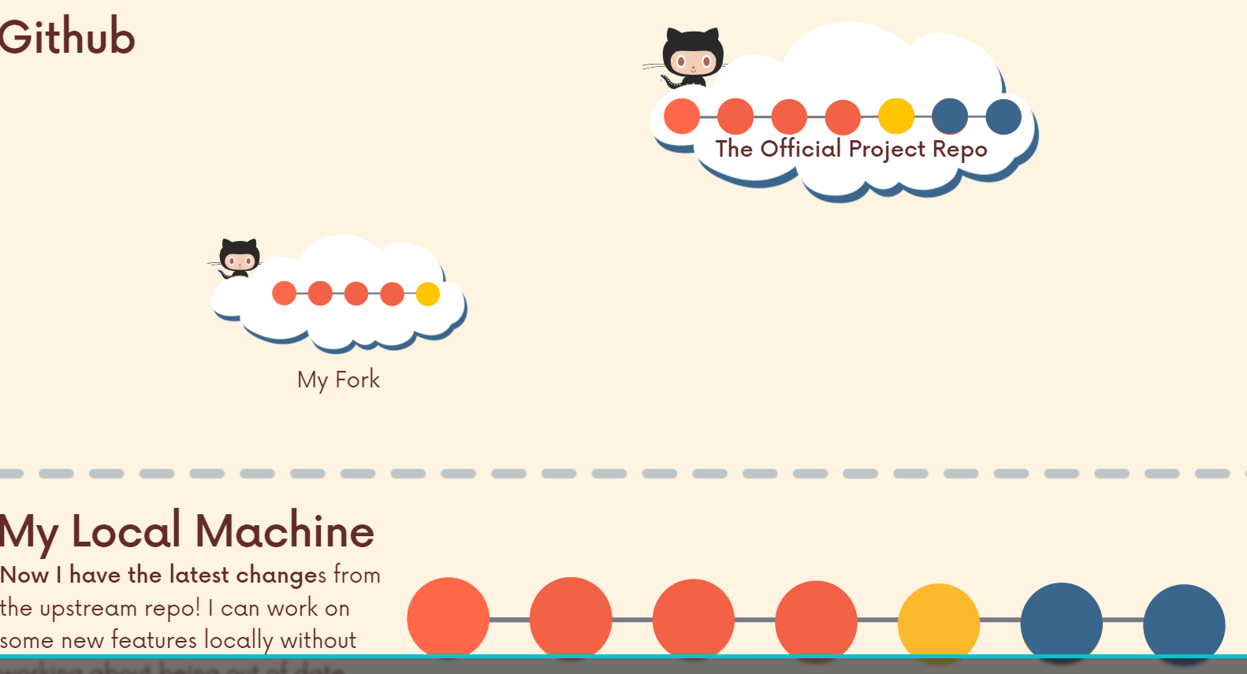

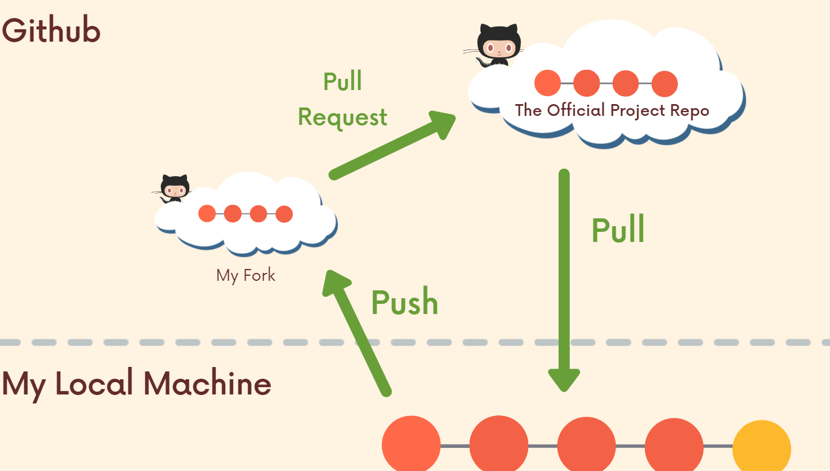

We make changes to our fork and then we can make a pull request to the original repo.

The whole point of this workflow is to allow people who don't have direct access, direct permission to push or to change anything in a project repository. They can still collaborate. They can still make requests by forking and then pushing their changes to their fork and opening up a PR from the fork to the original.

We'll wrap up by just talking about why this is a good idea. In some situations, this is not a workflow that you may want to use on every single project that you're working on. But again, at a larger scale where there might be some project that thousands of people might be interested in working in, or even if it's just two or three people, but you don't want to give them access directly to your repository, people can still make these suggestions. They can make their own changes and hope that you merge them and they can make a pull request from their forks. So this allows us to work with tons and tons of people without having to have direct collaborators added to a repo.

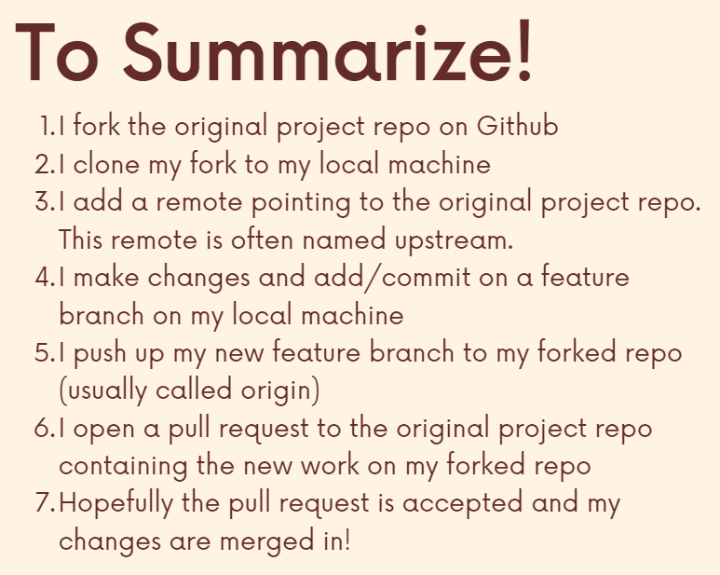 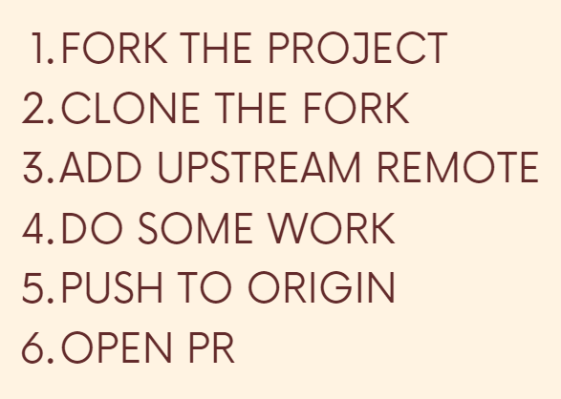

**Section 15: Rebasing**

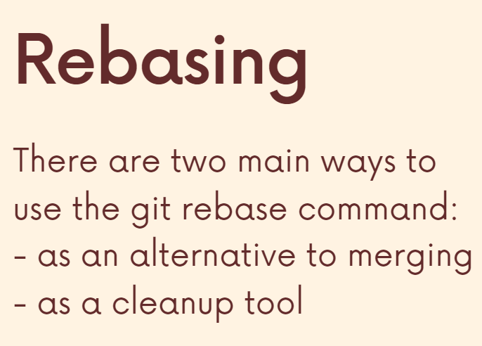

If we have a master branch which is very active (merging keeps happening on it from the feature branches) and meanwhile we are working on a feature branch then, we would want to get the latest branch commits with us ASAP (maybe theres a big fix and also I don’t wanna diverge from my master branch for a very long time). However, to do this we always have to make merge commits which can potentially lead to a large number of unwanted commits which makes our history less clean.

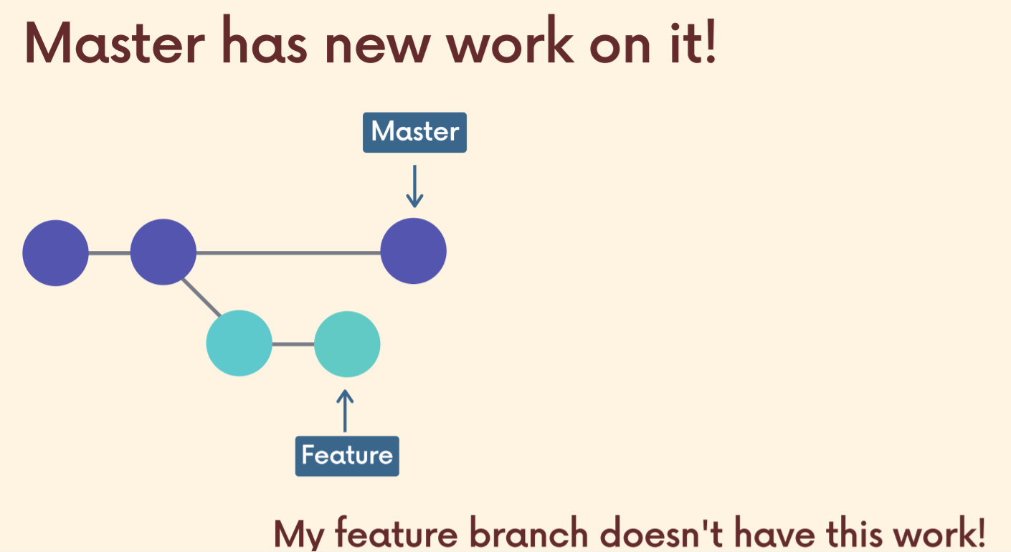

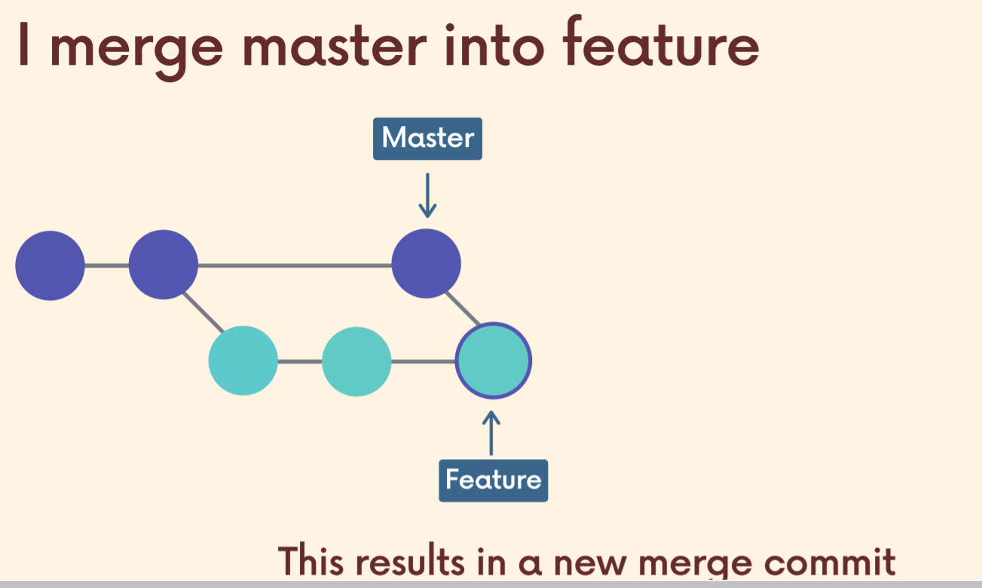

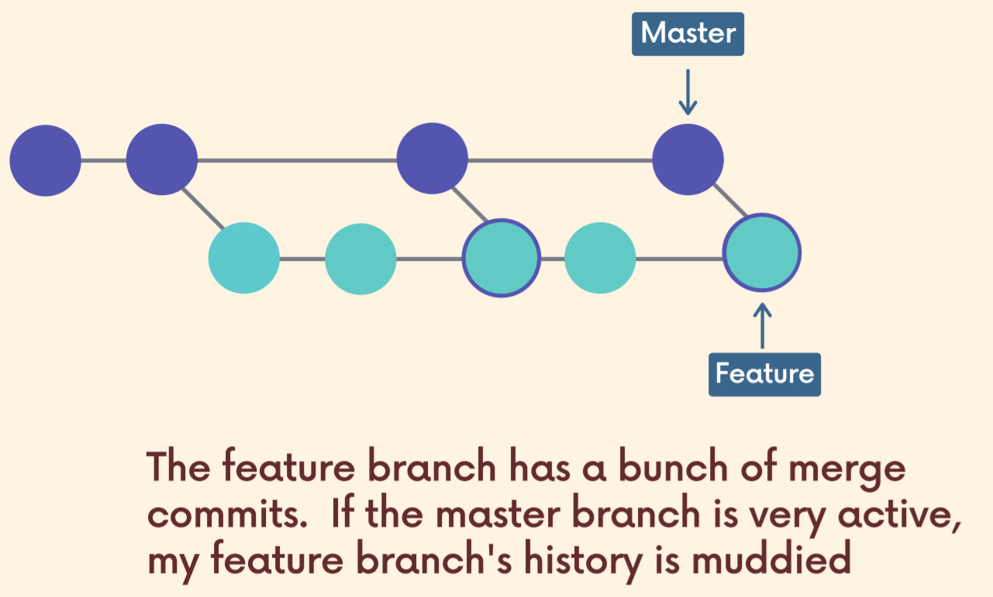

There’s gonna be a large number of useless/unwanted merge commits when we finally merge our branch with the master branch. That makes our commit history dirty.

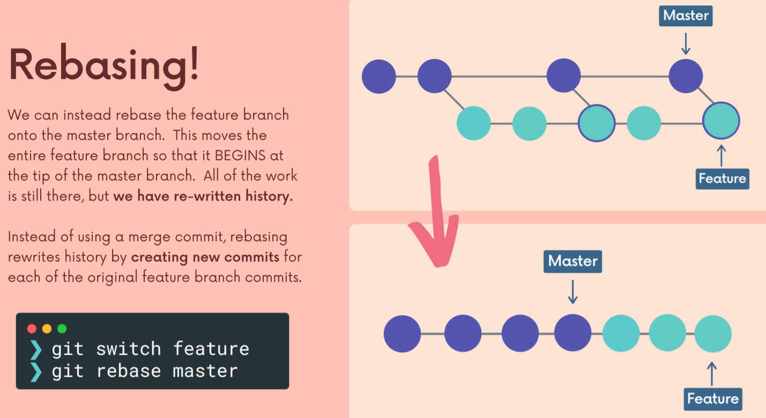

So I have my feature branch and then I want to get the changes from master, combine them with feature those new commits I can rebase in order to end up with this structure. My feature branch has a new base at the tip of the master branch. So it begins where master ends and we end up with this nice structure, linear. It's cleaner and it's more focused. Right. The history here, someone can see very quickly. These are the commits had to do with my branch and the changes I made versus here. Those commits are still there, but there's these merge commits that are in the way. So if we multiply that by 10 people working on feature branches, merging all the time, that's a lot of merge commits.

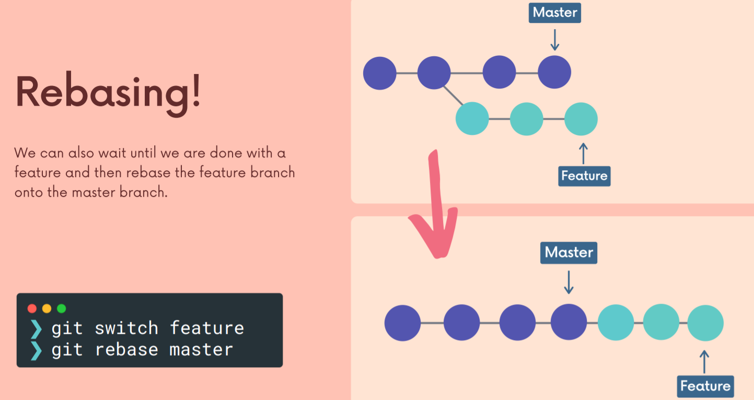

We use rebasing because with merge commits, as I keep working on my feature branch and people keep adding new commits to master which I have to get in my feature branch using merge commit then, when I access the history of my feature branch, its gonna be spoiled with a large number of useless merge commits.

Now, this isn't a huge deal, right? It's not the end of the world, but on a really large project with lots and lots of commits, it can be way nicer if you have a clean commit history or a clean project history where the commits are grouped together in a logical way and you minimize the number of those merge commits. So that is what rebasing helps us do.

We use rebase so that we don't end up with these merge committees, but instead we end up with this nice linear history by rewriting it.

Time to use rebasing…

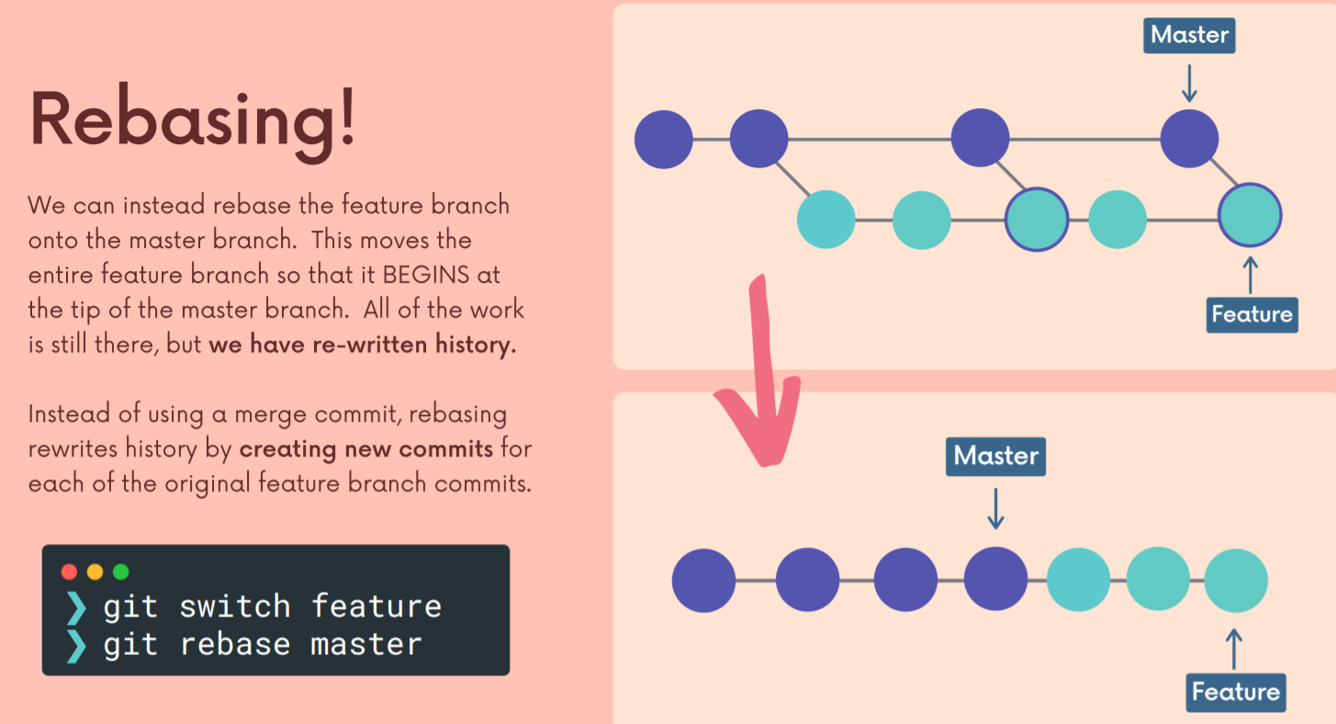

I want to be on my feature branch and then I call or I run, git rebase master. So this is not going to screw up or change the master branch. Instead, it's going to rewrite history by taking my feature branch commits creating new ones that are based on the originals and putting them all at the tip of the master branch or starting them at the tip of the master branch, rebasing them at the tip of this master. So all that work, how many commits I have on my feature branch, that work is not going to be destroyed or anything like that, but the commits are going to be recreated and they're going to be added to the tip of my master branch. So we end up with a linear structure. So all that work, how many commits I have on my feature branch, that work is not going to be destroyed or anything like that, but the commits are going to be recreated and they're going to be added to the tip of my master branch. So we end up with a linear structure.

**Before Rebasing**

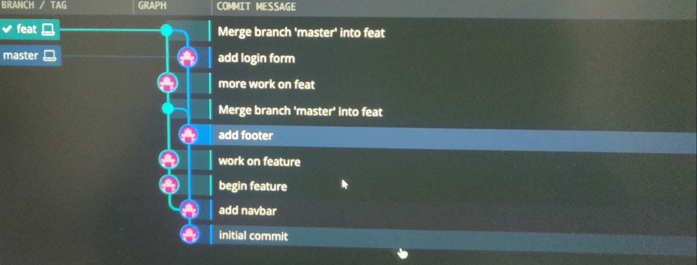

**After Rebasing**

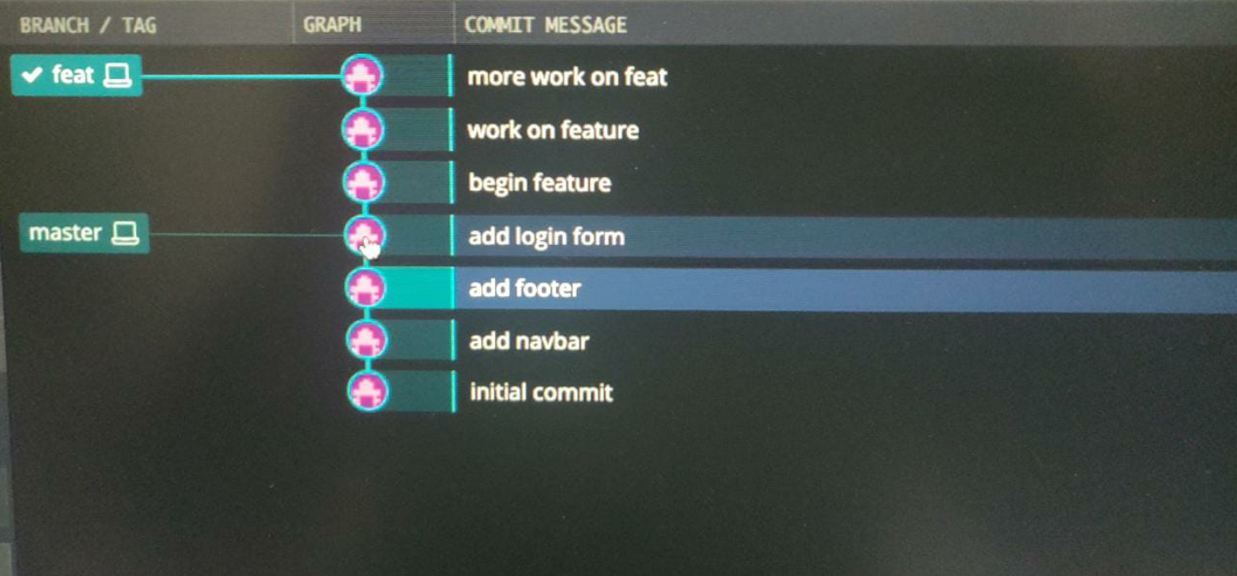

Hence, all of our work is still there, we have all 3 commits but now we don’t have any usless merge commits.

So now things are linear. We still have two branches, of course, but we've created new commits or GIT has created new commits for us based upon the original commits on the feature branch.

The commit hashes have also been changed since we came up with new commits (only for the three commits I made on my feature branch). However, the original commits on the master branch are unchanged and their hashes remain the same. Hence, ive made new commits/history. (hence we rebased the feature branch on tip of the master branch and all of the commits on the feature branch were re-created)

**We are not rebasing the master branch rather, we are rebasing on the tip of the master branch.**

**When and when not to rebase**

Never rebase a branch/commits which have been shared with others as it will lead to alternate history for everyone wherein some people might have certain commits in their history and other people might have some other commits in their history.

So you work on a feature branch, whatever you're doing in there, fixing a bug, adding a new feature, whatever it is, you can rebase your work from that branch onto the master branch or onto another branch. Right. You're not changing the master branch. You don't change the branch that you are rebasing onto. We didn't change the master branch here. We only changed my commits on the feature branch. So that's important.

The branch that you are on when you call Rebase is the one that is replaced, as we talked about. Let's go back here. Here I'm on the feature branch, I rebased onto master. That's fine, I'm not messing up master branch. I'm not changing the history on master. I'm only changing the history on my feature branch. I'm changing those commit

**Hence, we don’t want to rebase commits/rewrite history that other people have. So once you push that feature branch up, if somebody has pulled that down, if they have that history, if they're working on it, if you don't want to, you don't want to rebase. Only rebase stuff that it our own and then we can push it up. Never rebase commits/history that others have.**

**Handling Conflicts and Rebasing**

If we edit line 5 in our feature branch and someone edit’s the same line and pushes it to master branch and then we go on rebasing our feature branch on to the master branch, we get a conflict. Just like the old regular merge conflict we can just select incoming changes or not.

Just fix the conflict, **git add filename** and then don’t commit rather, run **git rebase –continue.**

**Section 16: Cleaning up history with interactive rebase**

So now we're going to talk about a second way of using the Git rebase command, we can use it to rewrite history, we can edit commits, we can change, commit message, commit messages. We could change the contents of a commit. We can drop or delete an entire commit. We can even reorder things using get rebase.

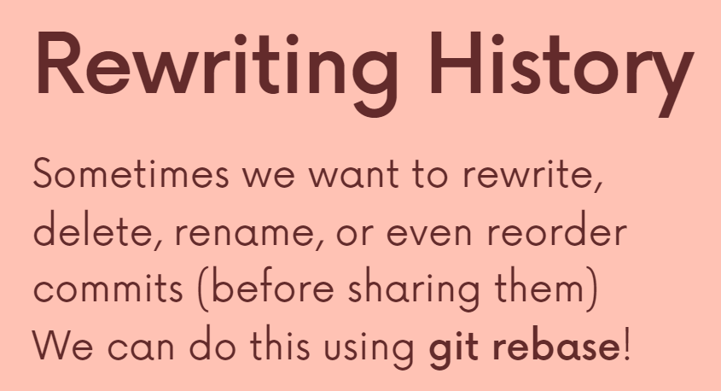

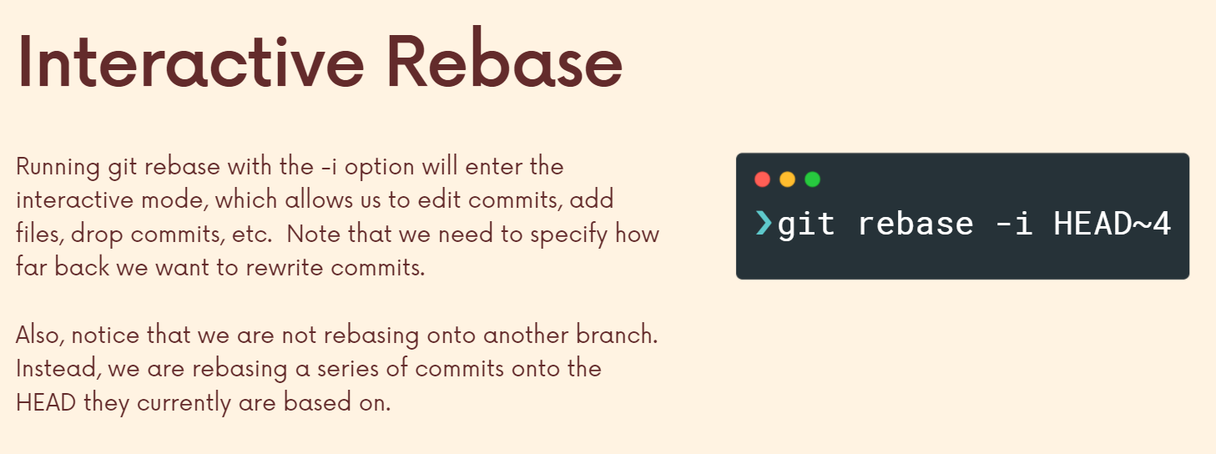

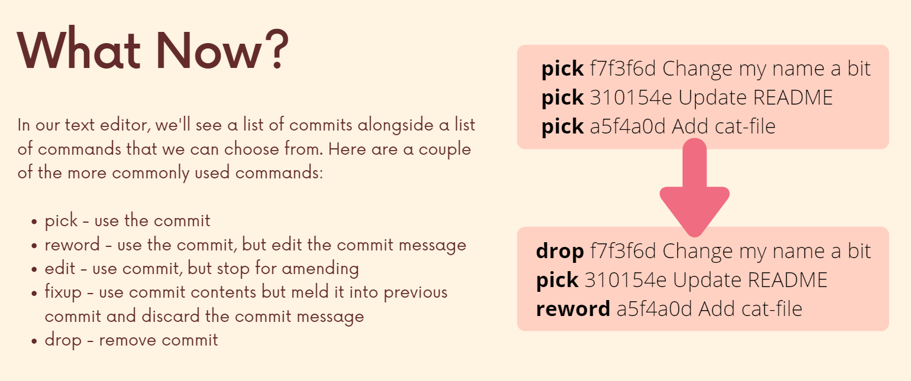

If we reword a commit, its hash changes aswell. However, more importantly, the hashes of the commits following that commit changes aswell since each commit takes in consideration its parent commit (hence all new commit). Every commit changed after that one (all new commit because of the generation of new commit hashes).

So that pick command just means keep the content, keep everything you can from this commit. But it may end up, but we need to remake that commit if something changes before it.

If I use fixup, the commit and its message are gone but the changes made by the commit are incorporated. On the other hand if I drop a commit then even its changes are gone.

**Section 17: Git tags**

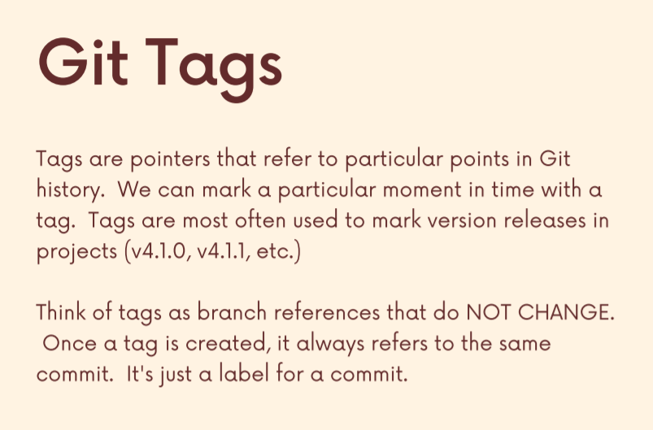

(Below figure) Anyone who sees this repository, I’m tagging this node. Unlike a branch reference which updates automatically (to the latest commit), we have to manually update a tag else it always tags the same commit. A tag is a pointer to a commit in time.

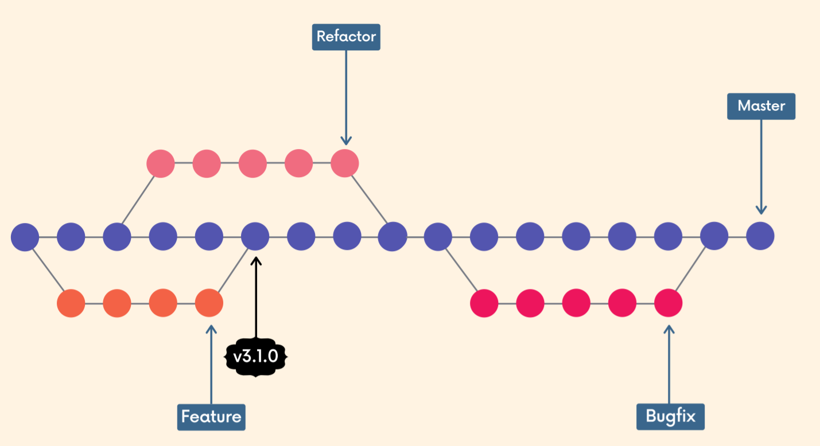

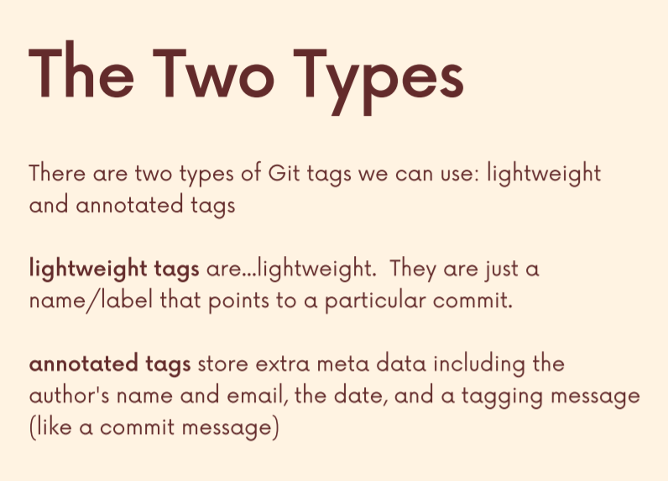

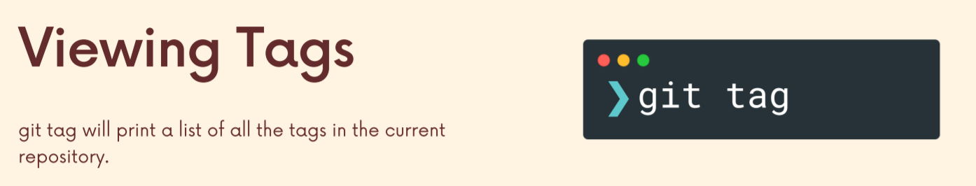

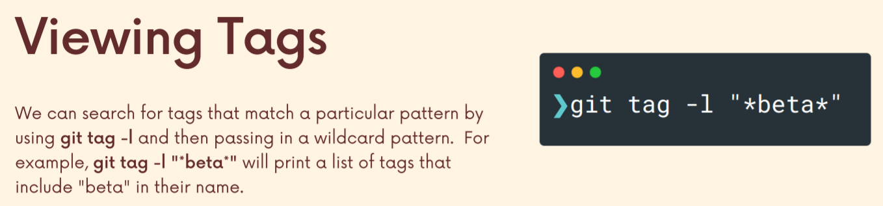

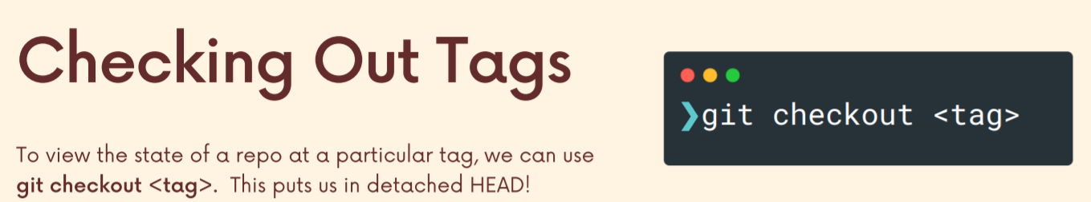

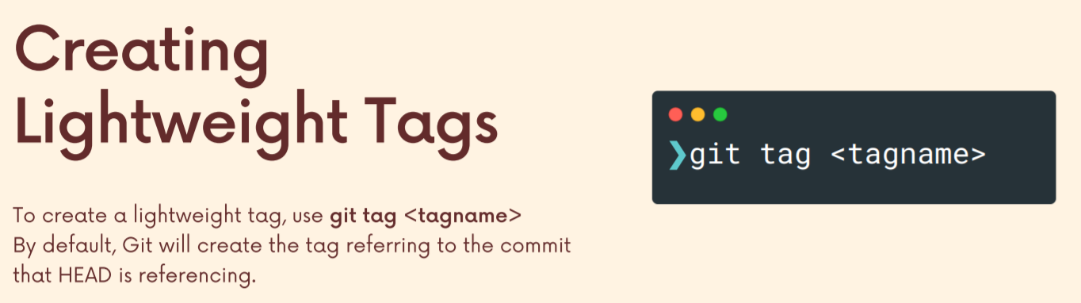

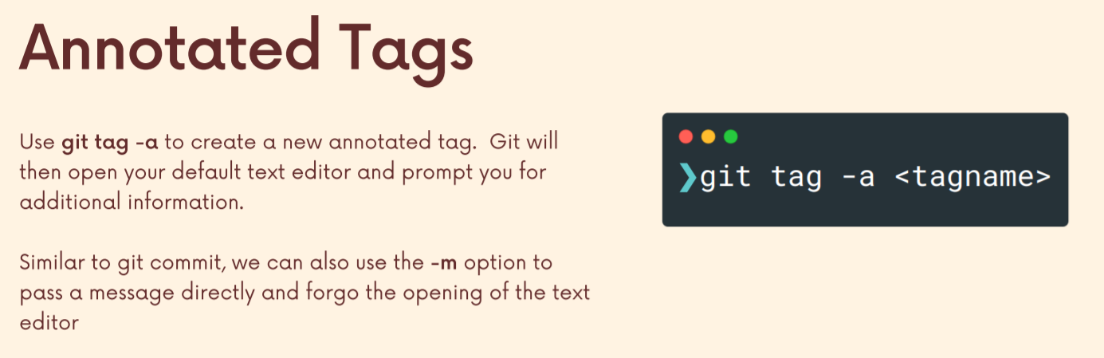

Till now we have tagged the latest commit, however to tag a previous commit:

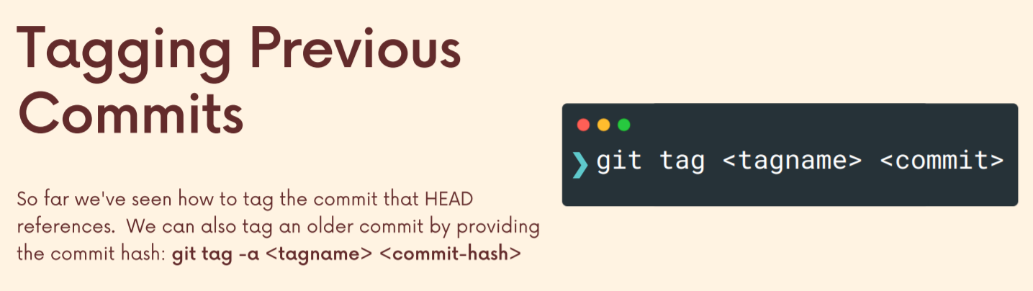

If for some reason we need to move a tag, so we need to have it referred to a different commit, we can use the option to force that tag through because git does not like it if we try and reuse a tag (tag names need to be unique and I can’t re-use a tag name).

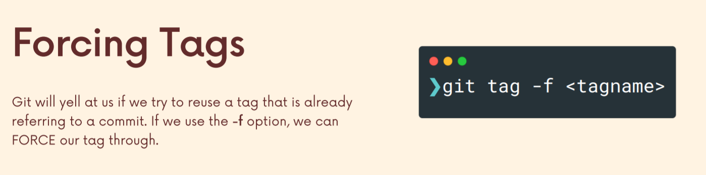

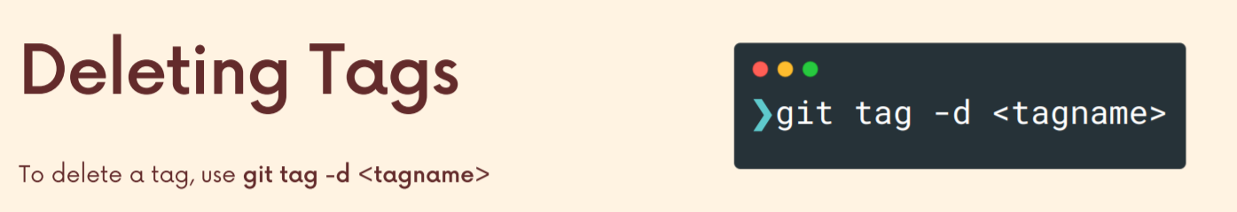

Now, one last important note about tags has to do with pushing by default, when you push up changes to a remote repository, tags are not going to be included. So you can push tags actually two different ways. You can push all of your tags that are new using dash dash tags, or you can go to the get docs and they talk about how you can push a single particular tag like this, git push and then a remote name.

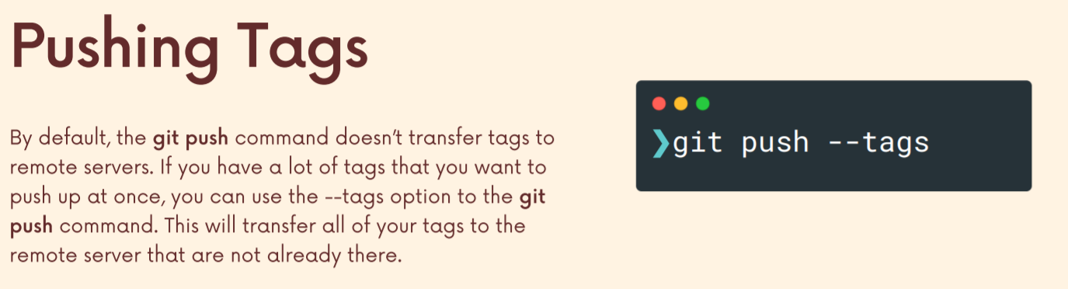

So moral of the story, tags are not included by default. When you push, you can push them one at a time or you can push all tags in a repo using dash dash tags.

**Section 18: GIT BTS**

**Section 19: The Power of Reflogs – Retrieving Lost Work**

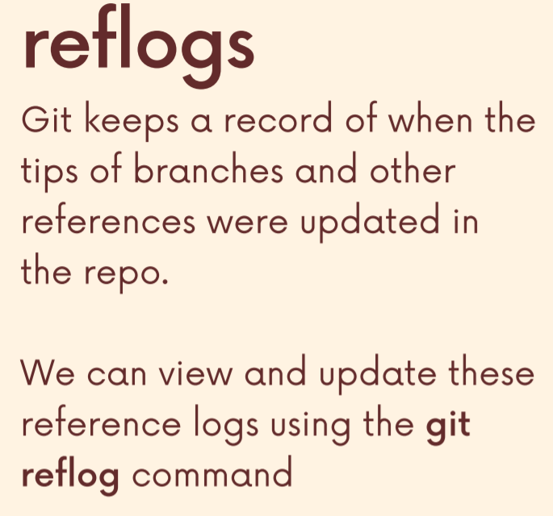

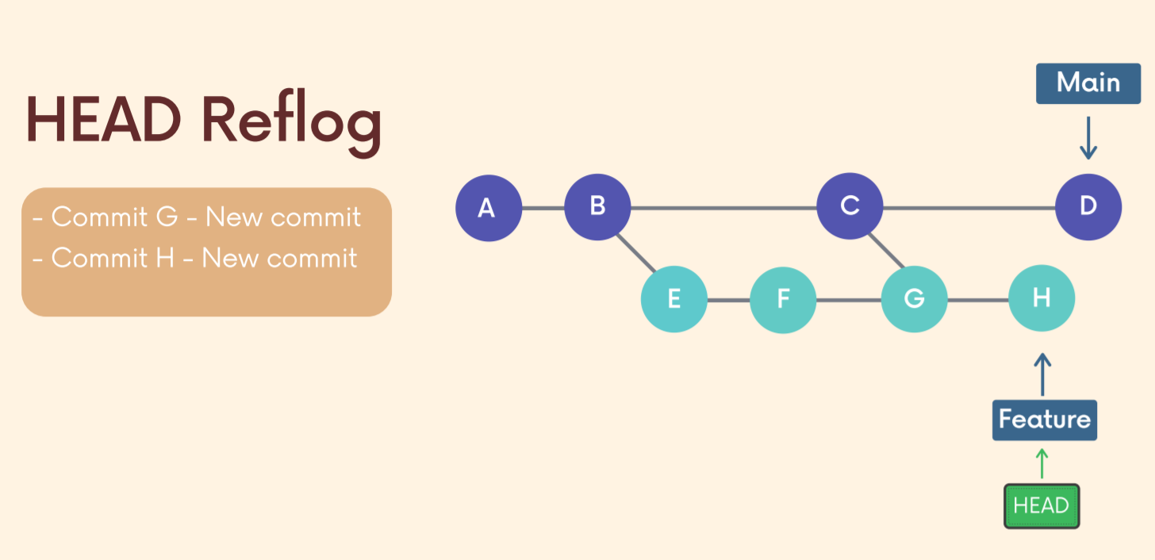

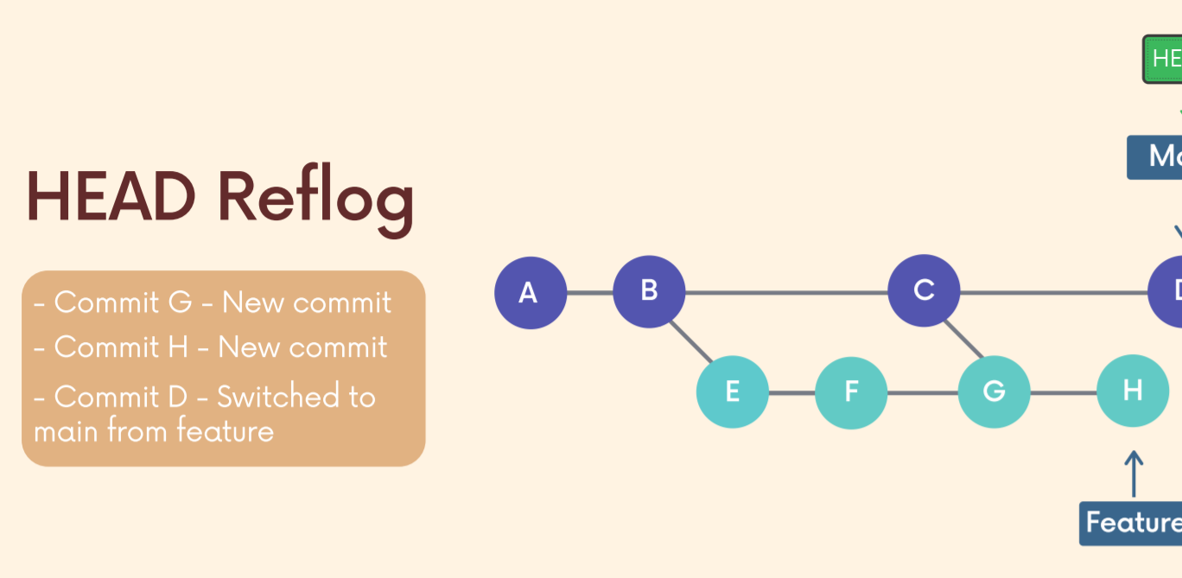

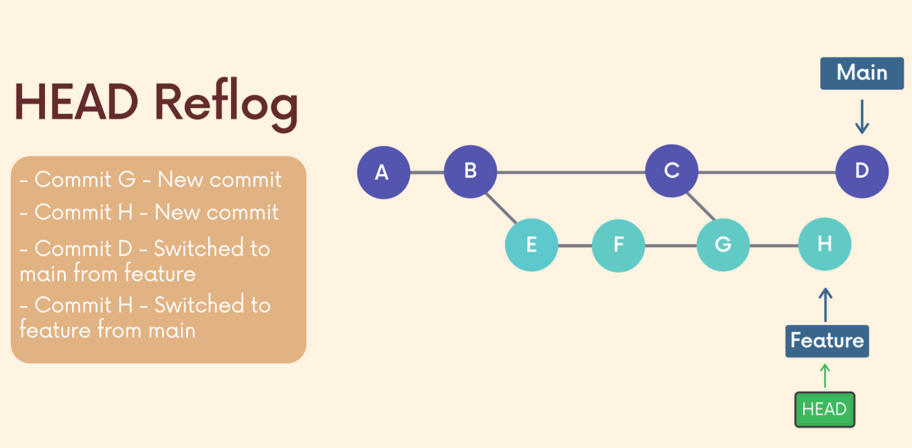

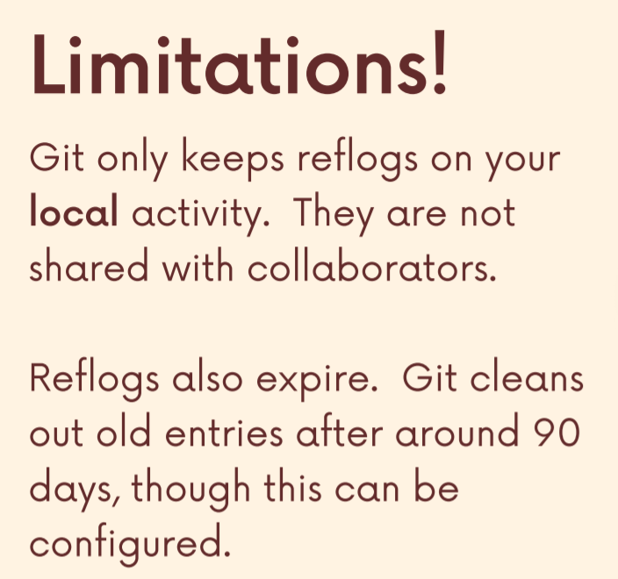

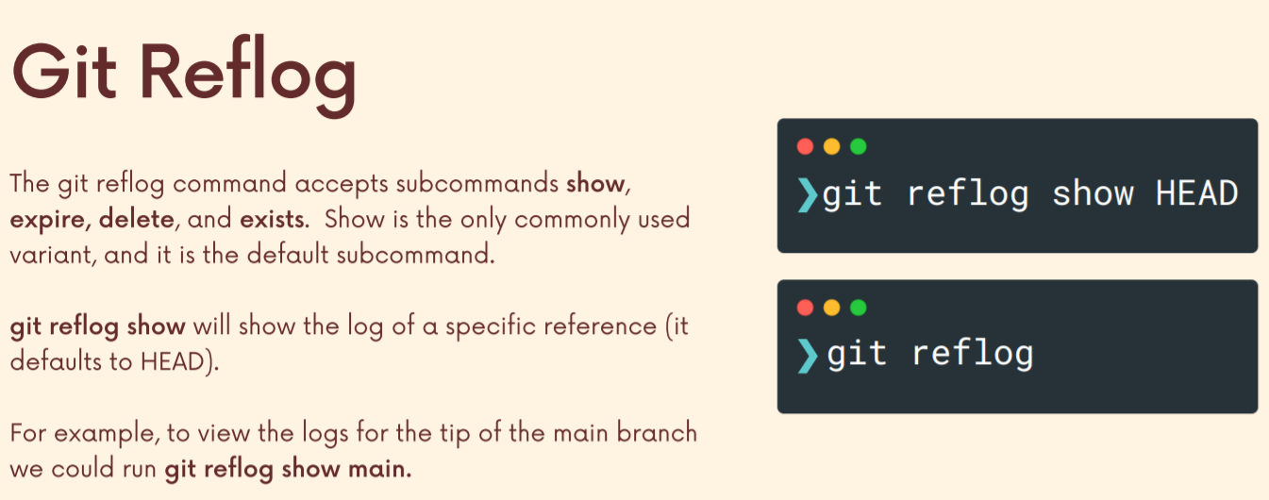

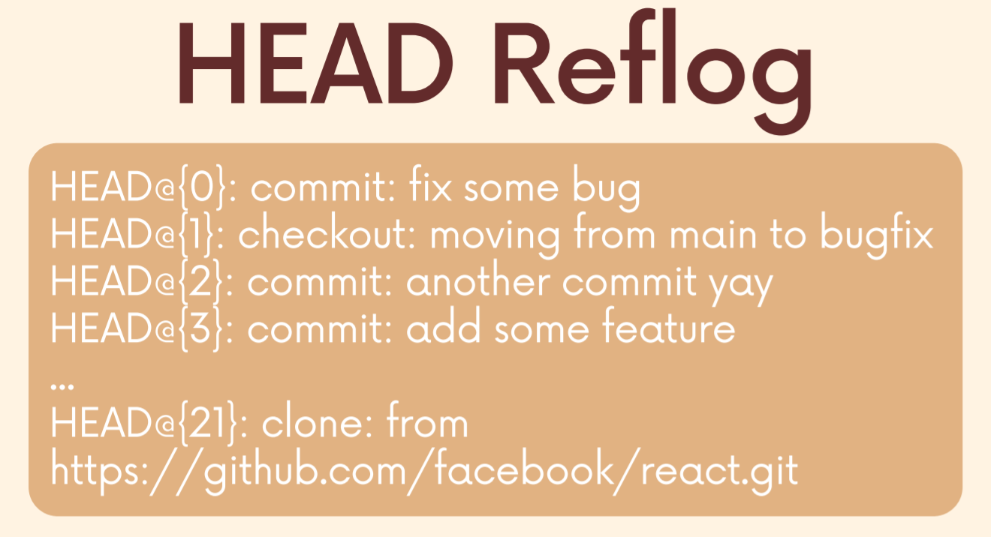

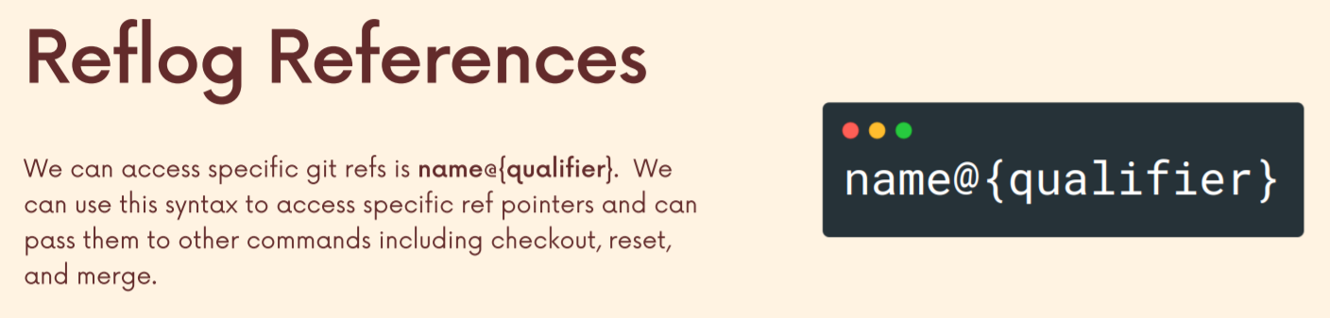

**Head~2**

We've seen this this means the parent of head and then its parent, two generations of parents ago. So basically the grandparent commit.

**Head@{2}**

But if I do head at two, this may not even be commits that we are your parent commits that we're going back in time. We may be on the same exact commit and we just switch branches because head at two is just saying to move to go in the reflog for head. That might just be changing branches, it might be detached head, who knows.

We can use timed references to know that what did a branch look like at any particular time in the past. We can see how the file looked 2 days back and we can also use diff to compare the file as of today and that of 2 days back.

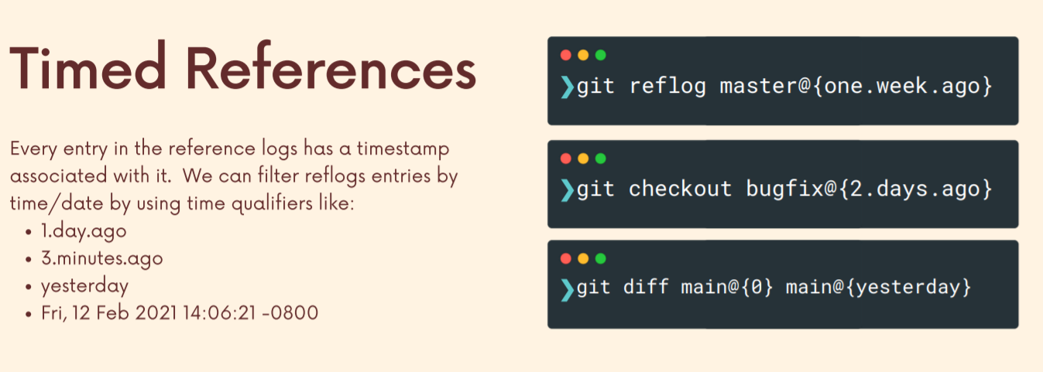

Use 1: We can go back 1 week ago when our master branch was working perfectly and check it out (**git checkout master@{1.week.ago}**). Hence, I don’t have to find the commit hash or anything and I can directly time travel 1 week back.

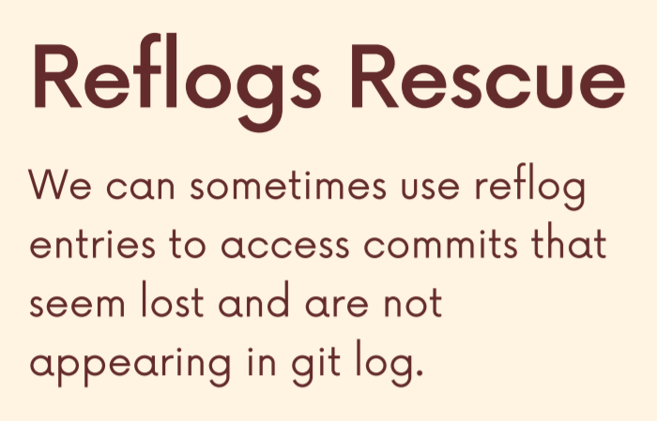

<https://www.udemy.com/course/git-and-github-bootcamp/learn/lecture/25091012#overview>

<https://www.udemy.com/course/git-and-github-bootcamp/learn/lecture/25091014#overview>

**Section 20: Aliases (20mins can watch on udemy)**